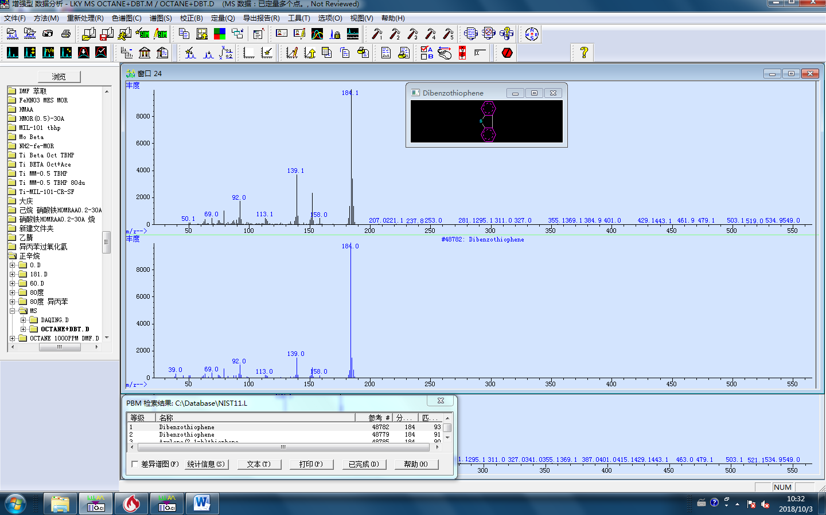

**Fig. S1. Mass spectrum of dibenzothiophene.**

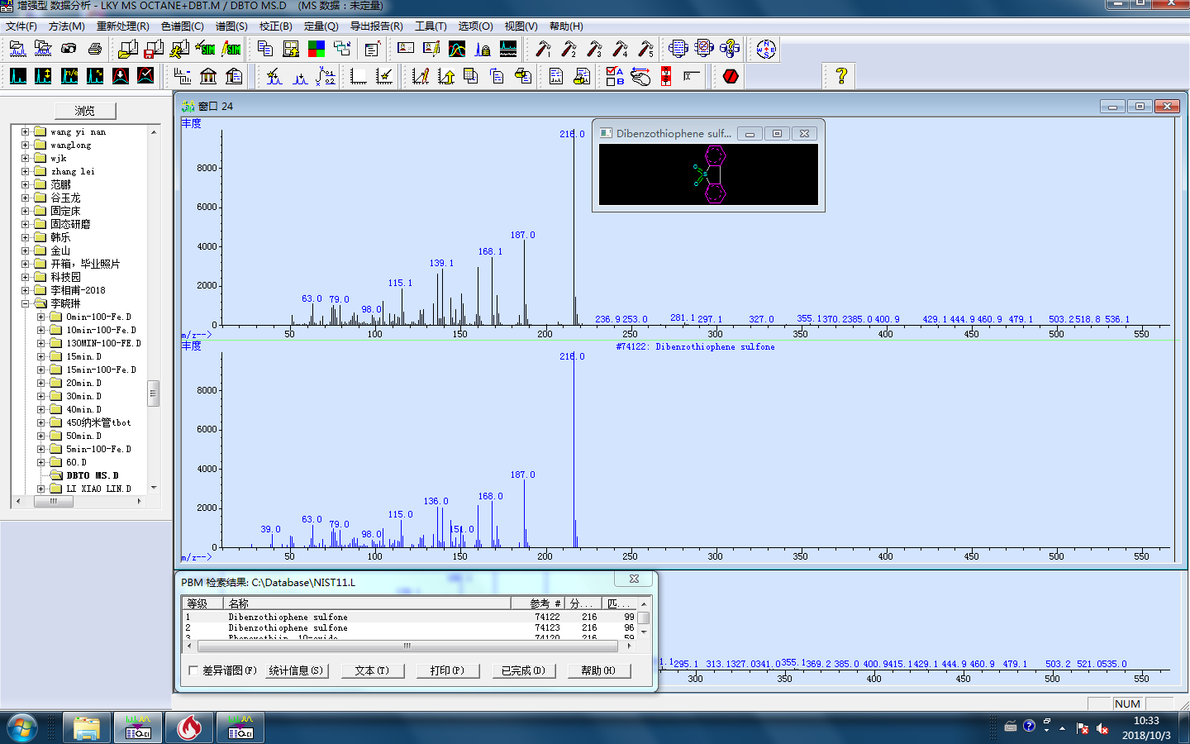

**Fig. S2. Mass spectrum of dibenzothiophene sulfone.**