**Supplementary materials**

**Application of Laccase/DDQ as a new bioinspired catalyst system for the aerobic oxidation of tetrahydroquinazolines and Hantzsch 1,4-dihydropyridines**

Mastaneh Shariatia, GholamhassanImanzadeh*a, Amin Rostami*b, Nadya Ghoreishyb, Somayyeh Kheirjoua

**1HNMR** **spectra of products**

**1HNMR spectrum of** **2-Phenyl quinazoline**



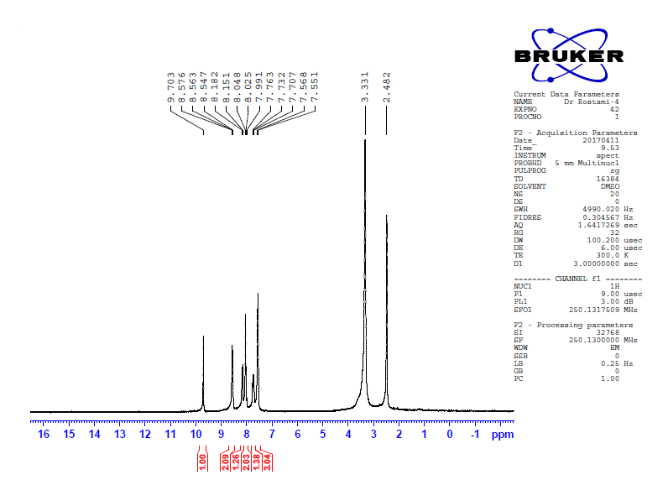

**Expanded 1H NMR spectrum (between 7.3 and 8.9 ppm) of** **2-Phenyl quinazoline**

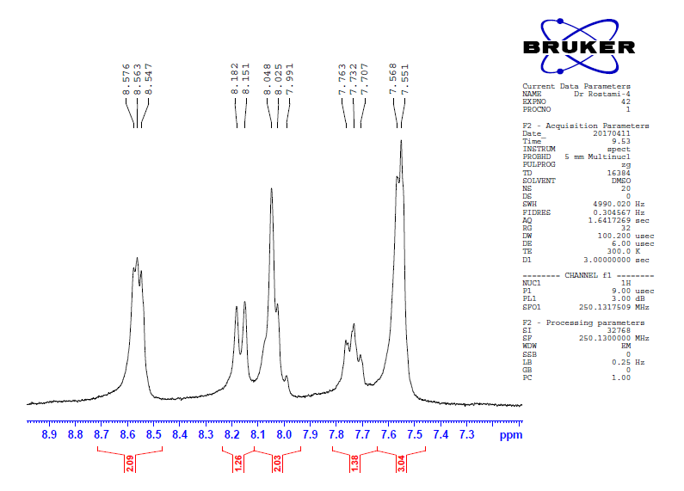

**1HNMR spectrum of** **2-(4-Methoxylphenyl) quinazoline**



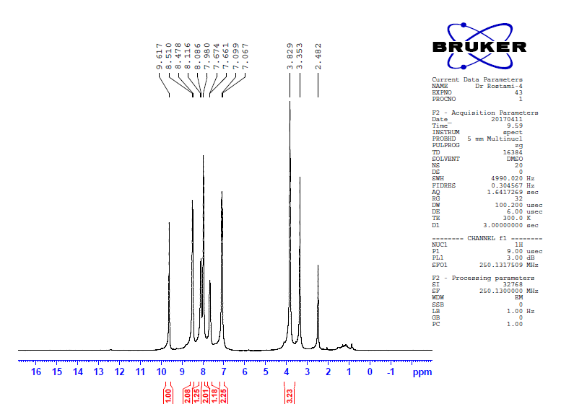

**Expanded 1H NMR spectrum (between 7.0 and 10.0 ppm) of** **2-(4-Methoxylphenyl) quinazoline**

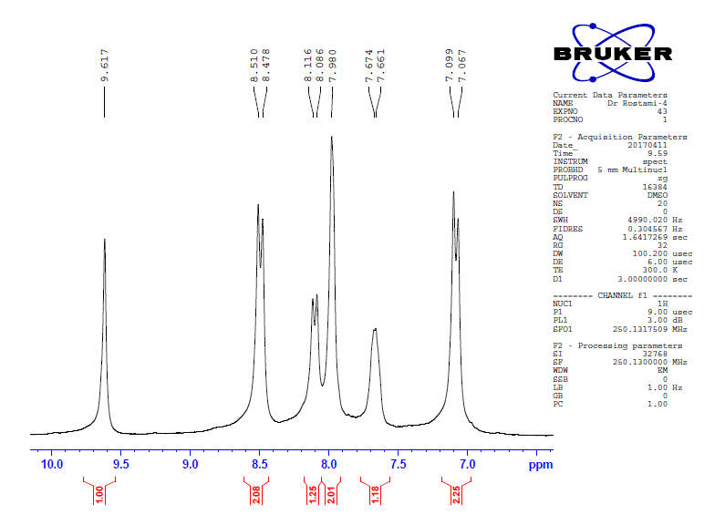

**1HNMR spectrum of** **2-(3-Methoxyphenyl) quinazoline**



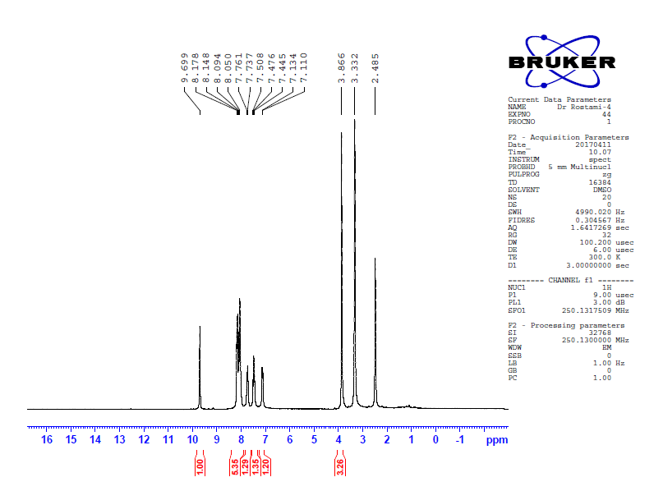

**Expanded 1H NMR spectrum (between 6.6 and 8.8 ppm) of** **2-(3-Methoxyphenyl) quinazoline**

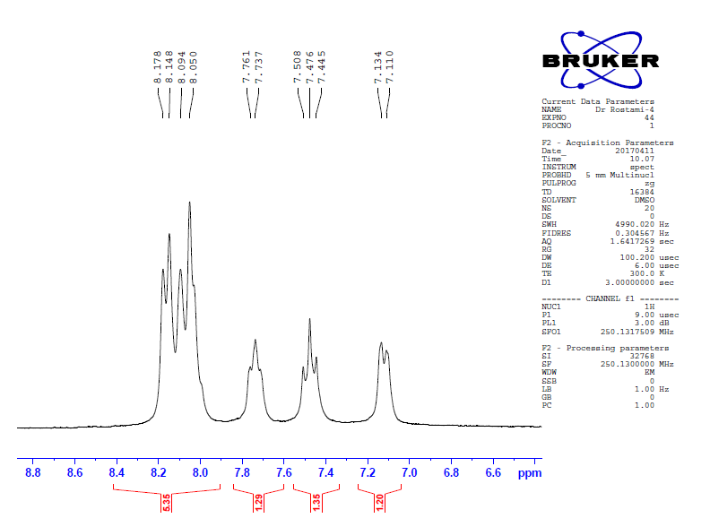

**1HNMR spectrum of** **2-(3-Fluorophenyl) quinazoline**



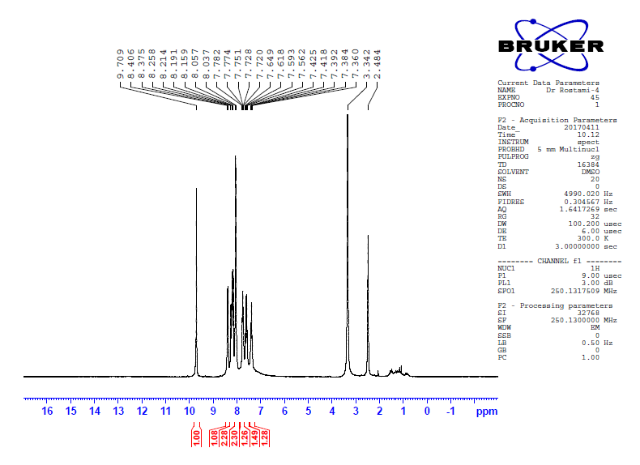

**Expanded 1H NMR spectrum (between 7.0 and 9.5 ppm) of** **2-(3-Fluorophenyl) quinazoline**

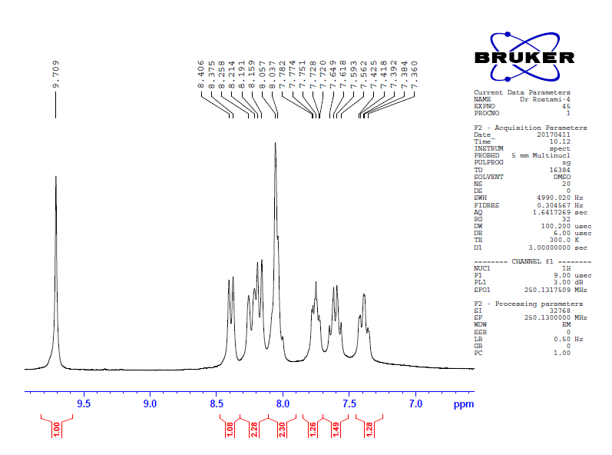

**1HNMR spectrum of** **2-(3-Chlorophenyl) quinazoline**



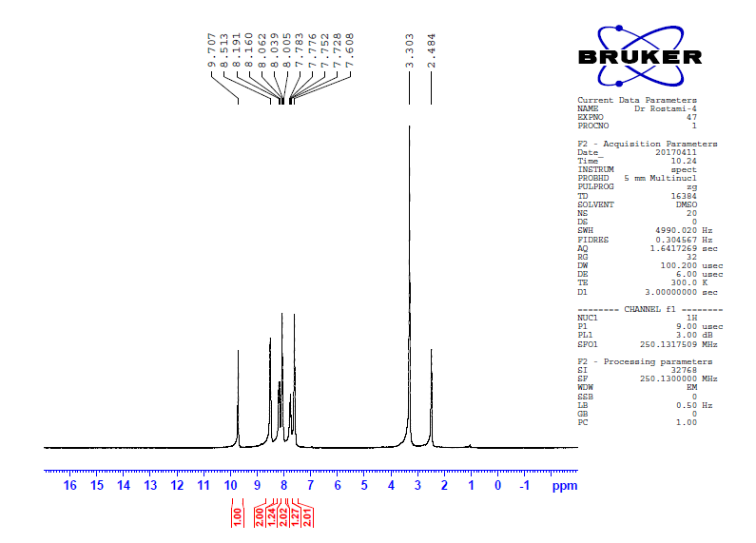

**Expanded 1H NMR spectrum (between 7.5 and 10.0 ppm) of 2-(3-Chlorophenyl) quinazoline**

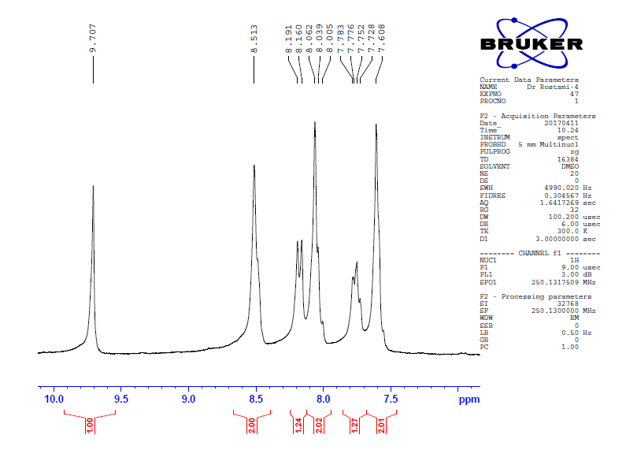

**1HNMR spectrum of** **2-(3-Bromophenyl) quinazoline**



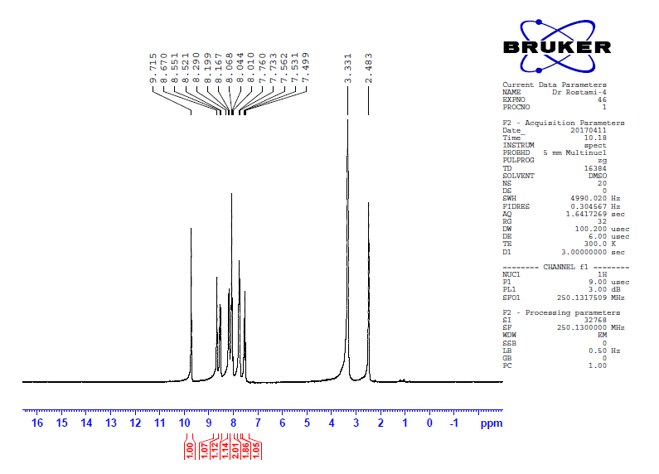

**Expanded 1H NMR spectrum (between 7.0 and 9.2 ppm) of** **2-(3-Bromophenyl) quinazoline**

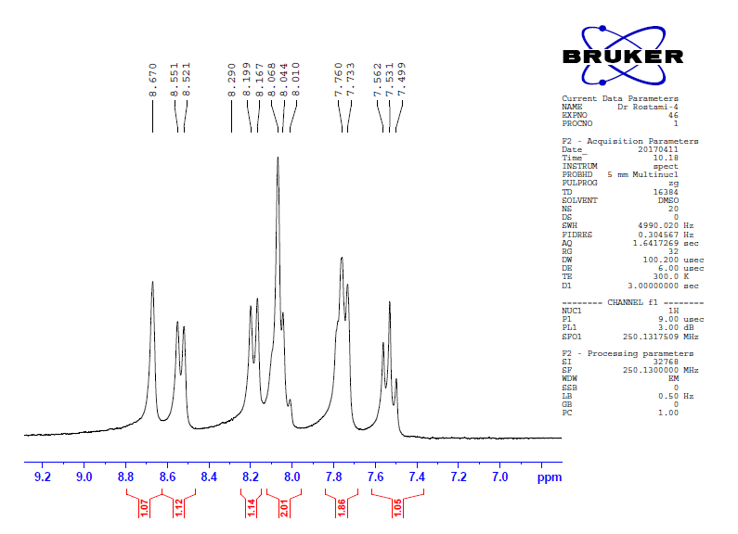

**1HNMR spectrum of** **Diethyl 2,6-dimethyl-4-phenyl-3,5-pyridinedicarboxylate**



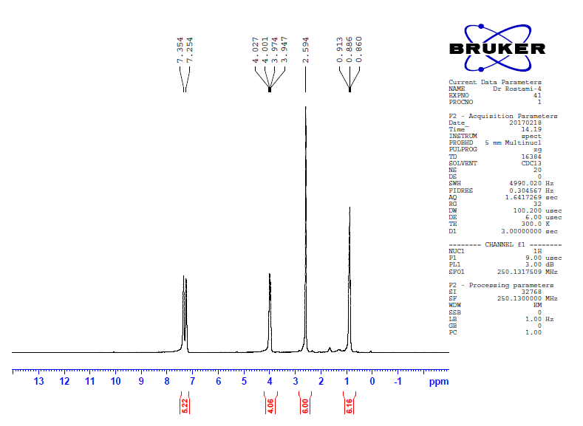

**Expanded 1H NMR spectrum (between 0.5 and 3.0 ppm) of** **Diethyl 2,6-dimethyl-4-phenyl-3,5-pyridinedicarboxylate**

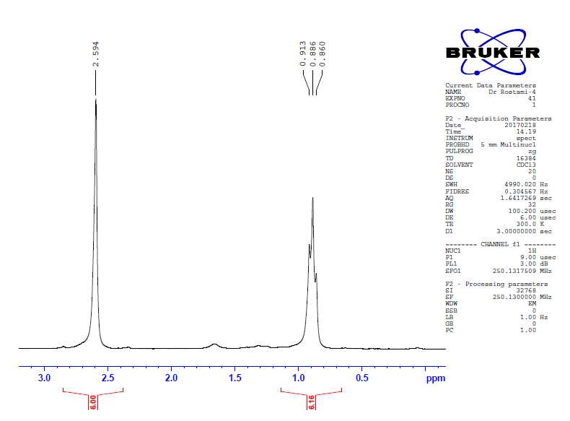

**1HNMR spectrum of** **Diethyl 2,6-dimethyl-4-(*p*-tolyl)-3,5-pyridinedicarboxylate**



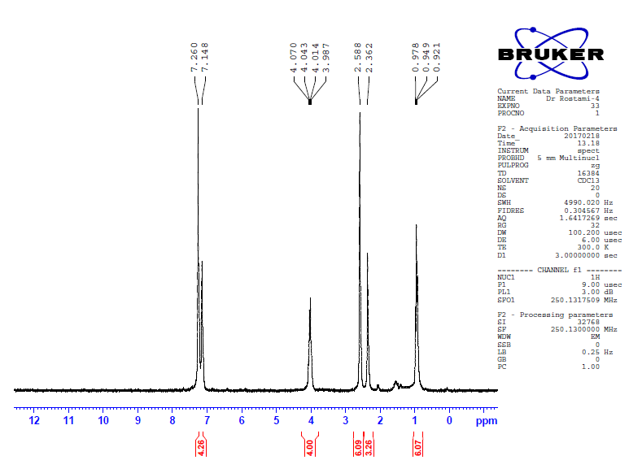

**Expanded 1H NMR spectrum (between 1.0 and 4.0 ppm) of Diethyl 2,6-dimethyl-4-(p-tolyl)-3,5-pyridinedicarboxylate**

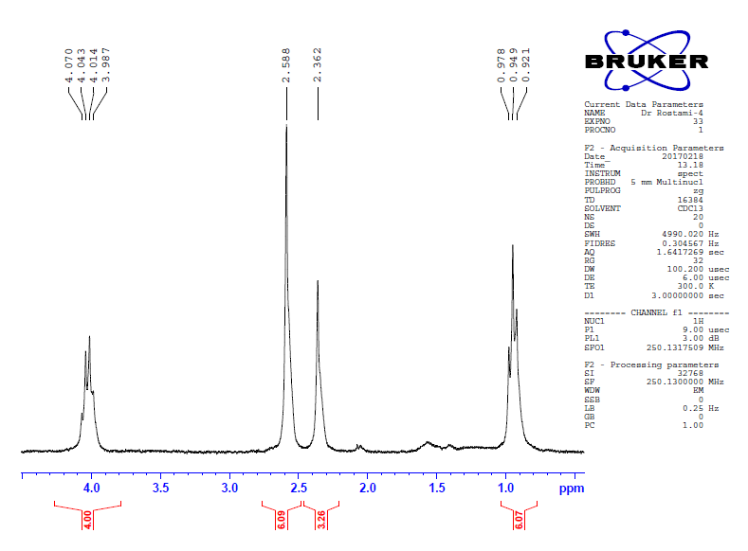

**1HNMR spectrum of** **Diethyl 2,6-dimethyl-4-(4-Methoxyphenyl)-3,5-pyridinedicarboxylate**



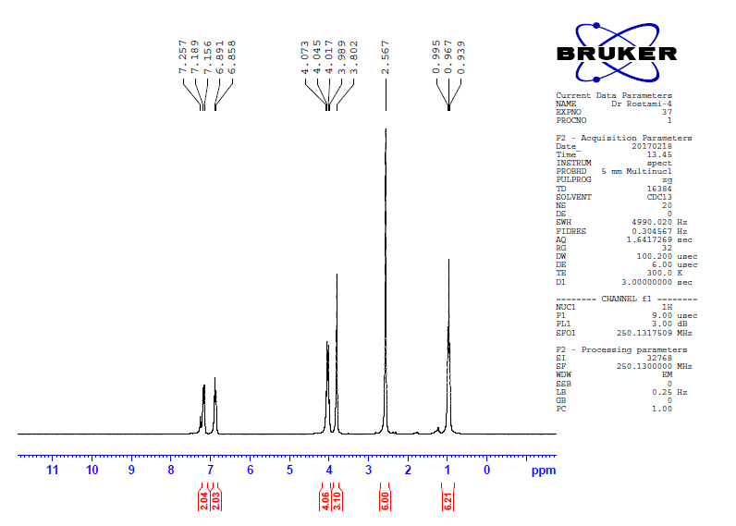

**Expanded 1H NMR spectrum (between 1.0 and 4.5 ppm) of Diethyl 2,6-dimethyl-4-(4-Methoxyphenyl)-3,5-pyridinedicarboxylate**

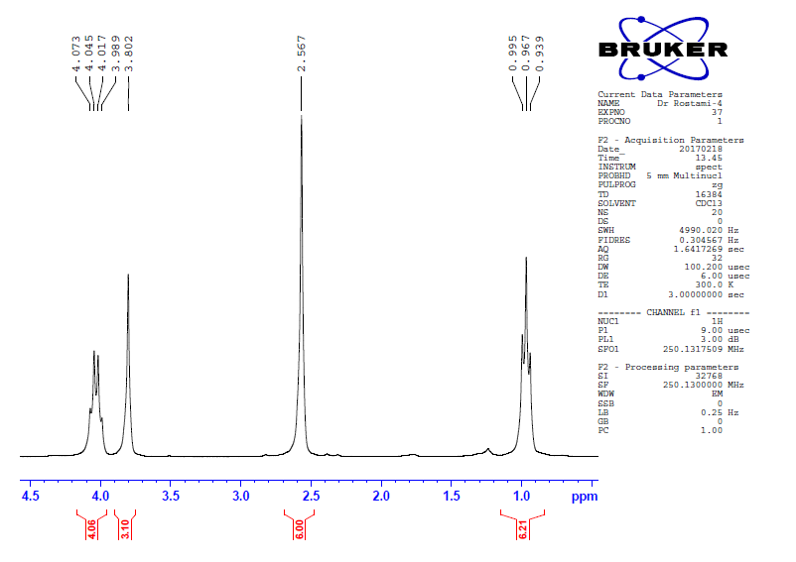

**1HNMR spectrum of** **Diethyl 2,6-dimethyl-4-(3,4,5-trimethoxyphenyl)-3,5-pyridinedicarboxylate**



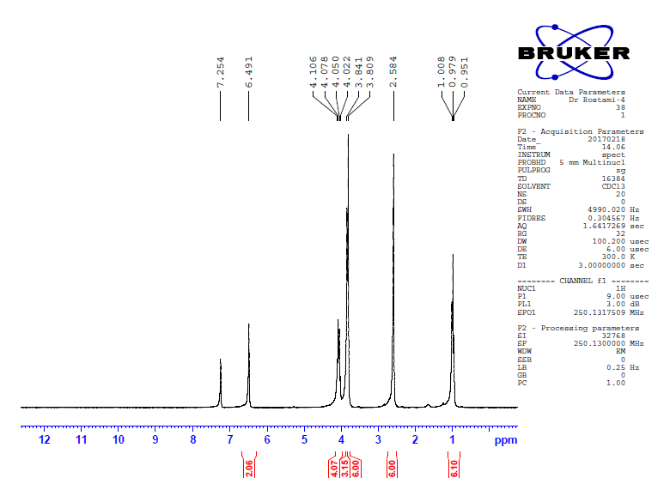

**Expanded 1H NMR spectrum (between 2.2 and 4.8 ppm) of Diethyl 2,6-dimethyl-4-(3,4,5-trimethoxyphenyl)-3,5-pyridinedicarboxylate**

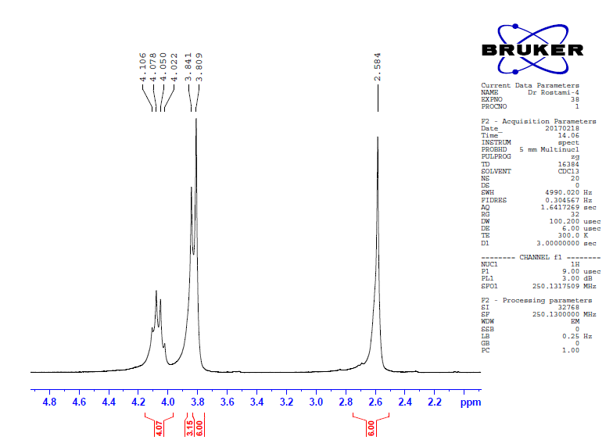

**1HNMR spectrum of** **Diethyl 2,6-dimethyl-4-butyl-3,5-pyridinedicarboxylate**



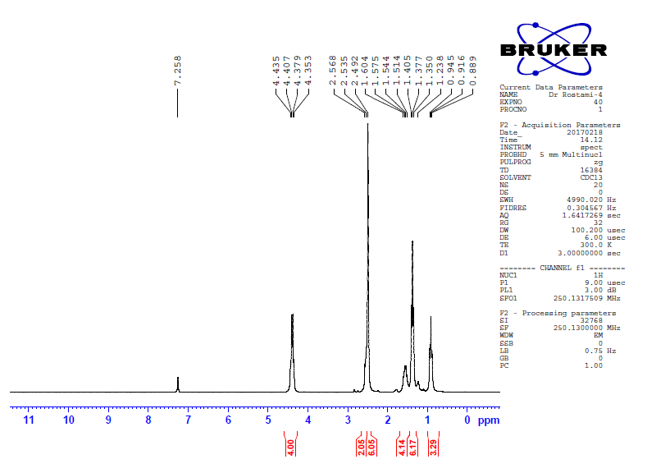

**Expanded 1H NMR spectrum (between 0.6 and 3.0 ppm) of** **Diethyl 2,6-dimethyl-4-butyl-3,5-pyridinedicarboxylate**

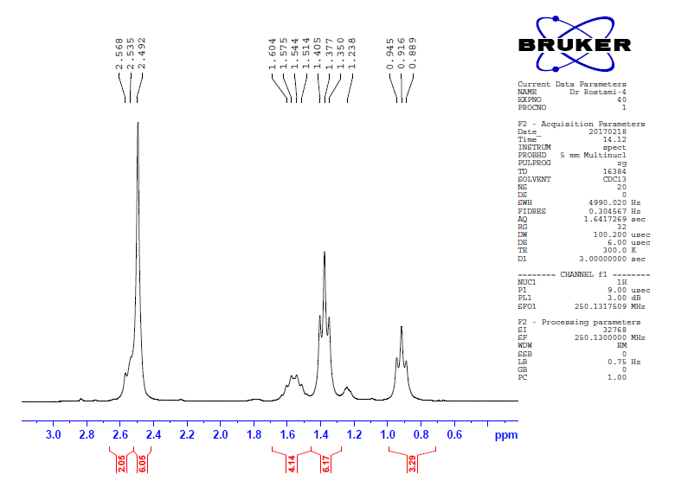

**1HNMR spectrum of** **Diethyl 2,6-dimethyl-4-(3-chlorophenyl)-3,5-pyridinedicarboxylate**



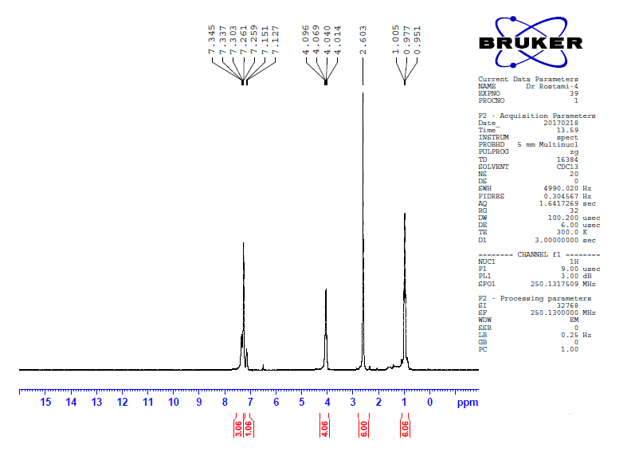

**Expanded 1H NMR spectrum (between 1.0 and 4.5 ppm) of** **Diethyl 2,6-dimethyl-4-(3-chlorophenyl)-3,5-pyridinedicarboxylate**

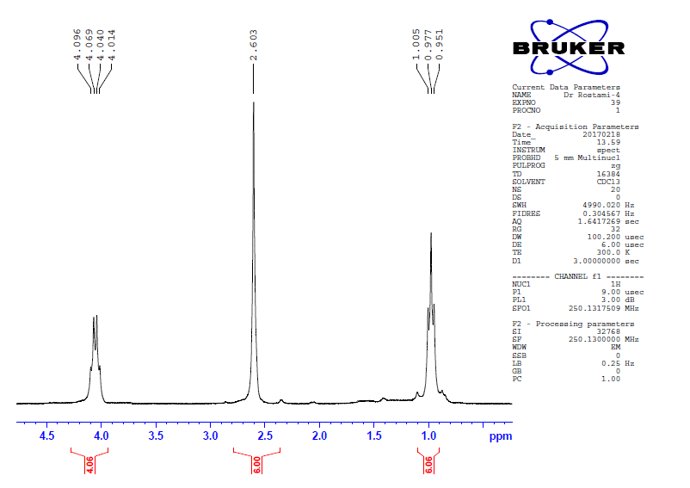

**1HNMR spectrum of** **Diethyl 2,6-dimethyl-4-(2-fluorophenyl)-3,5-pyridinedicarboxylate**



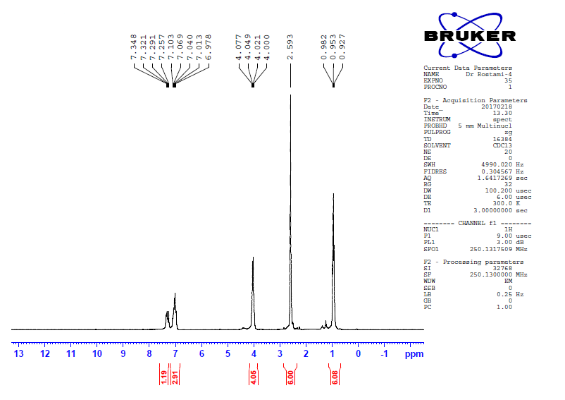

**Expanded 1H NMR spectrum (between 1.0 and 4.5 ppm) of** **Diethyl 2,6-dimethyl-4-(2-fluorophenyl)-3,5-pyridinedicarboxylate**

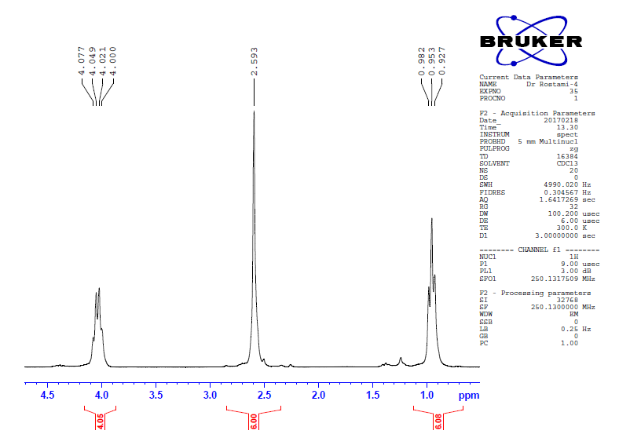

**1HNMR spectrum of Diethyl 2,6-Dimethyl-4-(4-nitrophenyl)-3,5-pyridinedicarboxylate**



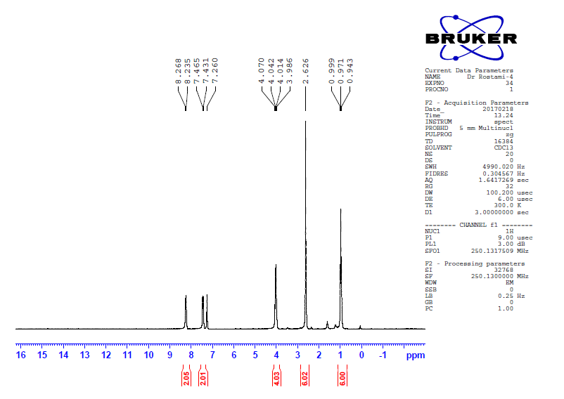

**Expanded 1H NMR spectrum (between 1.0 and 4.0 ppm) of** **Diethyl 2,6-Dimethyl-4-(4-nitrophenyl)-3,5-pyridinedicarboxylate**

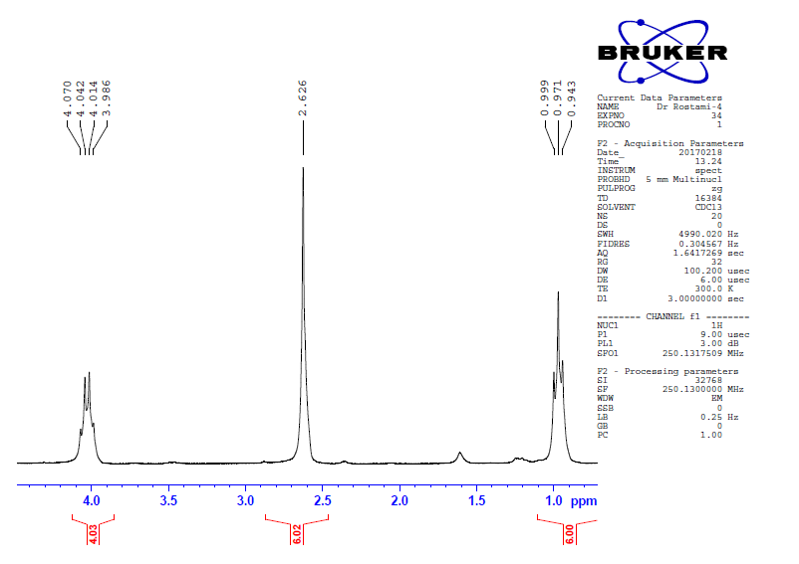

**1HNMR spectrum of** **Diethyl-2,6-dimethyl-4-(4-cinamyl)-3,5-pyridinedicarboxylate**



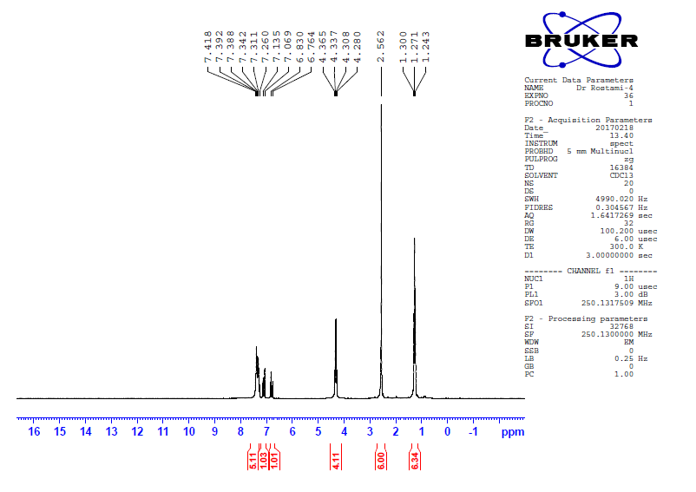

**Expanded 1H NMR spectrum (between 1.0 and 4.5 ppm) of** **Diethyl-2,6-dimethyl-4-(4-cinamyl)-3,5-pyridinedicarboxylate**

