Supplementary Information

Tetranuclear [Fe^{II}₂Fe^{III}₂]²⁺ molecular switches: [Fe^{II}(bik)₂(N-)₂] spin-crossover complexes containing [Fe^{III}(Tp)(CN)₃]⁻ metalloligands as N- donor

By Delphine Garnier et al.

Figure S1. Cyclovoltammogram of PPh₄[Fe(Tp*)(CN)₃] (5)
Table S1. Crystal data and structure refinement parameters for PPh₄[Fe(Tp*)(CN)₃].CH₃CN (5)
Figure S2. Perspective and top view of the anionic complex in PPh₄[Fe(Tp*)(CN)₃].CH₃CN
Table S2. Selected bond lengths (Å) and angles (°) for PPh₄[Fe(Tp*)(CN)₃].CH₃CN
Figure S3. Magnetic properties of 2 depicted as the χ_{M}T versus T curve (solvated and in-situ desolvated sample.
Figure S4. χ_{M}T versus T curves of 3 and 4 measured upon heating (from low temperature to 400 K) and upon cooling (from 400 K to low temperature).
Figure S5. χ_{M}T versus T curves simulated using the Slicher Drickammer model.
Figure S6. Measurement of the χ_{M}T product versus time at 10 K for the compound 4 under laser light irradiation

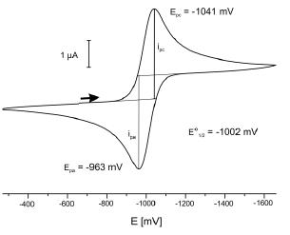
Figure S1. Cyclovoltammogram of PPh₄[Fe(Tp*)(CN)₃] (5) at room temperature in dried acetonitrile (vs Fc/Fc⁺). Scan rate ν = 100 mV.s⁻¹, Pt/[nBu₄N][PF₆]/Ag.
The redox process in PPh₄[Fe(Tp*)(CN)₃] occurs at a half potential of E°_{1/2} = -1002 mV (ΔEp = 78 mV) a value lower than that found for PPh₄[Fe(Tp)(CN)₃] (E°_{1/2} = -824 mV vs [Fc]/[Fc]⁺ ).

Table S1. Crystal data and structure refinement parameters for PPh₄[Fe(Tp*)(CN)₃].CH₃CN (5)

Compound | PPh₄[Fe(Tp)*(CN)₃] · CH₃CN
Molecular formula | C₄₄H₄₅BFeN₁₀P
M [g·mol⁻¹] | 811.54
Crystal system | monoclinic
Space group | P2₁/c
a [Å] | 16.3287(5)
b [Å] | 9.8451(3)
c [Å] | 26.4596(8)
  | 90.00
  | 103.2530(10)
  | 90.00
V [Å³] | 4140.3(2)
Crystal size | 0.160×0.120×0.100
µ [mm⁻¹] | 0.448
ρ_{calculated} [g·cm³] | 1.302
Z | 4
T [K] | 200
2θ_{max} [°] | 60.23
Collected reflexions | 41529
Unique reflexions | 12087
Number of parameters/restraints | 515/0
R1 [I ≥ 2σ(I)] | 0.0541
wR2 (all data) | 0.1752
Max/min residual electron density [e×Å⁻³] | 0.84/-0.80
Radiation | Mo K λ = 0.71073)
Diffractometer | Bruker Kappa Apex2

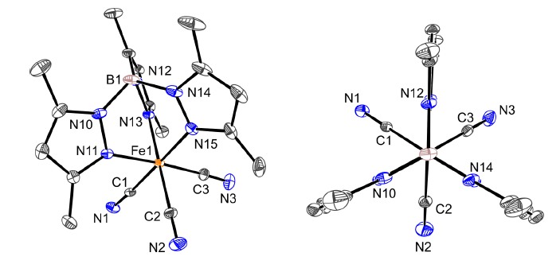
Figure S2. Perspective and top view of the anionic complex in PPh₄[Fe(Tp*)(CN)₃].CH₃CN
The complex PPh₄[Fe(Tp*)(CN)₃].CH₃CN (5) crystallises in the monoclinic space group P21/c, (Z = 4). Its crystal structure consists of a negatively charged tricyanido tris(3,5-dimethylpyrazolyl)borate iron(III) complex, its tetraphenyl phosphonium countercation and an acetonitrile molecule. It is isostructural to the literature-known PPh₄[Fe^{II}(Tpm*)(CN)₃] · 2 MeCN, where the change in oxidation state of the iron ion compensates the replacement of the neutral scorpionate Tpm* ligand ( ) by the negatively charged Tp*. The Fe–C bond lengths exhibit a mean distance of 1.923 Å, which is typical for iron(III) cyanide complexes. The Fe–N bonds are about the same length with a mean value of 2.010 Å. This difference contributes to the elongation along the pseudo C3v symmetry axis (Fe···B). Selected bond lengths and angles are listed below.
Table S2. Selected bond lengths (Å) and angles (°) for PPh₄[Fe(Tp*)(CN)₃].CH₃CN (5)
Fe1–C1 1.922(3)  Fe1–C2 1.930(3)  Fe1–C3 1.917(3) |  | Fe1–N11 2.025 (2)  Fe1–N13 1.990(2)  Fe1–N15 2.014(2)
C1-Fe1-C2 89.66(11),  C1-Fe1-C3 87.19(12),  C2-Fe1-C3 86.56(11),  N11-Fe1-N13 89.96(9),  N11-Fe1-N15 89.33(9),  N13-Fe1-N15 88.36(9), | C1-Fe1-N11 90.84(10),  C1-Fe1-N13 90.38(9),  C2-Fe1-N11 90.58(11),  C2-Fe1-N15 91.60(11),  C3-Fe1-N13 92.27(11),  C3-Fe1-N15 93.32(11), |  | Fe1-C1-N1 176.8(3)  Fe1-C2-N2 178.8(3)  Fe1-C3-N3 178.4(3)

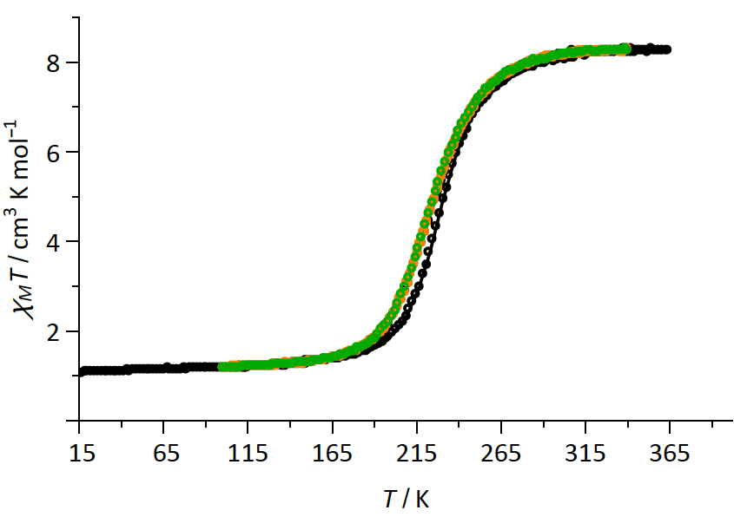
Figure S3. Magnetic properties of 2 depicted as the χ_{M}T versus T curve. The black curve represents the properties of the fresh sample (measured upon heating) while the orange curve represents the properties of the in-situ desolvated sample. Once dehydrated the sample show a well reproducible spin-transition (green curve).

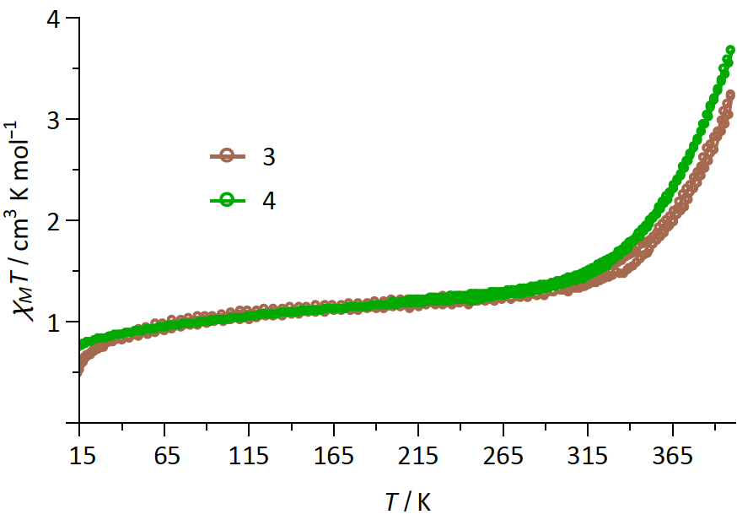
Figure S4. χ_{M}T versus T curves of 3 and 4 measured upon heating (from low temperature to 400 K) and upon cooling (from 400 K to low temperature). In both cases, the χ_{M}T curve superimposed to each other showing that the loss of solvent (occurring when measuring upon heating under reduced He pressure) does not affect the spin crossover behaviour.

ΔH = 24 kJ.mol⁻¹.K; ΔS = 105 J.mol⁻¹.K;  Γ = 1.6 kJ.mol⁻¹.K | ΔH = 23.5 kJ.mol⁻¹.K; ΔS = 105 J.mol⁻¹.K;  Γ = 1.0 kJ.mol⁻¹.K

Figure S5. χ_{M}T versus T curves simulated using the Slicher Drickammer model. Experimental data are in black. The simulated data is in red.

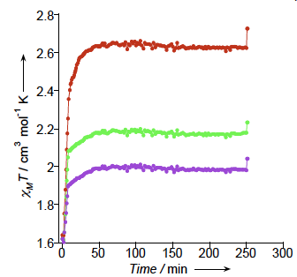
Figure S6. Measurement of the χ_{M}T product versus time at 20 K for compound 4 under laser light irradiation (ca. 5 mW/cm²) at 808 nm (red), 532 nm (green) and 405 nm (violet).

Shi, C.-C.; Chen, C.-S.; Hsu, S. C. N.; Yeh, W.-Y.; Chiang, M. Y.; Kuo, T.-S. Inorg. Chem. Commun. 2008, 11 (10), 1264–1266.

