Supplementary Information
Figure S1: TEM image of the calcined silica monolith.
Figure S2: TEM image of PBA nanoparticles inside the porosity.
Figure S3: Magnetization curves of the pure RbCoFe powder.
Figure S4: Difference of the magnetization before and after irradiation for the diluted RbCoFe powder.
Figure S5: Magnetization trend during irradiation for the diluted reference powders.
Figure S6: Difference of the magnetization before and after irradiation for the diluted CsCoFe powder.
Figure S7: Magnetization trend during irradiation for the nanocomposites.
Figure S8: Difference of the magnetization before and after irradiation for the nanocomposites.
Figure S9: Temperature dependence of XT for the nanocomposites.

Figure S1. Representative TEM image of the calcined mesoporous silica monolith.

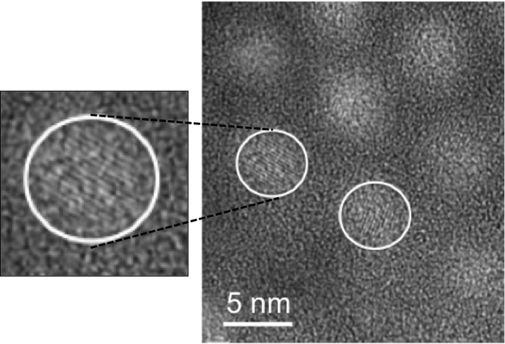
Figure S2. Representative TEM image of PBA nanoparticles inside the porosity of a silica monolith.

High-resolution TEM was performed using a JEOL JEM 2010 microscope equipped with a LaB₆ filament operating at a 200 kV accelerating voltage (Service de microscopie électronique, Sorbonne université, Paris, France). The white circles highlight the single-crystal PBA nanoparticles inside the pores. Parallel lines can be seen inside of each circle, demonstrating the single-crystal structure of the nanoparticles.

Figure S3. Magnetization curves of the pure RbCoFe powder before (grey line) and after (black line) irradiation.
The insets show the region of the thermal relaxation of the photo-excited state. In the case of partial excitation b), the difference of magnetization before and after irradiation is shown for an enhanced view of the relaxation trend.

Figure S4. Difference between the FC curves before and after complete excitation for RbCoFe diluted in silica.

Figure S5. Magnetization trend of the diluted reference powders RbCoFe (black) and CsCoFe (grey) during the irradiation with a 635 nm laser.

Figure S6. Difference between the FC curves before and after complete excitation for CsCoFe diluted in silica.

Figure S7. Magnetization trend of the nanocomposites nanoRbCoFe (black) and nanoCsCoFe (grey) during the irradiation with a 635 nm laser.

The drop in magnetization in the beginning is caused by the switching on of the laser and the heating of the sample due to irradiation. After turning off the laser, this decrease is reversed and the magnetization increases sharply at this point caused by the re-cooling of the irradiated sample.

Figure S8. Superposition of the difference between the FC curves before and after irradiation for nanoRbCoFe (black) and nanoCsCoFe (grey).

Figure S9. Temperature dependence of XT for nanoRbCoFe (black) and nanoCsCoFe (grey).

