**Iron-based nanomaterials as a magnetic mesoporous nanocomposite catalyzed the preparation of *N*-sulfonylimines**

Akram Ashouria[1]*, Saadi Samadia, Behzad Nasiria, Zohre Bahramib

aLaboratory of Asymmetric Synthesis, Department of Chemistry, Faculty of Science, University of Kurdistan, 66177-15175, Sanandaj, Iran

bFaculty of nanotechnology, Semnan University, Semnan, 35131-19111, Iran

**Supporting Information**

**Materials**…………………………………………………………………………….………..….…… 1

**Characterization of fresh and recovered nanomagnetic catalyst**…………………………….…… 2

**Characterization of some products** ……………………………………………….…….……...…… 4

**Materials.** All the chemicals were procured from Sigma-Aldrich or Merck Chemicals. 1, 4-dioxane, Et2O, and tetrahydrofuran were distilled from benzophenone/sodium under nitrogen prior to use. Phenyl was prepared according to the reported procedures. IR (KBr) spectra were recorded on a Bruker Vector 22 FT-IR spectrophotometer. The 1H NMR and 13C NMR spectra were recorded on BrukerAvIII HD- 500 MHz using TMS as the internal standard.

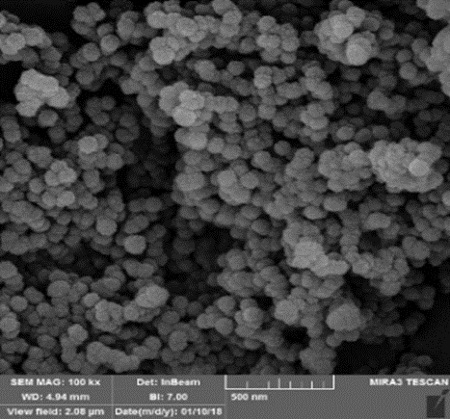

SEM image of fresh Fe3O4@MCM-41

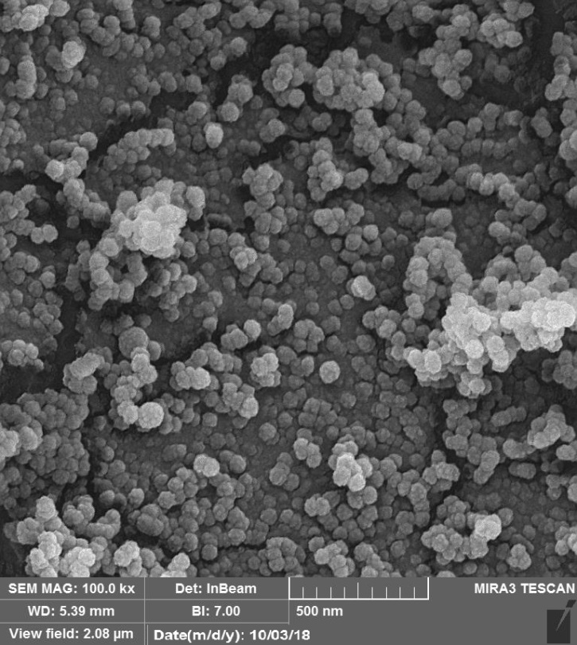

SEM image of recycled Fe3O4@MCM-41

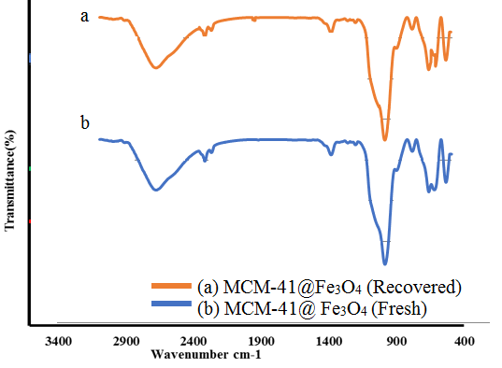

FT-IR spectra of fresh and recycled Fe3O4@MCM-41

***N*-(4-Methoxybenzylidene)-4-methyl-benzenesulfonamide** (Table 3, entry 8) mp: 128-129 ◦C [1]. 1H NMR (500 MHz, CDCl3) δ (ppm): 8.94 (s, 1 H), 7.87 (d, *J* = 8 Hz, 4 H), 7.32 (d, *J* = 7.7 Hz, 2 H), 6.96 (d, *J* = 8.2 Hz, 2 H), 3.87 (s, 3 H), 2.42 (s, 3 H); 13C NMR (125 MHz, CDCl3) δ (ppm): 168.1, 164.3, 143.2, 134.7, 132.6 (2C), 128.7 (2C), 126.8 (2C), 124.2, 113.6 (2C), 54.6, 20.5.

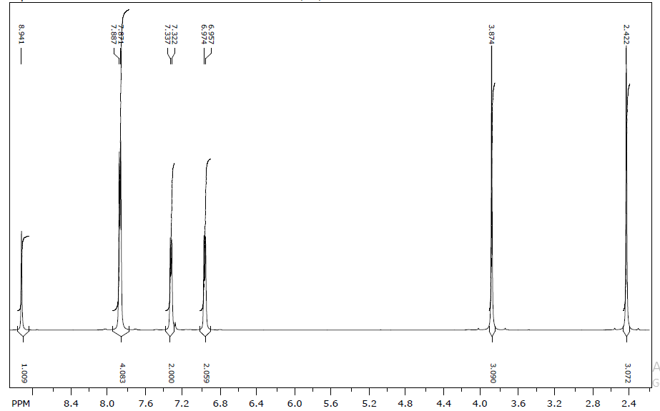



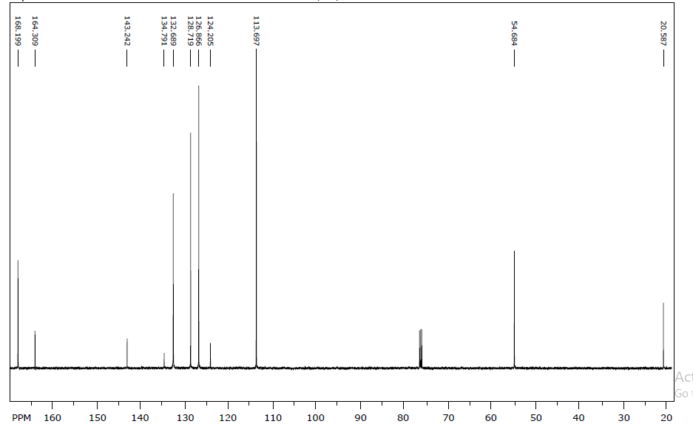



***N*-(4-methylbenzylidene)-4-methyl- benzenesulfonamide** (Table 3, entry 6) mp: 116-118 ◦C [2]. 1H NMR (500 MHz, CDCl3) δ (ppm): 8.99 (s, 1 H), 7.89 (d, *J* = 7.5 Hz, 2 H), 7.82 (d, *J* = 7.4 Hz, 2 H), 7.34 (d, *J* = 7.49 Hz, 2 H), 7.29 (d, *J* = 7.43 Hz, 2 H) 2.43 (s, 3 H) 2.42 (s, 3 H);13C NMR (125 MHz, CDCl3) δ (ppm): 168.9, 145.3, 143.4, 134.4, 130.4 (2C), 128.9 (2C), 128.8, 128.7 (2C), 127.0 (2C), 20.9, 20.6.

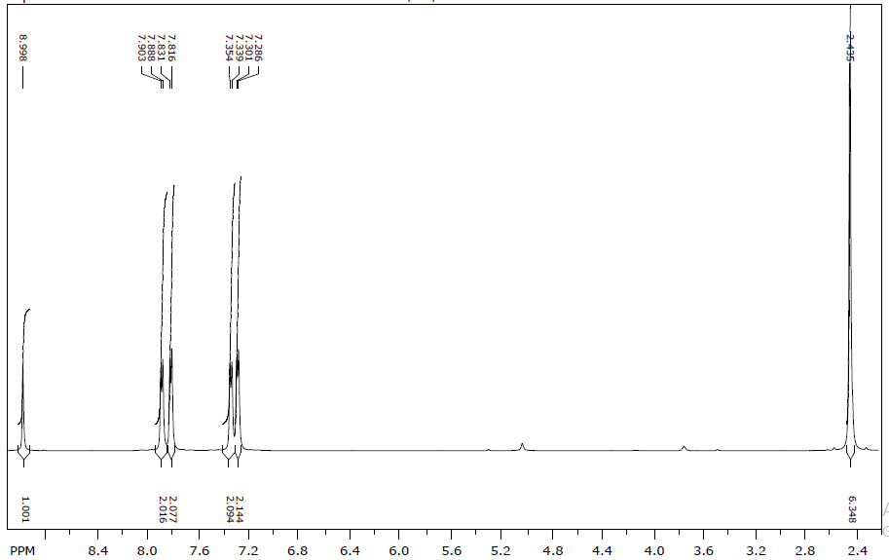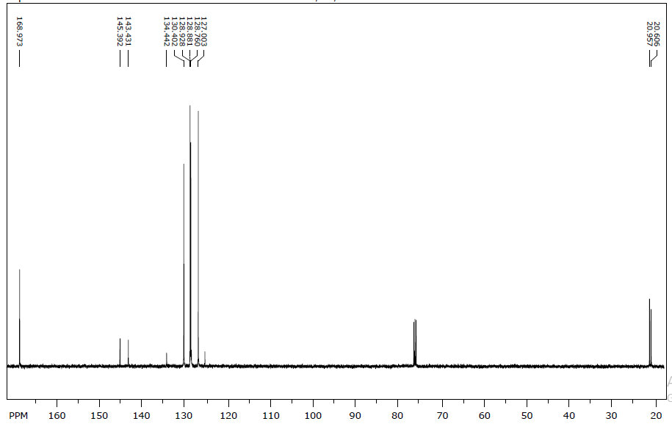



***N*-(4-chlorobenzylidene)-4-methylbenzenesulfonamide** (Table 3, entry 1) mp: 175-179 ◦C [3].1H NMR (500 MHz, CDCl3) δ (ppm): 2.43 (3H, s), 7.35 (d, *J* = 8.1 Hz, 2H), 7.46 (2H, d, *J* = 8.5 Hz), 7.86 (2H, d, *J* = 8.5 Hz), 7.88 (2H, d, *J* = 8.3 Hz), 8.99 (1H, s); 13C NMR (125 MHz, CDCl3) δ (ppm): 168.6, 144.8, 141.4, 134.8, 132.3, 130.8, 129.8, 129.5, 128.1, 21.6.

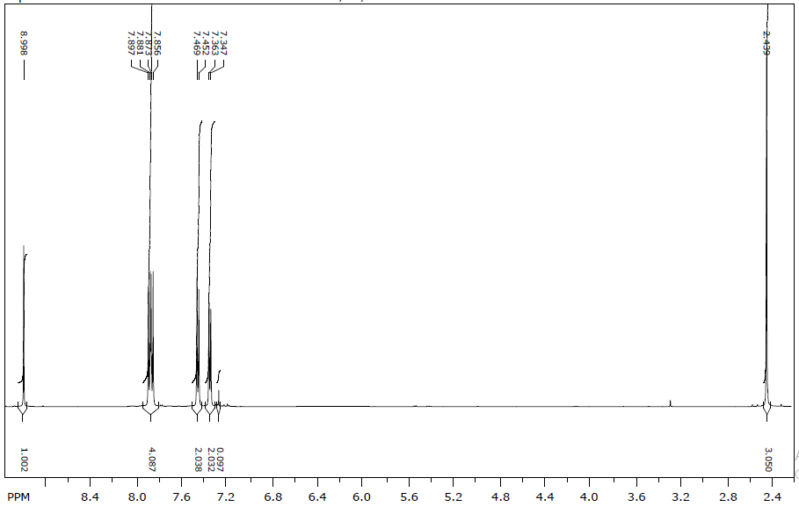



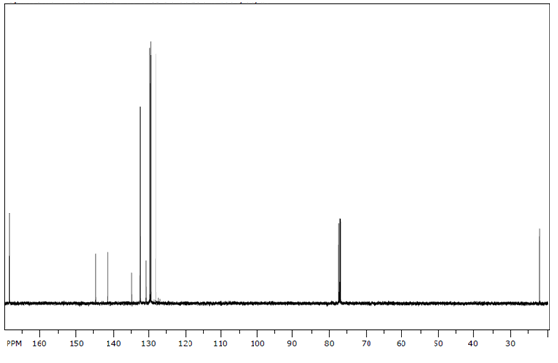



**References**

[1] S. Samadi, A. Ashouri, M. Ghambarian, RSC Adv., 7 (2017) 19330-19337.

[2] T.S. Jin, M.J. Yu, L.B. Liu, Y. Zhao, T.S. Li, Synth. Commun., 36 (2006) 2339-2344.

[3] C.-Y. Chen, H.-X. Li, M.E. Davis, Microporous Mater., 2 (1993) 17-26.

1. Received 1 January 2015. Accepted 1 January 2015. Published 1 January 2015.

   🖂 Akram Ashouri. Tel.: +98-873-366-46008; e-mail: a.ashouri@uok.ac.ir