**Supplemental data**

1. **Characterisation Analysis (Detail Description)**

The specific surface area of the ion exchange resins was measured by N2 physisorption analysis via the Micromeritics ASAP 2000 porosimeter. Prepared samples were degassed using two-stage temperature ramping under a vacuum of <10 mm Hg, followed by sample analysis via nitrogen gas. The BET method was employed to calculate the surface area, average pore diameter, and total pore volume.

The contents of C, H, N, and S in the catalysts were determined using Elementar vario MACRO Cube. The sample was combusted in pure oxygen with tin as the catalyst. Excess oxygen was reduced and CO2, H2O, and N2 were produced as the combustion products. The gaseous were dried using a magnesium perchlorate trap and separated using a packed GC column. These gases were detected using a thermal conductivity detector. Meanwhile, sulphur was determined separately using an oxygen flask combustion analysis, followed by a titration. The samples were combusted in oxygen flasks containing water and few drops of hydrogen peroxide and left for 40 min. Then, the indicators were added to the solution. The solution was titrated with barium perchlorate until a permanent hint of red was observed.

IEC was determined through the titration method. The analysis took place in a 50-mL Erlenmeyer flask with a pre-determined mass of a catalyst (ca. 0.5 g) in contact with 50 mL of 0.1 M of sodium hydroxide (NaOH). The flasks were sealed with parafilm and were shaken for 72 h in an orbital shaker. After that, the solution was filtered and 5-mL aliquots were back titrated with 0.1 M of hydrochloric acid (HCl), while methyl red was the indicator.

PSD of the catalyst was evaluated using Malvern Mastersizer 2000. In this study, the wet dispersion analysis was chosen to measure the distribution pattern of the catalyst and Fraunhofer and Mie theory was employed to analyze the sample. During the laser diffraction measurement, particles were passed through a focused laser beam and the particle size distributions were obtained by measuring the angular variation in the intensity of scattered light as the laser beam passed through a dispersed particulate sample.

The surface morphology of catalysts was analyzed using CARL ZEISS SEM. The samples were placed on a metal stub, while carbon conductive pad and silver metal was placed at both sides of the samples as a conductor during the analysis. Then, the samples were coated with gold particles under vacuum condition before the analysis.

FTIR analysis was used to identify the functional groups of the catalysts. The catalyst was first ground into powder form and mixed with KBr powder. Then, it was pressed to form a pellet under hydraulic pressure. Basically, the background emission spectrum of the IR source was first recorded before the emission spectrum of the IR source with the sample took place. The background signal was determined by having a pellet of blank potassium bromide (KBr) as the reference. The absorption spectrum from the natural vibration frequencies indicates the presence of chemical bonds and functional groups in the catalysts. Typically, the FTIR spectra are presented as a plot of % transmittance versus wavenumber in (cm-1). The frequency ranges are measured as wavenumbers, typically over the range of 4000 - 500 cm-1.

The TGA analysis was performed via a thermogravimetric analyzer (Q500) to determine the degradation temperature and decomposition point of the catalyst. The analysis was carried out between the room temperature and 1000°C in different gas atmospheres of oxygen and nitrogen. The heating rate was 10 °C/min and the sample was placed on a pan and weighed before it was placed in the machine. Weight variations observed at specific temperatures correlate to volatilization of sample components, decomposition, oxidation/reduction reactions, and other side reactions or changes. TGA analysis continuously measures the weight of a sample as a function of temperature and time.

XRF was carried out to quantify the elemental composition of the materials. The XRF analyzer determines the chemistry of a sample by measuring the fluorescent (or secondary) X-ray emitted from a sample when it is excited by a primary X-ray source. In this study, XRF Bruker S8 Tiger was utilized in order to determine the amount of chlorine present in the precursor particle.

1. **Preparation of SHER in the graphical form**

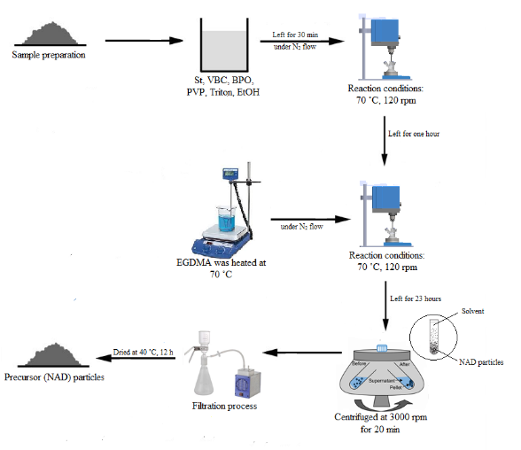

Process to synthesise of precursor (NAD) particles

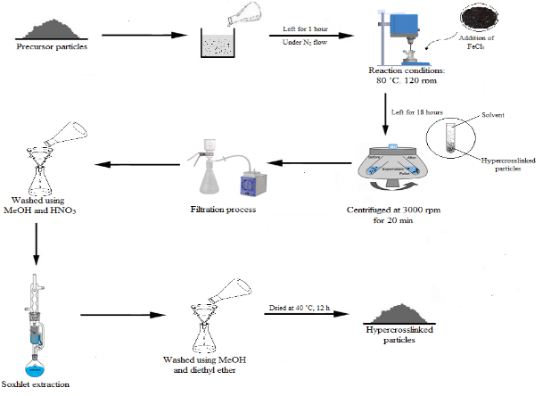

Process to synthesise hypercrosslinked beads

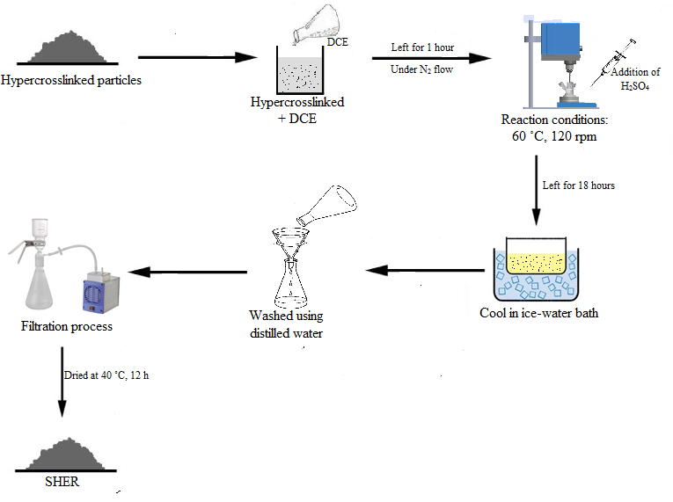

Sulphonation of hypercrosslinked exchange resin

1. **FTIR analysis**



SHER

Diaion SK1BH

Diaion PK228LH

Diaion RCP145H

The FTIR spectra of SHER, RCP145H, PK228LH and SK1BH catalyst.

The FTIR spectra for SHER, Diaion RCP145H, Diaion PK228LH, and Diaion SK1BH was presented in the figure above. The FTIR spectra for these resins are quite similar. The presence of OH bonding around 3000 cm-1 and above is due to the preparation and molding of the potassium bromide (KBr) disc. The moisture was adsorbed from the surrounding air during the preparation of the ground resin and molding the KBr tablet. Due to hygroscopic nature of the cation exchange resins, they adsorbed the water derived from the moisture and consequently, the OH bond was formed. However, at this point, SHER showed a very small intensity compared to the other resins. This is due to the hydrophobic surface of SHER, resulted from the reaction activity during the synthesis process. A sharp peak around from 1000 cm-1 to 1250 indicates the S=O stretching vibration of the sulphonic acid group. A peak stretching around 1171 cm-1 until 1226 cm-1 represents the asymmetric SO3. Meanwhile, the peaks present between 1000 cm-1 to 1110 cm-1 indicate the presence of symmetric SO3 bonding.