Extraction and complexation of lanthanide ions by
dihomooxacalix[4]arene and calix[4]arene tetraketone derivatives:
an experimental and molecular dynamics investigation

Supporting Information

Contents:
Figure S1. Radial distribution functions 2
MD simulation details 3
PMF calculation details 4
References 5

 | In acetonitrile, with TfO⁻ | In dichloromethane, with Pic⁻
La³⁺⊂1d | 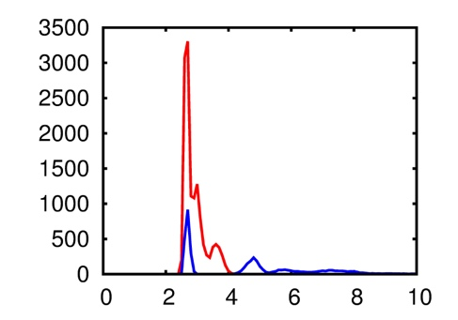 | 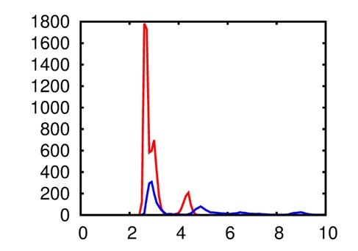
 | 8.9 + 1.0 | 7.1 + 3.9
La³⁺⊂2d | 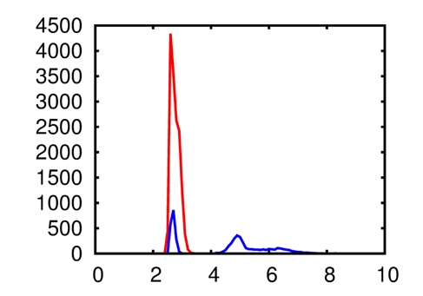 | 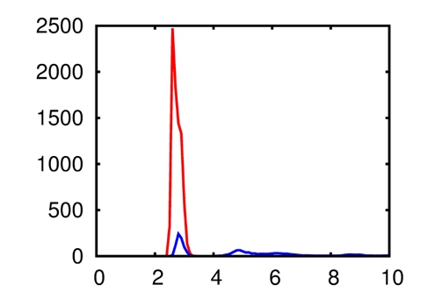
 | 8.0 + 1.0 | 8.0 + 2.0
Yb³⁺⊂1d | 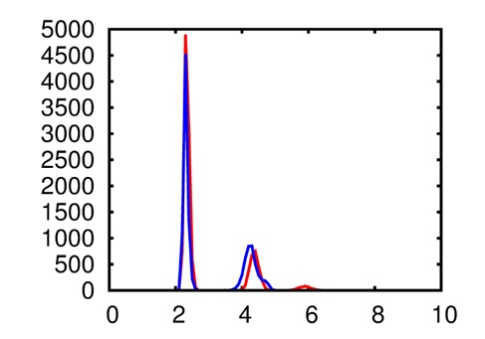 | 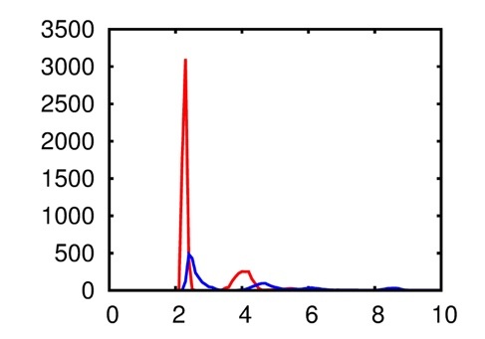
 | 4.0 + 3.6 | 5.9 + 4.1
Yb³⁺⊂2d | 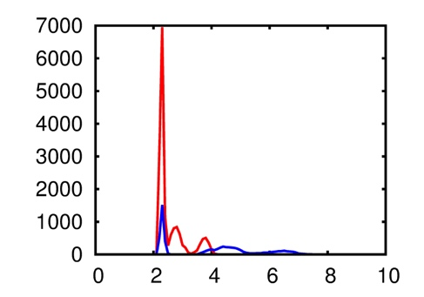 | 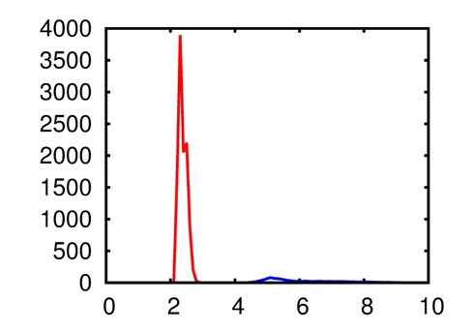
 | 7.9 + 1.6 | 8.0 + 0.0

Fig. S1. M^{3+…}calixarene and M^{3+…}anions radial distribution functions (RDFs) as a function of the distance (in Å) in pure acetonitrile and dichloromethane (O_{calixarene}, O_{Pic}, O_{TfO} are the reference centers). Color codes: M^{3+…}calixarene in red, M^{3+…}ani−ons in blue. Integration numbers (up to 4 Å) of the RDFs are given in italics below the corresponding curves.

MD Simulations

Solute and solvent atom pairs i and j display Coulomb interactions via their charges q_{i} and q_{j}. Cross terms in van der Waals interactions were constructed using the Lorentz-Berthelot rules. The structures of the free 1d and 2d calixarenes and lanthanide complexes were optimized by QM calculations at the B3LYP/6-31G(d,p) level with large ECPs for La and Yb. Calixarene parameters come from ref [1] with RESP charges calculated on the full uncomplexed calixarene. Lanthanide cations were described with a +3 charge. Water was represented with the TIP3P model [2], acetonitrile with the model from ref [3] and a 5 points model for dichloromethane was used [4]. La³⁺ and Yb³⁺ are from ref [5], triflate (TfO⁻) anions are from Baaden et al. [6] and picrate (Pic⁻) anion from ref [7]. The solutions were simulated with 3D-periodic boundary conditions, using an atom-based cutoff of 12 Å for non-bonded interactions, and correcting for the long-range electrostatics by using the Ewald summation method. The characteristics of all simulated systems are given in Table S1. The MD simulations were performed at 300 K starting with random velocities. The temperature was monitored via a coupling to a thermal bath using the Berendsen algorithm [8] with a relaxation time of 0.2 ps. In the (NPT) simulations, the pressure was similarly coupled to a barostat with a relaxation time of 0.2 ps. A time step of 2 fs was used to integrate the equations of motion via the Verlet leapfrog algorithm. After 1000 steps of energy minimization, 0.25 ns of dynamics were performed with the ions in order to allow the solvent to relax around the solute. This was followed by a dynamics of 0.25 ns at constant volume and of 1 ns at a constant pressure of 1 atm. The evolution of the mixture was then followed for 50 ns of dynamics (NVT ensemble).

Table S1. Characteristics of the simulated systems (composition, box size, time)

System | Number and type of solvent | Box size  (x,y,z) in Å | Time  (in ns)
M³⁺⊂ 1d; 3 TfO⁻ | 1500 MeCN | 51.9 x 51.9 x 51.9 | 50
M³⁺⊂ 2d; 3 TfO⁻ | 1500 MeCN | 51.9 x 51.9 x 51.9 | 50
M³⁺⊂ 1d; 3 Pic⁻ | 650 CH₂Cl₂ | 42.1 x 42.1 x 42.1 | 50
M³⁺⊂ 2d; 3 Pic⁻ | 650 CH₂Cl₂ | 42.1 x 42.1 x 42.1 | 50
M³⁺⊂ 1d; 3 Pic⁻ | 1000 CH₂Cl₂ + 4000 H₂O | 39.1 x 39.1 x 154.1 | 10
M³⁺⊂ 2d; 3 Pic⁻ | 1000 CH₂Cl₂ + 4000 H₂O | 39.1 x 39.1 x 154.1 | 10

M³⁺ = La³⁺ or Yb³⁺

Free energy profile (PMF simulation)

The change of free energy ΔG(d) was calculated for the interface crossing of the calixarene as a function of the z position (d) of M³⁺ (see Fig. 6 of main text). We proceed starting from the position of the complexes in the organic phase obtained after the MD simulation (λ=1), the z position of the cation is then increased by 100 Å (λ =0) to move the complex into the aqueous phase, by Δd steps of 0.5 Å. At each step 200 ps of equilibration + 200 ps of sampling were performed. See, for example, ref [9, 10] for computational details and tests at liquid/liquid interfaces.
Changes in free energy were calculated using the thermodynamic integration (TI) method based on Equation (1) [11]:
$∆G=\int_{0}^{1}{{〈\frac{∂U}{∂λ}〉}_{λ}dλ}$$∆G=\int_{0}^{1}{{〈\frac{∂U}{∂λ}〉}_{λ}dλ}$ (1)

Analysis of results

The trajectories were analyzed using our MDS software [12]. Snapshots were drawn with the VMD software [13]. Total potential energy E_{pot} and interactions between selected neutral groups (IL ions, MCl_{n} ions, water) were calculated using Ewald summation. The radial density functions (RDFs) were calculated, unless otherwise specified, between selected atoms during the last 5 ns of dynamics.

References

[1] M. Baaden; M. Burgard; C. Boehme; G. Wipff, Phys. Chem. Chem. Phys. 3 (2001) 1317-1325.
[2] W.L. Jorgensen; J. Chandrasekhar; J.D. Madura; R.W. Impey, M.L. Klein, J. Chem. Phys. 79 (1983) 926-936.
[3] W.L. Jorgensen; J.M. Briggs, Mol. Phys. 63 (1988) 547-558.
[4] T. Fox; P.A. Kollman, J. Phys. Chem. B 102 (1998) 8070-8079.
[5] F.C.J.M. van Veggel, D. Reinhoudt, Chem. Eur. J. 5 (1999) 90-95.
[6] M. Baaden; F. Berny, C. Madic, G. Wipff, J. Phys. Chem. A 104 (2000) 7659-7671.
[7] L. Troxler, J.M. Harrowfield, G. Wipff, J. Phys. Chem. A 102 (1998) 6821-6830.
[8] H.J.C. Berendsen; J.P.M. Postma, W.F.van Gunsteren, A. di Nola, J. Chem. Phys. 81 (1984) 3684-3690.
[9] G. Benay, G. Wipff, J. Phys. Chem. B, 118 (2014) 3133-3149.
[10] G. Benay; G. Wipff, New. J. Chem. 40 (2016) 2102-2114.
[11] P.A. Kollman, Chem. Rev. 93 (1993) 2395-2417.
[12] E. Engler; G. Wipff, MD-DRAW Software. Display of Dynamic Structures from MD Simulations. In Crystallography of Supramolecular Compounds, G. Tsoucaris, Ed. Kluwer: Dordrecht: 1996, 471-476.
[13] W. Humphrey, A. Dalke, K. Schulten, J. Mol. Graphics, 14 (1996) 33-38.

