Supporting Information

Decoration of copper foam with Ni nanorods and copper oxide nanosheets to produce a high-stability catalyst for the reduction of CO₂: Characterization of the electrosynthesis of isonicotinic acid

Safoora Mohammadzadeh, Hamid R. Zare*, Hossein Khoshro

Department of Chemistry, Faculty of Science, Yazd University, Yazd, 89195-741, Iran
*Corresponding Author: hrzare@yazd.ac.ir
Characterizations of Products:

Isonicotinic acid: ¹H NMR (CDCl₃, 400 MHz): δ 7.47 (d.d, 2H, j=3.2), δ 7.66 (d.d, 2H, j=3.2), δ 7.95 (s, 1H, CO₂H),¹³C NMR (CDCl₃, 100.6 MHz): δ 128.72, 130.83, 132.41, 167.63 ppm, FT-IR: 3379 cm⁻¹(O-H), 1714, 1665 (C=O), 1590 (C=C), 1095 (C-O).
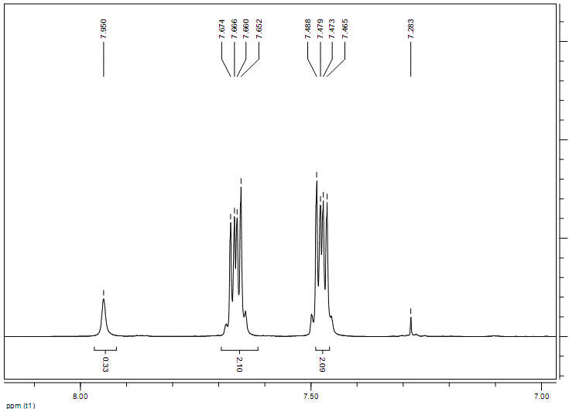
Fig. S1. ¹H NMR of isonicotinic acid

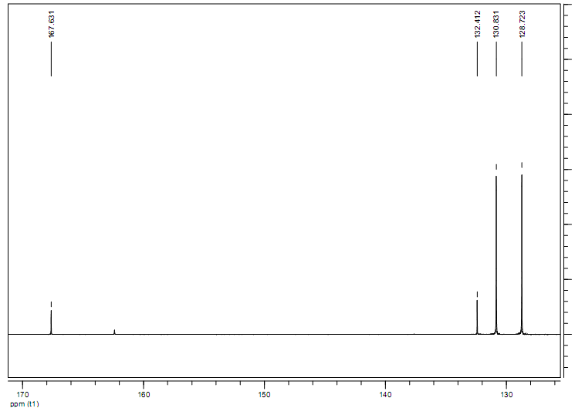
Fig. S2. ¹³C NMR of isonicotinic acid

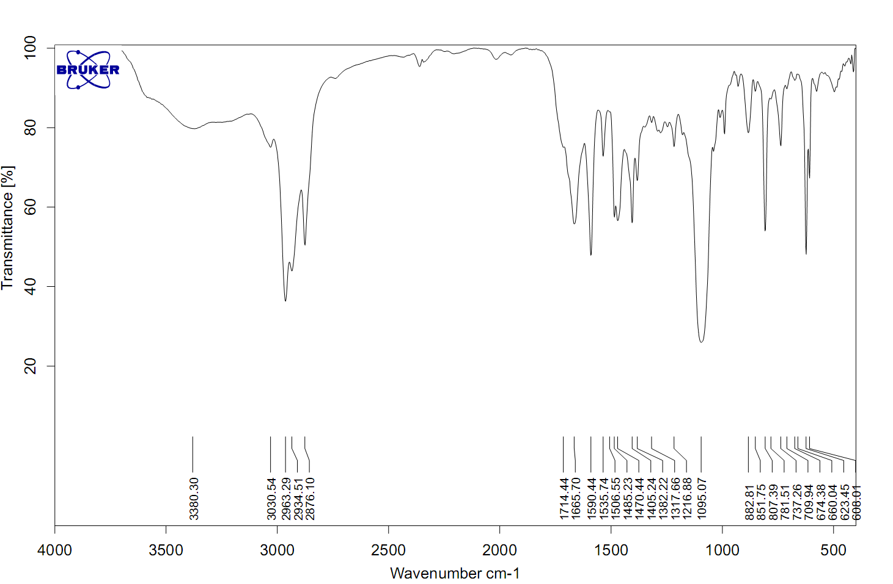
Fig. S3. FTIR spectra of isonicotinic acid
4,4'-Bipyridine: ¹H NMR (CDCl₃, 400 MHz): ¹H NMR: 7.48 (d, 4H, j= 6), 8.68 (d, 4H, j= 5), ¹³C NMR (CDCl₃, 100.6 MHz): δ 121.44, 145.57, 150.67 ppm; FT-IR: 1696, 1653 cm⁻¹(C=N), 1578, 1555 cm⁻¹ (C=C), 1453, 1248, 1085 and 756 cm⁻¹.

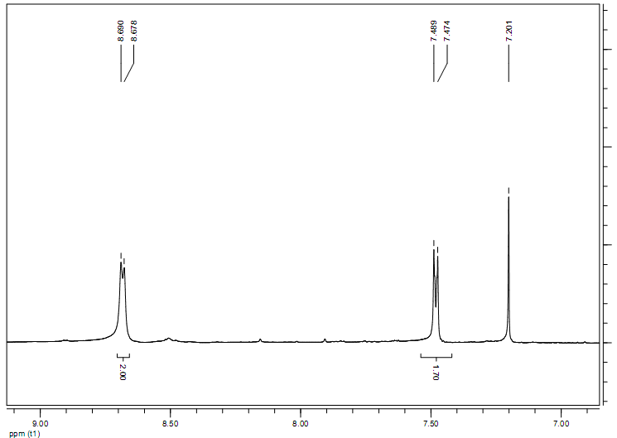
Fig. S4. ¹H NMR of 4,4'-bipyridine
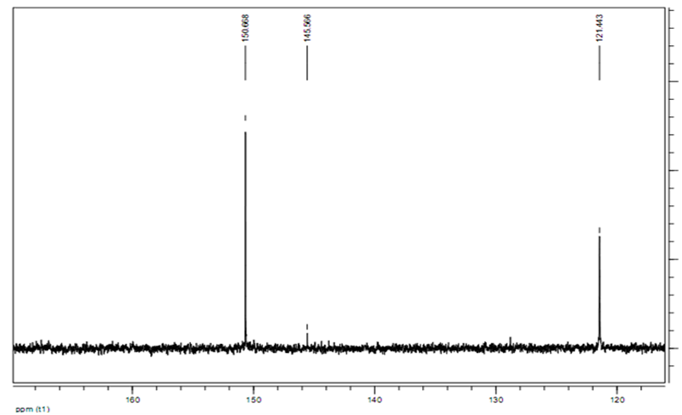
Fig. S5. ¹³C NMR of 4,4'-bipyridine
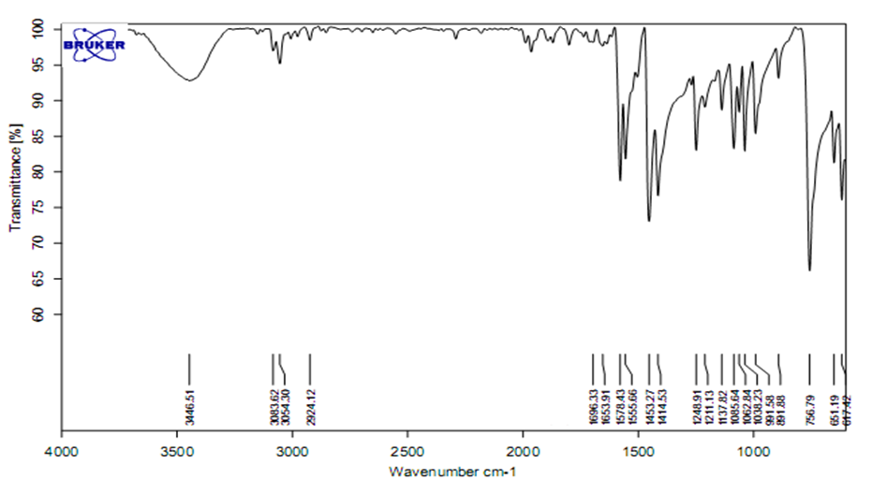
Fig. S6. FT-IR spectra of 4,4'-bipyridine

