Supplementary Figures

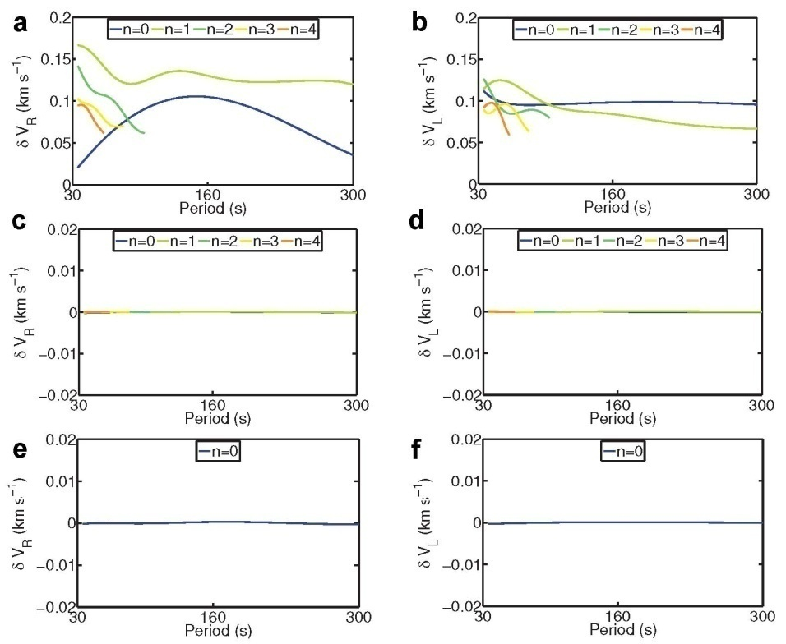
Figure S1. Validation of the inversion results for the isotropic 1066A model (Fig. 1) through the comparison of the phase velocity curves. Phase velocity differences of the fundamental and the first four overtones of the spheroidal modes (Rayleigh wave) (a) and the toroidal modes (Love wave) (b) between the isotropic 1066A model and the reference model before inversion. Phase velocity differences of the fundamental and the first four overtones of the spheroidal modes (Rayleigh wave) (c) and the toroidal modes (Love wave) (d) between the isotropic real 1066A model and the inverted model for the second test. Phase velocity difference of the spheroidal (e) and the toroidal (f) fundamental modes between the isotropic 1066A model and the inverted model for the first test.

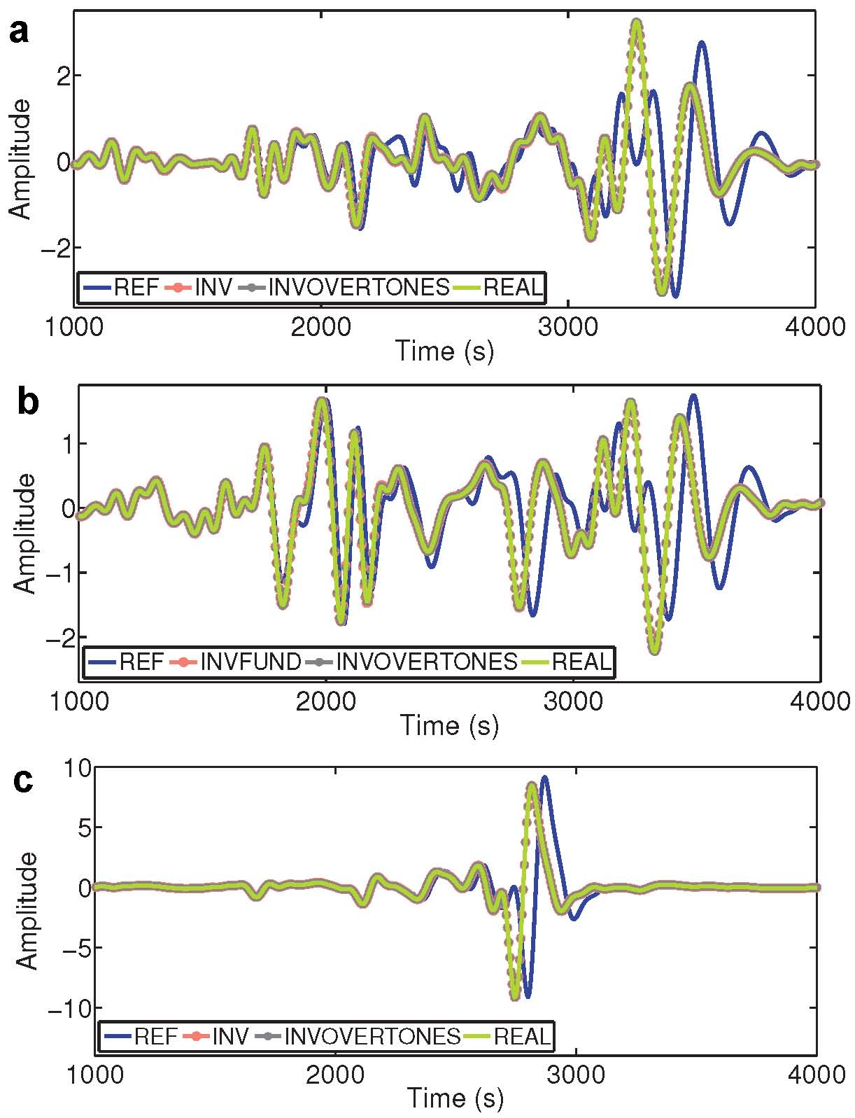
Figure S2. Validation of the inversion results for the isotropic 1066A model (Fig. 1) through the comparison of seismograms. Comparison of seismograms obtained by the normal mode summation method between the reference model, the 1066A model, and the inverted models of the two tests for the vertical (a), radial (b), and transverse (c) displacement components at station 109C for the Sichuan earthquake in 2013. The moment tensor for this earthquake was M_{rr}=1.04E+19, M_{θθ}=−0.43E+19, M_{φφ}=−0.61E+19, M_{rθ}=2.98E+19, M_{rφ}=−2.4E+19, and M_{θφ}=0.43E+19 (from the CMT catalog). The depth of the earthquake was 21.8 km, and the magnitude was Mw=6.6.

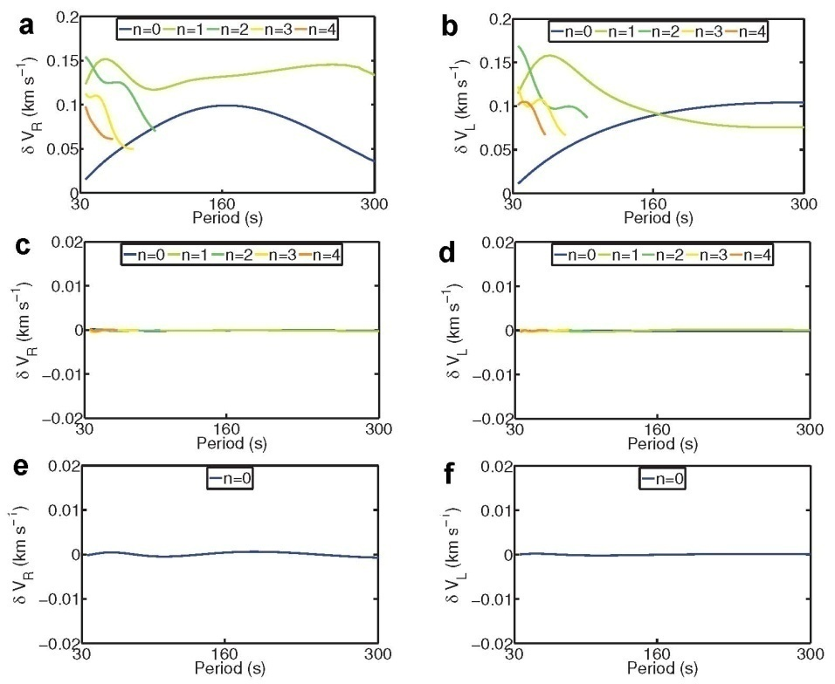

Figure S3. Validation of inversion results for the isotropic PREM (Fig. 2) through the comparison of the phase velocity curves. The comparison terms are the same as those given for Figure S1.

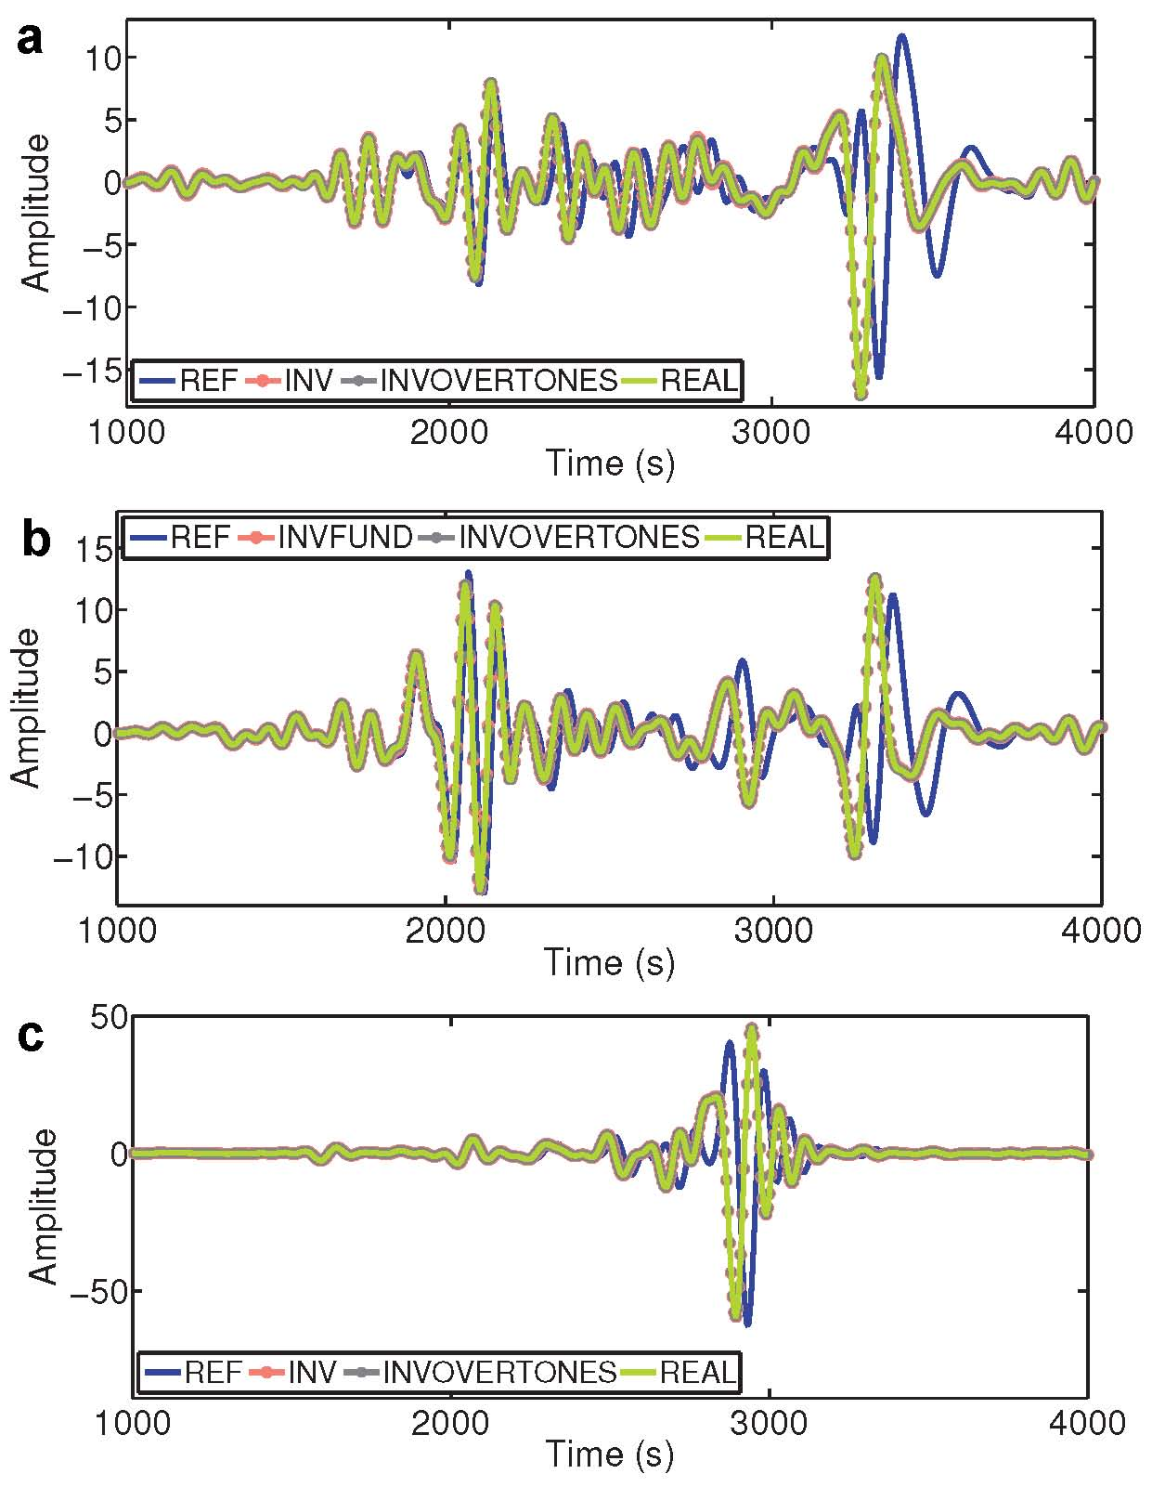

Figure S4. Validation of the inversion results for the isotropic PREM (Fig. 2) through the comparisons of the seismograms. The source and station are the same as those given for Fig. S2.

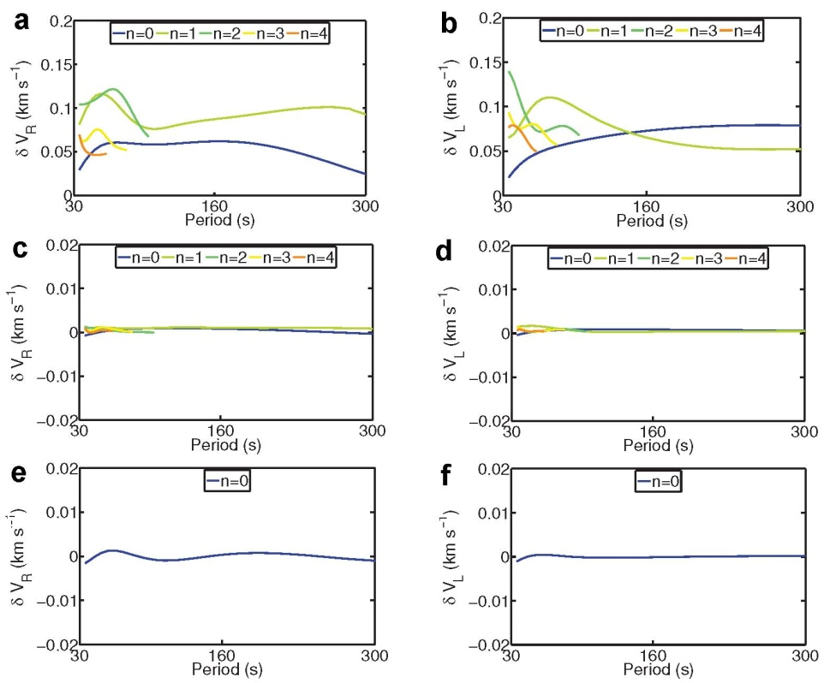

Figure S5. Validation of the inversion results for the isotropic PREM with a mislocation of the discontinuity (Fig. 3) through the comparison of the phase velocity curves. The comparison terms are the same as those given for Figure S1.

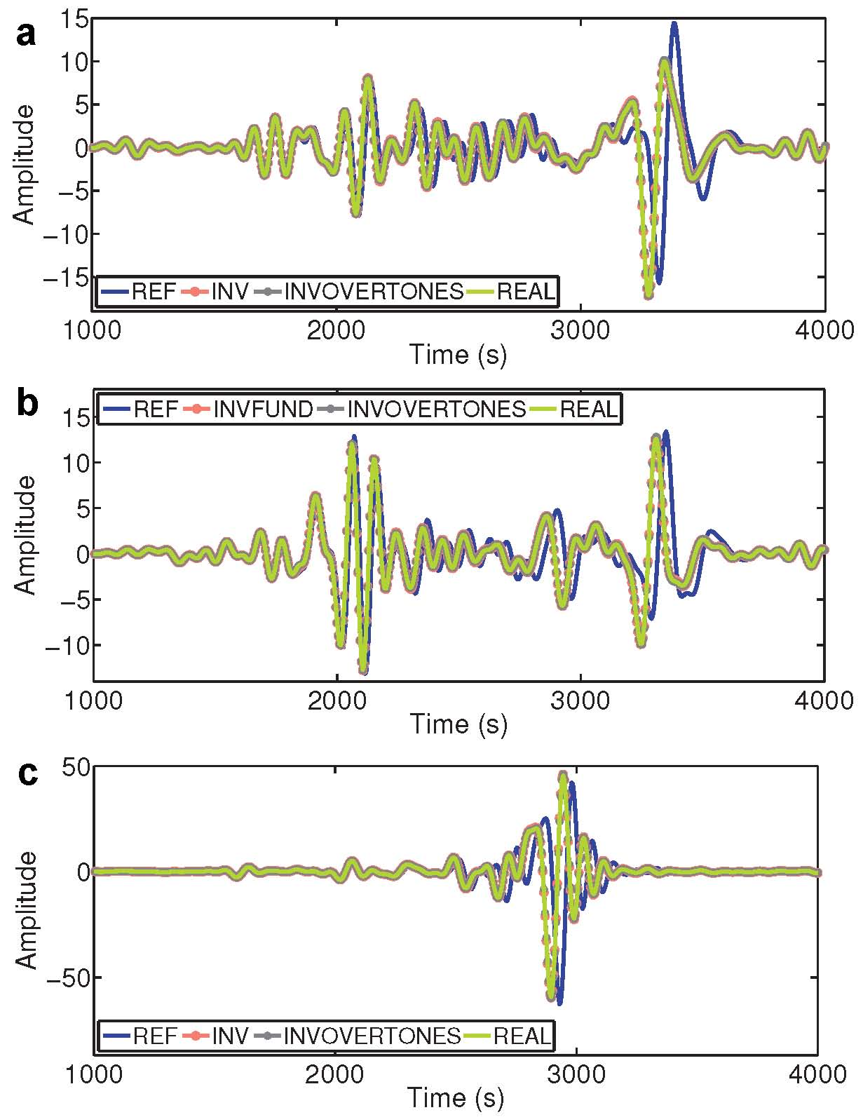

Figure S6. Validation of the inversion results for the isotropic PREM with the mislocation of the discontinuity (Fig. 3) through the comparison of the seismograms. The source and station are the same as those given in Fig. S2.

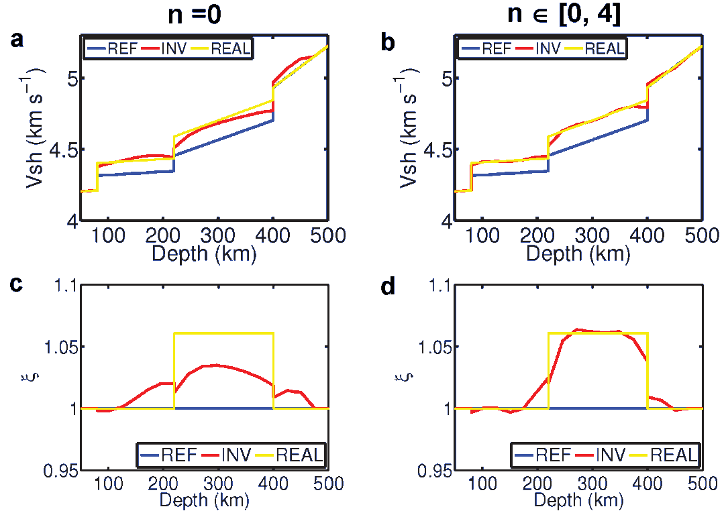

Figure S7. Inversion results for the horizontal S-wave velocity (V_{SH}) and the anisotropic parameter ξ for an anisotropic PREM for the two groups of tests. The reference isotropic PREM is the same as that given for Figure 3, and the real model is its perturbed anisotropic PREM (REAL).

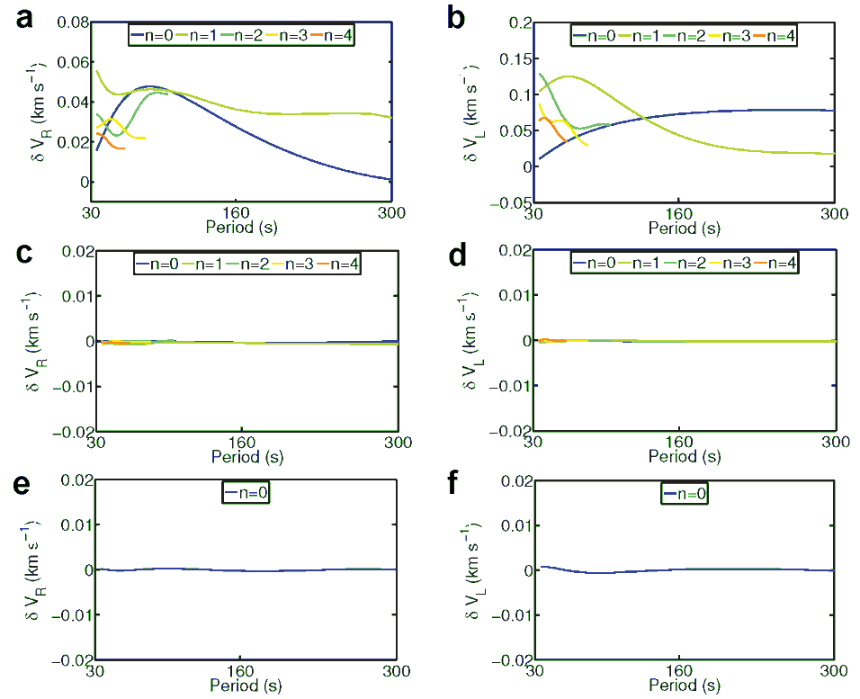

Figure S8. Validation of the inversion results for the anisotropic PREM (Fig. S7) through the comparison of the phase velocity curves. The comparison terms are the same as those given for Figure S1.

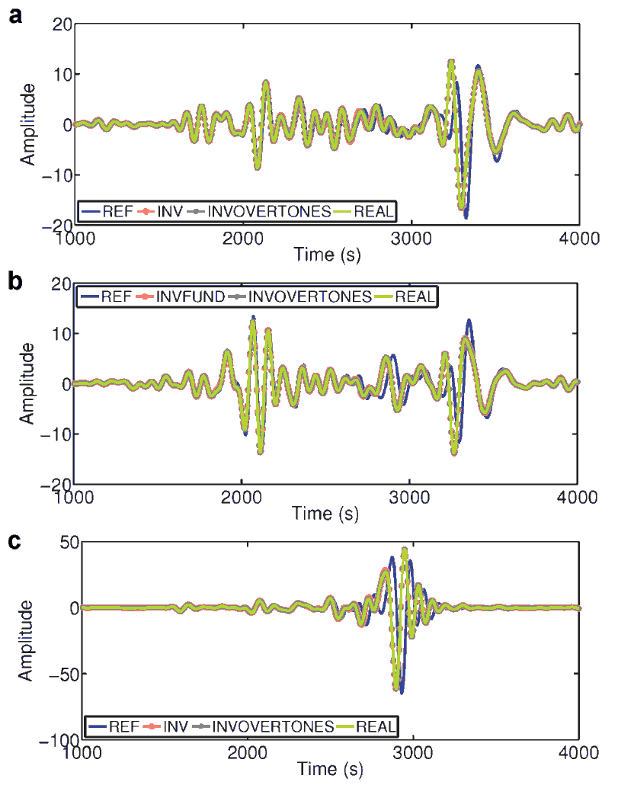

Figure S9. Validation of the inversion results for the anisotropic PREM (Fig. S7) through the comparison of the seismograms. The source and station are the same as those given for Figure S2.

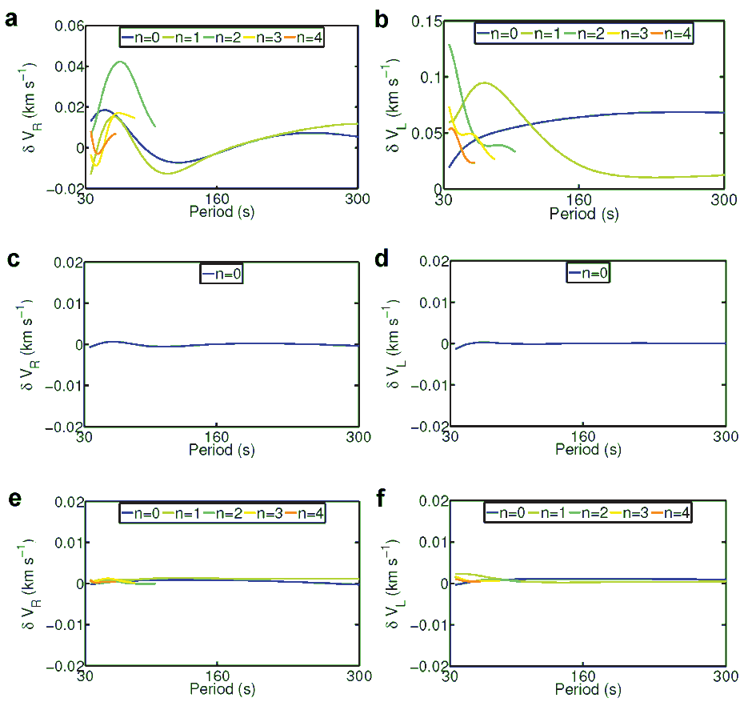

Figure S10. Validation of the inversion results for the anisotropic PREM with a mislocation of the discontinuity (Fig. 5) through the comparison of the phase velocity curves. The comparison terms are the same as those given for Figure S1.

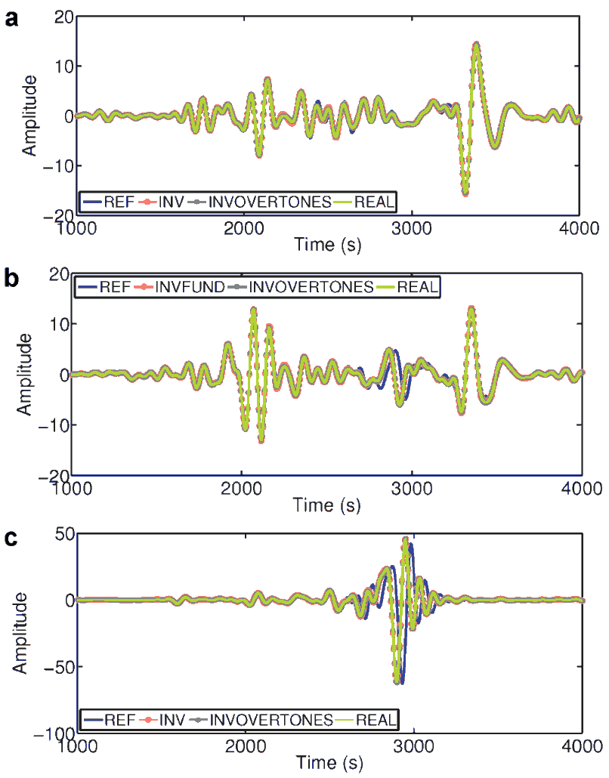

Figure S11. Validation of the inversion results for the anisotropic PREM with a mislocation of the discontinuity (Fig. 5) through the comparison of the seismograms. The source and station are the same as those given for Figure S2.

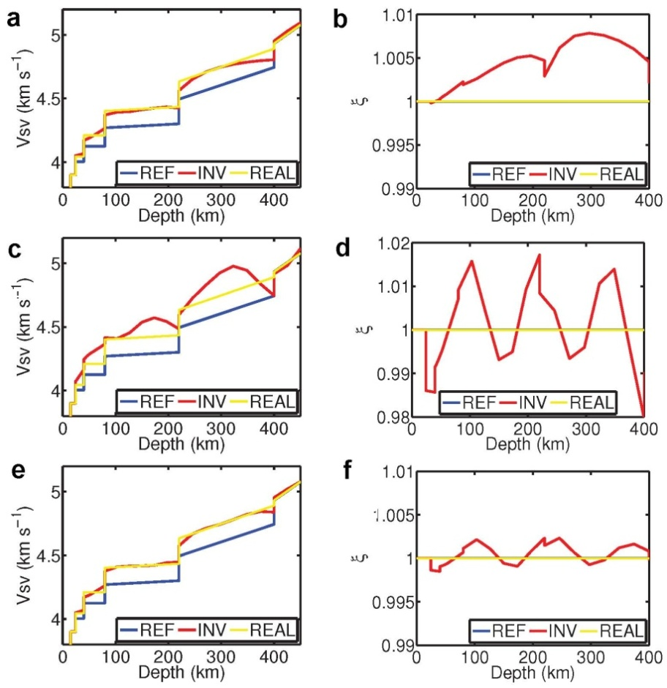

Figure S12. Inversion results of the vertical S-wave velocity (V_{SV}) (a, c, e) and the anisotropic parameter (ξ) (b, d, f) of an isotropic PREM for the three groups of tests. The dataset in the first test contains just the fundamental modes, while in the second and third tests they contain both the fundamental and the over tone modes. The starting model in the first and second tests are the same, while the third test is the inverted model of the first test.

