**Supplementary Material:**

**Improving the performance of precipitation outputs from Global Climate Models to predict monthly and seasonal rainfall over the Indian subcontinent**

**Archana Nair1, U.C Mohanty1 and T.C.Panda2**

**archana.raman07@gmail.com**

1School of Earth Ocean and Climate Sciences, Indian Institute of Technology, Bhubaneswar

2 Odisha Engineering College, Cuttack, Bhubaneswar

**S.1 Performance of Global Climate Models before any bias correction**

In this section, the performance of six GCMs at 357 gridpoints of Indian domain (10X10) is evaluated for each of the individual months of the monsoon and the season as a whole using correlation analysis. The correlation values between the GCM predicted precipitation and observed precipitation is found for a period of 1982-2013 and is shown in Figure S1 for JJAS season. The numbers on the upper right side of each subplot depicts the number of gridpoints which are found to have significant correlation (the significant correlation is greater than 0.3 by student’s t test at 90% confidence) with observed rainfall while the number on bottom right side of the subplot shows the value of correlation between observed rainfall and GCM simulated rainfall for the country as a whole. The subplot (a) to (f) illustrates different GCMs namely CCM3v6, CASST, CFSSST, CFSv2, COLA and GFDL. In the uncoupled model CCM3v6, only 47 gridpoints are found to have significant correlation and the model shows the correlation values widely spread over different parts of the country. The all India average correlation is found to be -0.2 which is not significant. The performance of CASST model is shown in subplot b. There are in all 35 gridpoints which are significantly correlated with observed rainfall and the major portion of significant correlation is found over northern parts of the country. Negative correlations are seen over most parts of the country and country as a whole depicts a correlation coefficient of 0.2. The next model (CFSSST) which is also an uncoupled model shows positive correlations over major portion of Northern India (Jammu & Kashmir, Punjab, Uttarakhand and parts of West Uttar Pradesh). The number of gridpoints with significant correlations is found to be only 28 and the all India average correlation is 0.1. The fourth model (CFSv2) which is a fully coupled model shows positive correlation over central parts of Indian subcontinent over Marathwada, Telangana, Coastal Andhra Pradesh, southern parts of Odisha and Konkan & Goa. There are 56 gridpoints where the correlation is found significant and the all India average correlation is found to be 0.5. The COLA model which is a coupled model shows 42 gridpoints which are significantly correlated with observed rainfall and the correlation is found to be 0.1 at all India basis. The next model is GFDL model which is also a coupled model and it shows significant correlation over most parts of the Central India. The country as a whole show a correlation value of 0.3 and the total number of significant gridpoints are 55.

Similarly, this exercise is carried out for each of the individual months of monsoon for all the models. Due to brevity of study, we are only representing the performance of raw models in the month of July (Figure S2). Here also, the numbers of gridpoints that are found to be significant are shown at the upper right side of each subplot and the corresponding correlated values at all India level is shown at the bottom right side of the same plot. We can observe that in CCM3v6 model, the number of gridpoints having significant correlation and the all India level correlation value is higher than that observed for JJAS (Figure S2). The all India level correlation is found to be 0.1 and the number of gridpoints is 64. In the CASST model, the gridpoints that are significant is 51 and the all India average correlation is 0.4. Positive correlations are found over Northwestern parts of the country. The CFSSST model shows 49 gridpoints that are significant and the all India average correlation is 0.3. The CFSv2 model shows 56 gridpoints that has significant correlation with observed precipitation. The all India average correlation is found to be 0.5. The COLA model, on the other hand show 60 points that is found to be significant but the correlation value is 0.1 at all India level with positive correlations over Tamilnadu and Jammu & Kashmir. Large number of negatively correlated points is observed over most parts of the country and therefore the correlation for country as a whole is found to be very less. The GFDL model shows 51 points that are significant and the all India average correlation is found to be 0.3.

**S.2.Performance of model outputs after bias correction/synthetic superensemble (SSE) in the month of July**

The CCM3v6 model after bias correction show significant improvement over its raw component. There are 71 gridpoints that are found to be significant and at all India level the correlation is 0.1. The CASST model show significant correlation in 83 gridpoints and at all India level the correlation is 0.4. In case of CFSSST model, the total numbers of significant gridpoints that are positively correlated are 80 and the all India average correlation is 0.3. In the CFSv2 model, the number of gridpoints that are positively correlated with observation increased to 92 from 56 but the correlation value at all India level is almost same. The COLA model also shows improvement over its biased counterpart. The numbers of gridpoints that are found to have significant correlation are 69 and the all India average correlation value is 0.1. In GFDL model 48 gridpoints are found to have significant correlation with observed rainfall and for country as a whole; a correlation value of 0.3 is seen.

**S.3 Correlation Coefficient: EM vs SPCR**

The performance of EM of the GCMs is shown in Figure S4 for season as a whole and for June, July, August and September months (upper right: number of significant gridpoints; bottom right: all India correlation). In JJAS season, positive correlations are seen over Himachal Pradesh, Haryana, Uttarakhand, West Uttar Pradesh, East Rajasthan and parts of Odisha, Telangana, Tamilnadu, Rayalseema, West-Bengal & Sikkim and Nagaland-Mizoram-Manipur-Tripura (NMMT). The total numbers of gridpoints that are significant are 37 and country as a whole show a correlation of 0.3. In the month of June, parts of Jammu & Kashmir, Punjab, Himachal Pradesh, Uttarakhand, East Uttar Pradesh, Saurashtra & Kutch, Gujarat, Madhya Maharastra, South Interior Karnataka, Rayalseema, Telangana, Coastal Andhra Pradesh and Tamilnadu show positive correlation values. Negative correlations are seen over Assam & Meghayala, Bihar, West Rajasthan and Punjab. The number of gridpoints that are found to have significant correlation with observed rainfall is 43 and the value of correlation for country as a whole is 0.2. In the month of July, positive correlations are seen over Himachal Pradesh, Punjab, West Uttar Pradesh, Uttarakhand and East Uttar Pradesh. Positive correlations are also seen over North and South Interior Karnataka in the south peninsular part of the country. The number of gridpoints with positive correlation is 54 and the all India average correlation is 0.3. In the month of August, there are 59 gridpoints that are found to have positive correlation with observed rainfall and the all India average correlation is 0.5. Positive correlations are also seen over Northern India, Himachal Pradesh, Uttarakhand, Punjab, Haryana, West Rajasthan, Saurashtra& Kutch and Gujarat. Some patches of positive correlations are also found over South Interior Karnataka and Tamilnadu. In the month of September, positive correlations are seen over Jammu & Kashmir, Punjab, Himachal Pradesh, West Rajasthan and Haryana. Positive correlations are also seen over Northeast parts of the country over West-Bengal & Sikkim, Bihar, Andhra Pradesh and Assam & Meghalaya. Some parts of Madhya Maharashtra, North Interior Karnataka and Rayalseema also show positive correlations. 86 gridpoints are seen that are found to be significantly correlated with observed rainfall. The all India average correlation is found to be 0.6.

**S.3.1 Correlation Coefficient: EM vs SPCR**

In this part of the study, the skill of SPCR technique is discussed for individual months of monsoon. In the month of June, the skill of SPCR over India as a whole is found to be 0.3. The number of gridpoints that are found to have significant correlation with observation is 41. One of the advancements of SPCR over EM is that negative correlations in EM are replaced by positive correlations. It can be seen that over parts of Jammu & Kashmir, Himachal Pradesh, Uttarakhand, West and East Uttar Pradesh, Vidharbha, Chhattisgarh, West Madhya Pradesh, Madhya Maharashtra positive correlations are seen which is absent in EM of the models. In the Northeast parts of the Indian subcontinent negative correlations which was seen in EM is improved and those points are now positively correlated with observed rainfall. In the month of July, the all India average correlation is found to be 0.4 and the number of gridpoints that are found significantly and positively correlated with observed rainfall is 104 which yielded an overall improvement of 15% of the gridpoints of the Indian domain. Positive correlation values are seen over Jammu & Kashmir, Punjab, Himachal Pradesh, West Rajasthan, Uttarakhand, Haryana, West Uttar Pradesh and parts of West and East Madhya Pradesh. Over Northwestern parts of the country (Saurashtra & Kutch and Gujarat) positive correlations are seen. The northern parts of Konkan & Goa also show positive correlation. Some positive correlations are also seen over Vidharbha and Marathwada subdivisions. In the month of August, positive correlations are found over Jammu & Kashmir and parts of South Interior Karnataka, Rayalseema, Tamilnadu. Positive correlations are also noticed over Marathwada, Odisha and Gangetic West Bengal. Over Northeast parts of the country Assam & Meghalaya and West Bengal & Sikkim positive correlations are seen. The all India average correlation is found to be 0.1 which is not significant and is much less than EM of the GCMs. This correlation is found to be less, as in this case, there are also gridpoints that are negatively correlated with observed rainfall and that is why the correlation is found to be less when the all India average is taken. The total numbers of gridpoints that are found significant with observed rainfall are 83. In the month of September, the number of gridboxes that are found to be positively correlated with observed rainfall is found to be 123 which show an overall improvement of 15% gridpoints more than the EM. The all India average correlation is found to be 0.7 which is also greater than EM of the models. Positive correlations are seen over northern India over Jammu & Kashmir, Himachal Pradesh, Punjab, Haryana, East Rajasthan, West Madhya Pradesh, Vidharbha, Chhatisgarh and Odisha. The Gujarat, Konkan & Goa, Madhya Maharashtra, Marathwada and Telangana also show positive correlation. The above discussion is also summarised in Table S1 where the performance of SPCR is shown over EM with the total number of gridpoints that are found significant and the all India level correlation value.

**S.4 Predictive skill of SPCR in anomalous years**

In the year 2012, the observed JJAS rainfall shows negative anomalies all over the Indian gridpoints. Some positive anomalies are seen over West Rajasthan, East Rajasthan, West Madhya Pradesh, parts of Jammu & Kashmir and northeast parts of the country. The positive anomalies over Odisha and Chhatisgarh are well represented in the EM of the models. Over rest of the country, negative anomalies are seen. In the SPCR technique positive anomalies are seen over West Rajasthan, East Rajasthan and parts of Jammu & Kashmir. The positive anomalies over Northeast are not represented well. In June, the observed rainfall shows negative anomalies all over the Indian subcontinent except Northeast of the country where positive anomalies are seen. In case of the EM, negative anomalies are seen over almost all parts of the country but negative anomalies over northeast parts of the country are not reproduced well. Positive anomalies are seen over Telangana, Chhatisgarh, Odisha, Vidharbha and East Madhya Pradesh. After applying the SPCR, the forecast for 2012 show negative anomalies all over the Indian gridpoints but the positive anomalies over Northeast are reproduced to some extent only. In July, positive anomalies are seen over West Madhya Pradesh, East Madhya Pradesh, Chhatisgarh, East Uttar Pradesh and parts of Jammu & Kashmir and Northeast. Over rest of the points, negative anomalies are seen. In case of the EM positive anomalies are seen over Northeast and parts of Odisha and Gangetic West Bengal. Over rest of the country, negative anomalies are seen. After SPCR, positive anomalies are found over Odisha, Gangetic West Bengal and over Northeast parts of the country. But the positive anomalies over other parts of the country are not captured well. Over rest of the country negative anomalies are seen. In the month of August, positive anomalies are seen over Jammu & Kashmir, West and East Rajasthan, Tamilnadu, over parts of Odisha, Chhatisgarh and Northeast parts of the country. Negative anomalies are seen over rest of the country. In the EM, negative anomalies are seen over most parts of the country and it is not able to capture the observed feature. After the SPCR technique, the positive anomalies are captured well over West and East Rajasthan, Tamilnadu, over parts of Odisha and Chhatisgarh. However, the positive anomalies over Northeast are not captured well. In the month of September, positive anomalies are seen over Saurashtra & Kutch, Gujarat, West and East Rajasthan, West Madhya Pradesh, Chhatisgarh, Odisha and parts of Northeast. In the EM, the models are not able to capture positive anomalies over Northwest parts of the country whereas over Odisha and part of Northeast the positive anomalies are captured well. In the case of SPCR, the positive anomalies over Northwestern parts of the country are well simulated beside the positive anomalies over Odisha and Chhatisgarh, though the magnitude is not well captured. Over Northeastern parts of the country, the positive anomalies are not seen. The negative anomalies over rest of the gridpoints are well captured.

**Table S1 Performance of the synthetic SPCR over the ensemble mean of the models**

|  |  |  |  |
| --- | --- | --- | --- |
|  | | **EM MODEL** | **AFTER SPCR** |
| **JJAS** | gridpoints | 37 | 97 |
| correlation | 0.3 | 0.4 |
| **JUNE** | gridpoints | 43 | 41 |
| correlation | 0.2 | 0.3 |
| **JULY** | gridpoints | 54 | 104 |
| correlation | 0.3 | 0.4 |
| **AUGUST** | gridpoints | 59 | 83 |
| correlation | 0.5 | 0.1 |
| **SEPTEMBER** | gridpoints | 86 | 123 |
| correlation | 0.6 | 0.7 |

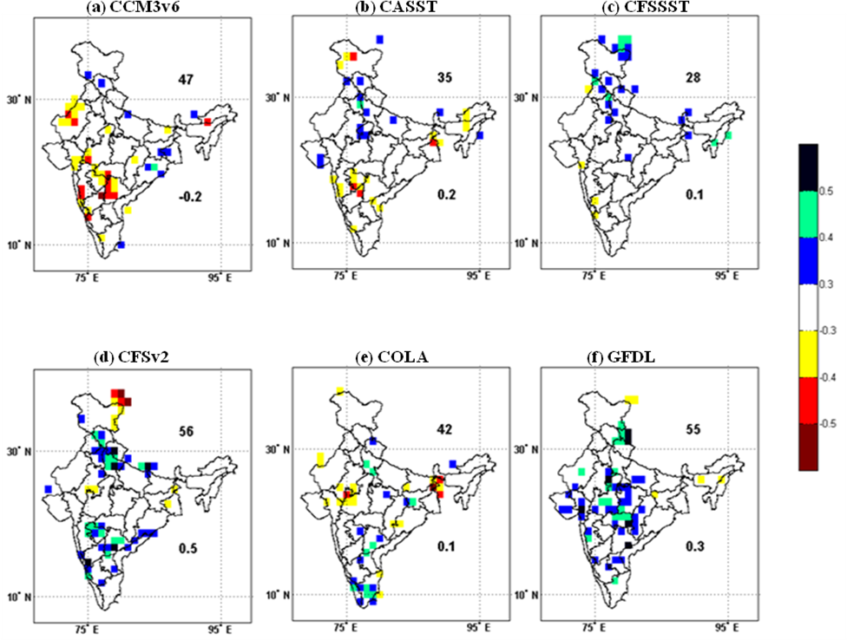

Figure S1 The performance of raw GCMs shown at10 x 10  resolution for the JJAS season.

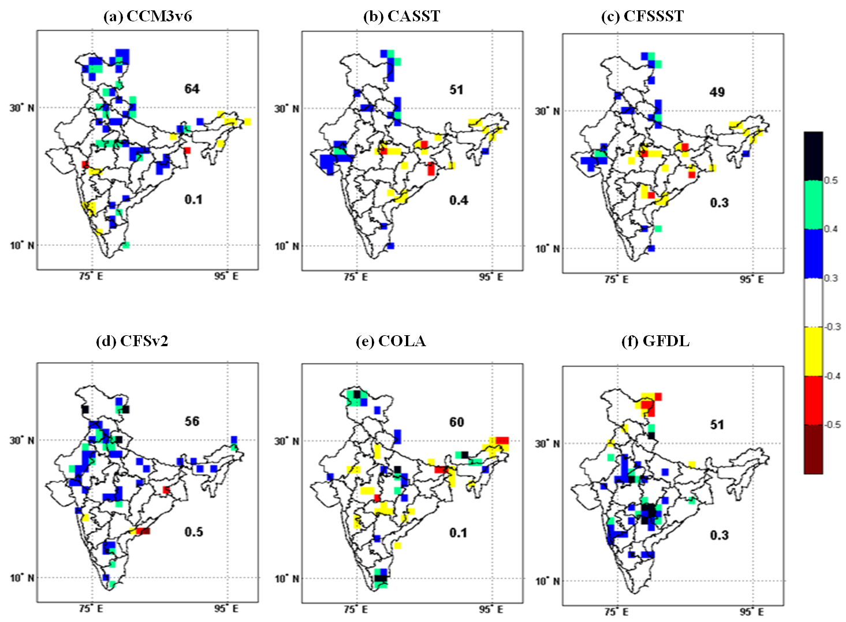

Figure S2 The performance of raw GCMs shown at10 x 10  resolution for July month

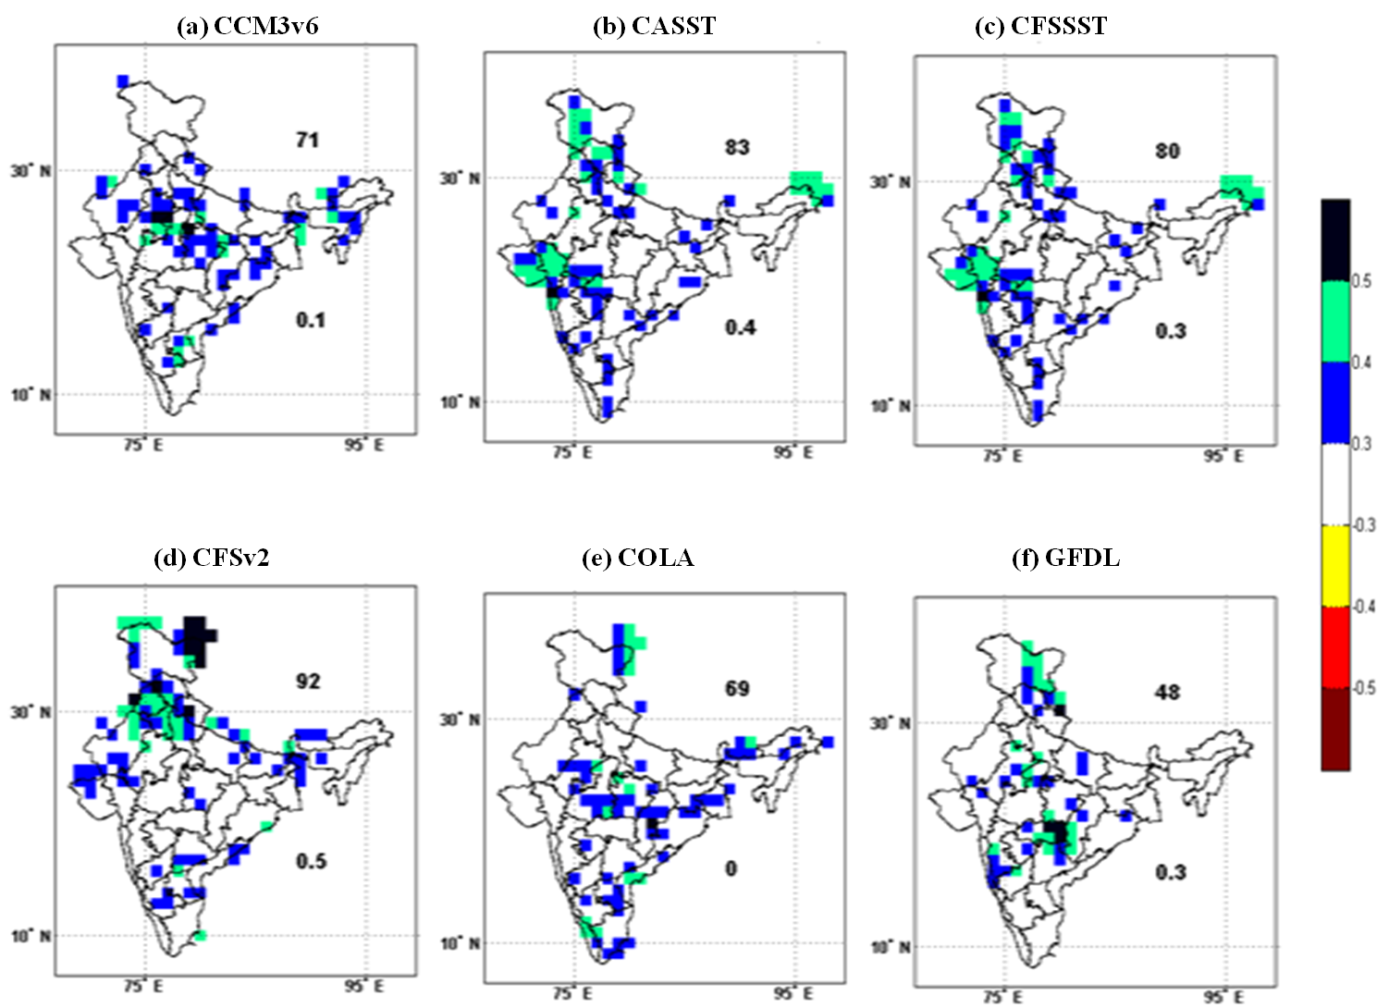

Figure S3 The performance of bias corrected GCMs shown at10 x 10  resolution in the month of July.

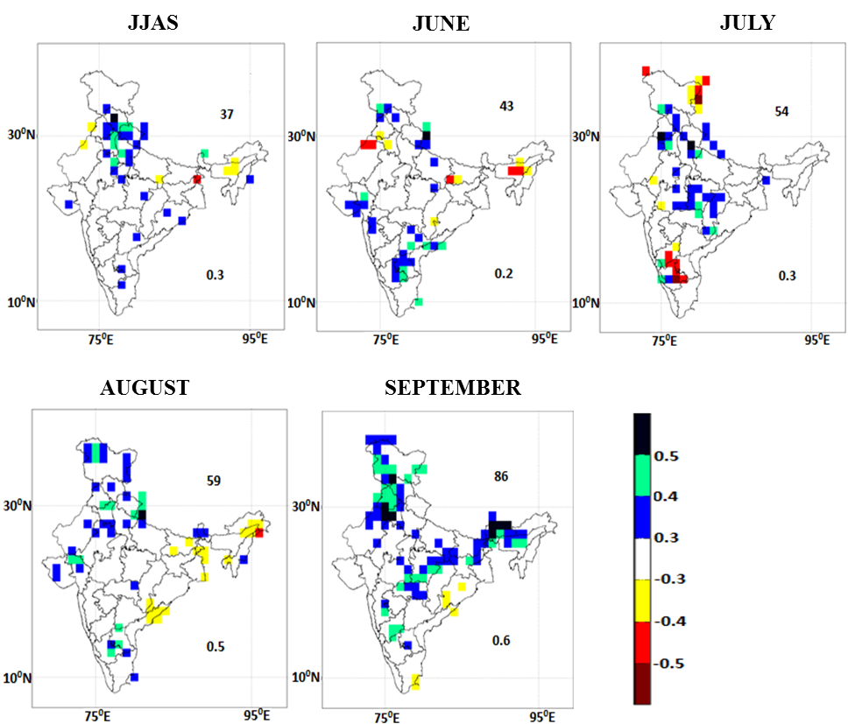

Figure S4 The performance of EM of the models for the season and individual months of monsoon.

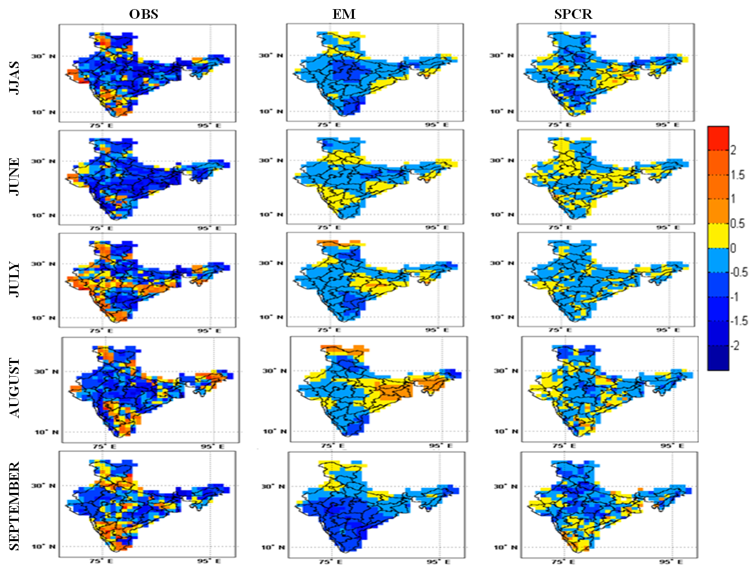

Figure S5 The rainfall anomalies shown for the year 2009 for EM (middle panel), for SPCR (right panel) and for observation (left panel).

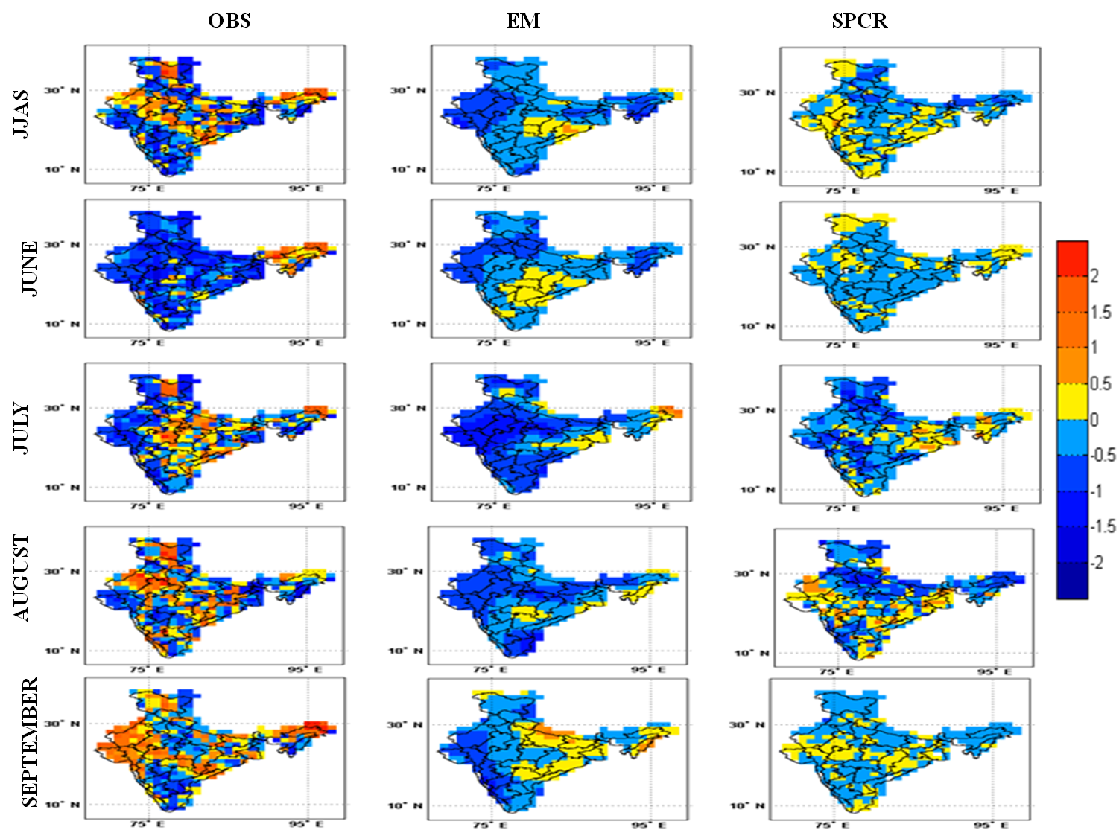

Figure S6 The rainfall anomalies shown for the year 2012 for EM (middle panel), for SPCR (right panel) and for observation (left panel).