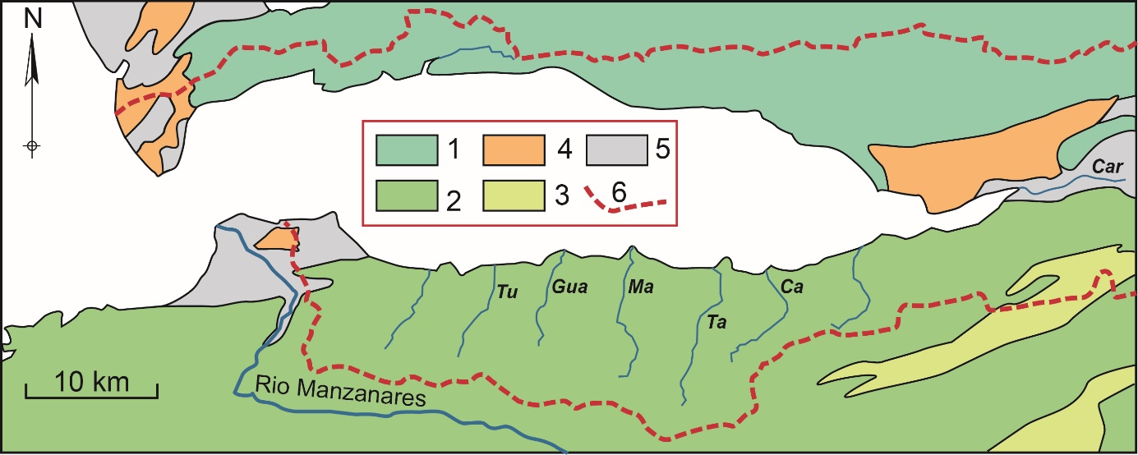
Supplementary Material S1
Simplified geological map of the Gulf of Cariaco’s watershed. Simplified from Hackley et al. (2005).1) Upper Jurassic–Cretaceous metamorphic series, quartz-rich micaschists and metavolcanic rocks; 2) Early Cretaceous siliciclastic sediments (claystones, sandstones); 3) Late Cretaceous hemipelagites (siliceous mudstones, cherts); 4) Pliocene–Pleistocene (bioclastic limestones, shelly sandstones, marls); 5) Late Pleistocene–Holocene siliciclastic deposits; 6) limit of onshore hydrographic basin; Tu, Tunantál River; Gua, Guaracayal R.; Ma, Mariguïtar R.; Ta, Tarabacoa R.; Ca, Cachamaure R.; Car, Cariaco R.

Reference
Hackley, P.C., Urbani, F., Karlsen, A.W., Garrity, C.P., 2005. Geologic shaded relief map of Venezuela. USGS, Open-File Report (2005-1038).

