Supplementary Material 3

1. Synthetic topography

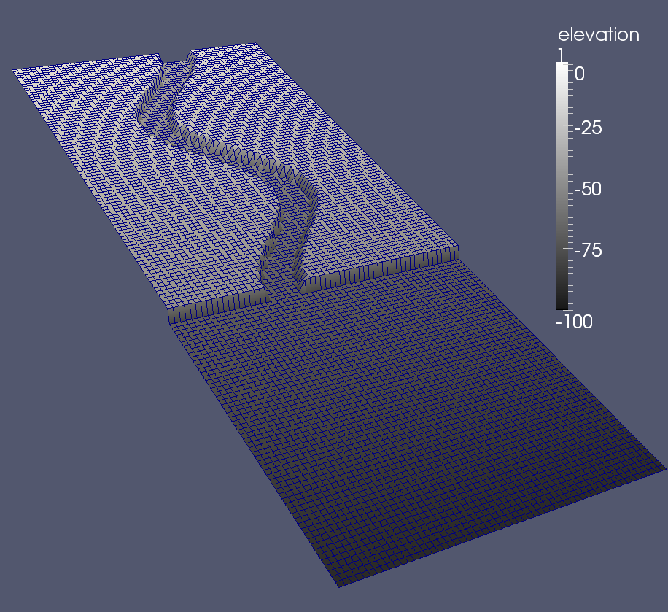
Figure S1: 3D view of the synthetic topography. The grid is 3 km wide and 7.5 km long, with a 50×50 m resolution. The upstream part of the simulated domain features a 25-m deep and 400-m wide sinuous channel with a sinuosity of 1.32 and a slope of 0.5°. The downstream part is a 3×3-km² flat unconfined topography.

2. Single-event simulation

The first simulation (parameters are described in Table S1) features a single 20-m-thick event input at the upstream entrance of the channel with a duration of 2·10⁴ seconds (5 h 33 min) with a concentration of 6% equally distributed in sand and silt. Erosion and deposition processes were modeled with the Rouse approach considering the flow capacity to transport sediments.
Table S1 Simulations parameters on the synthetic topography described Section 3.1.1.
Lithology |  | Sand | Silt | Mud
Grain size (μm) |  | 135 | 30 | 5
Density [kg/m³] |  | 2600 | 2600 | 2600
Initial bed composition |  | 5% | 15% | 80%
Flow input | concentrations | 3% | 3% | 0%
 | thickness | 20 m
 | velocity | 2 m/s
 | duration | 20,000s
Drag coefficient |  | 1·10^{–3}
Erosion coefficient |  | 1e-7
Profile model |  | Rouse
Table S1: Parameters of the simulation on the synthetic topography

During the first stage (top panel of Figure S2), the flow stays mainly channelized and there is a weak overspill onto the channel banks preferentially on the concave side. Due to the use of the Rouse profile, sands remain confined within the channel, whereas silts can be transported onto the banks with the flow and then deposited when the flow decelerates, and the flow transport capacity decreases.
When the flow input stops (middle panel of Figure S2), the current reaches the unconfined area and spreads over the flat area. In the channel, the waning flow leads to the decantation of silts as the current tail passes into the channel. Finally, a large part of the fine-grained sediments transported by the flow is in bypass and is carried beyond the computational domain (bottom panel of Figure S2). At the channel mouth, the flow diverges and, as it wanes, sands then silts are deposited initiating the deposition of a lobe.
This single-event simulation performed with the Rouse approach allows a more realistic transfer of sediments with the flow distribution and, subsequently, a more realistic deposit distribution on the topography: the coarser lithology stays confined in the channel, whereas the finer one is able to overspill and deposit on the banks.

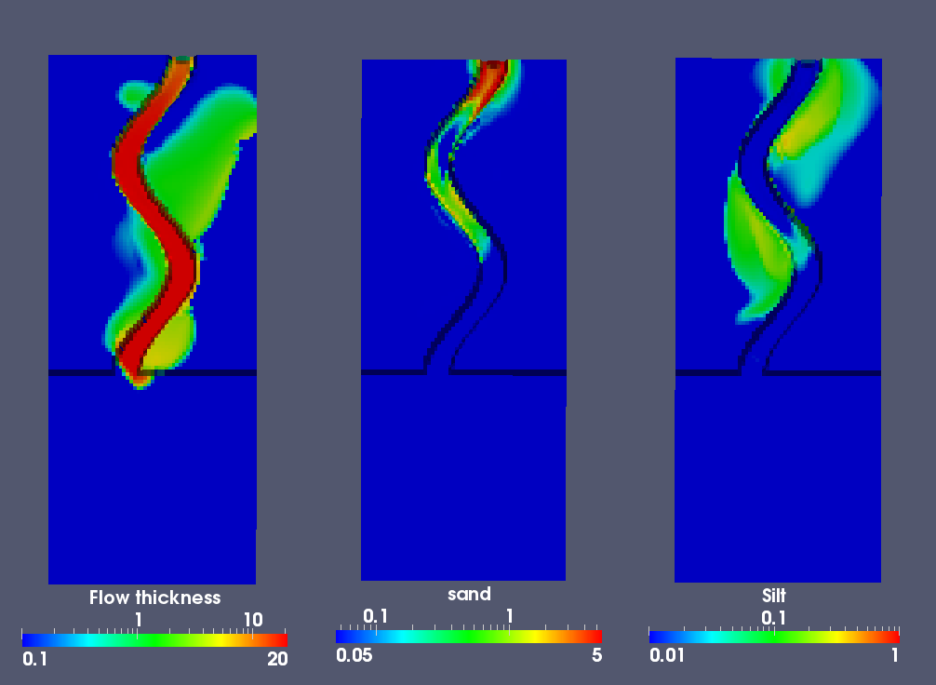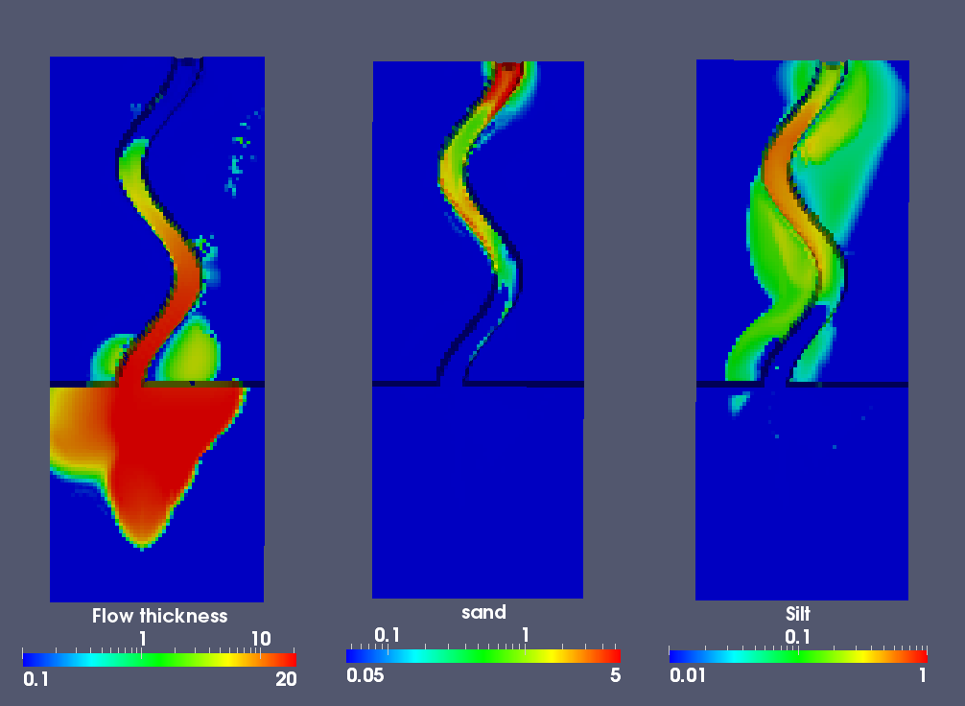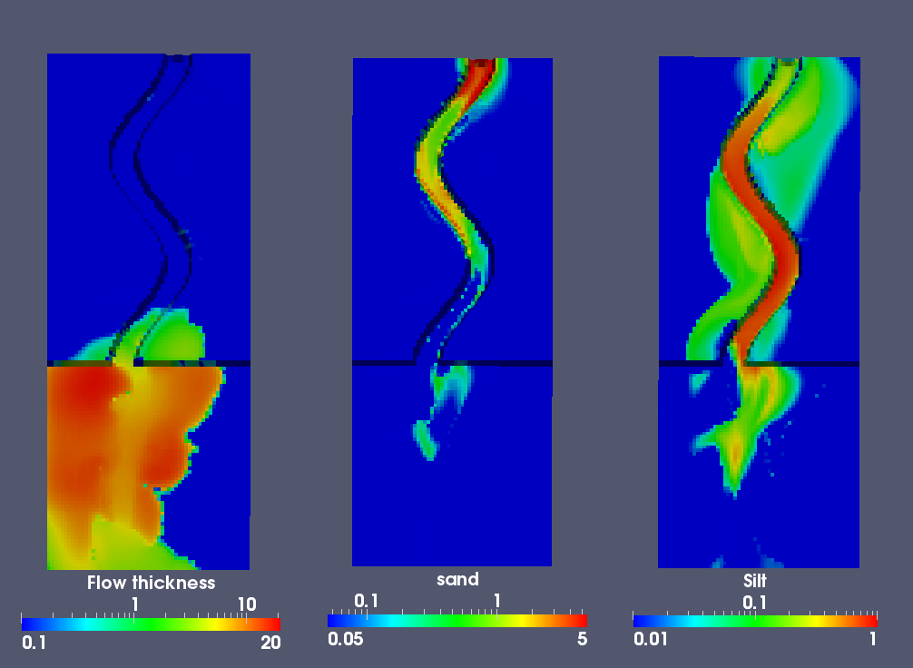
Figure S2: Plan view of simulation results through time at 21,000 s, 34,000 s, and 84 000 s from top to bottom. From left to right: flow thickness (m), sand and silt deposits (m). Color bars are in log-scale.

3. Parameters of the multi-event simulation on the synthetic topography
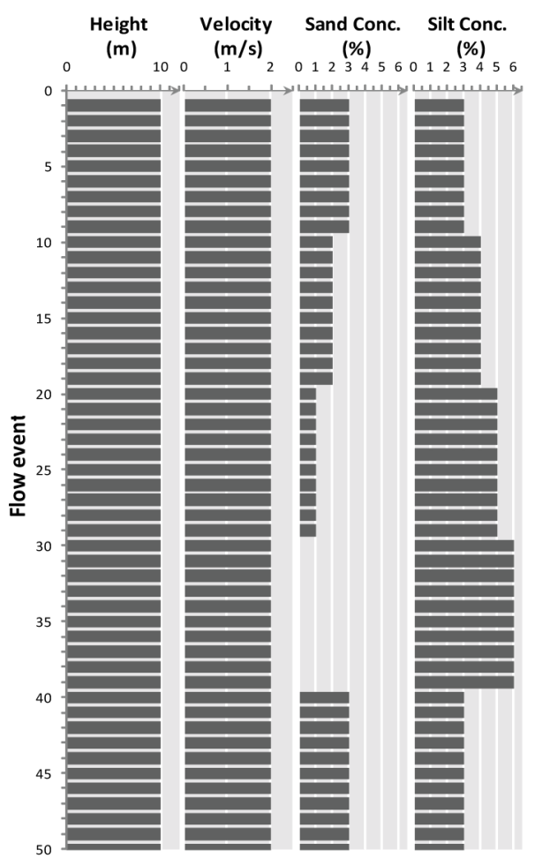
Figure S3: Flow parameters of the 50 events sequence stacked vertically. From left to right, flow thickness (or height), flow velocity, sand and silt concentrations (from Maktouf, 2012).

