Supplementary Material 4

1. Makran topography
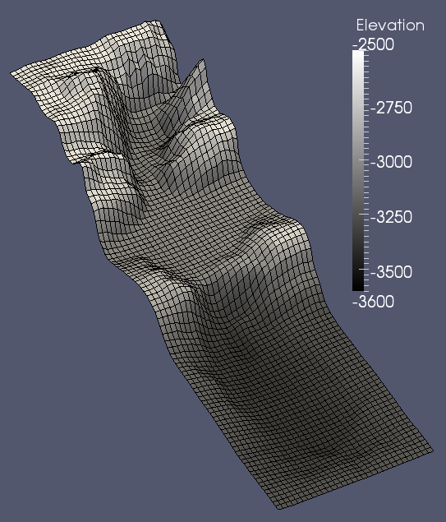
Figure S4: 3D view of the Makran topography of dimension 12.4 km×38.4 km, with a 400×400-m grid resolution.

D2 Parameter details of the multi-event simulation performed on the Makran topography described section 3.2

Lithology |  | Sand | Fine silt
Grainsize (μm) |  | 300 | 20
Density [kg/m³] |  | 2650 | 2450
Initial bed composition |  | 20% | 80%
Flow input | Type 1-Muddy flow concentrations | 1% | 2%
 | Type 2-Sandy flow concentrations | 3% | 1%
 | Thickness | 150 m
 | Velocity | 1 m/s
 | Duration of the single event | 8000 s
Drag coefficient |  | 3·10^{–3}
Erosion coefficient |  | 1·10^{–7}
Profile model |  | Rouse
Table S2: Makran simulation parameters

