Section S2. Calibration borehole examples
Drilling and water salinity determination.

Drilling was carried out with a rotary machine without drilling fluids (no water or mud), using casing which followed the rock bit instrument. Such drilling procedure enabled hydrogeologists to record the hydraulic head distribution over the different sub-aquifers encountered and to sample undisturbed groundwater (once a quiet period is reached) at any required water horizon below the water table. Water samples, which were collected either through pumps or by appropriate water sampling device, were analyzed for their chemical and isotopic composition. Analyses were conducted according to standard methods and procedures adopted at the laboratory of the GSI (Yechieli et al., 2004). Electrical conductivity measurements were carried out during drilling for preliminary detection in-situ the fresh-saline water interface. After drilling boreholes were equipped by perforated PVC pipes (5cm diameter). The space between borehole and PVC was filled by coarse (2mm) quartz sand. Later, boreholes were used for water salinity monitoring (Yechieli. 2007).
Calibration borehole examples
Mn-5E borehole (site 27 in Fig. S2 b) was drilled in the northern DS basin in the margin of an alluvial fan near Mineral Beach Spa (Fig. S3).
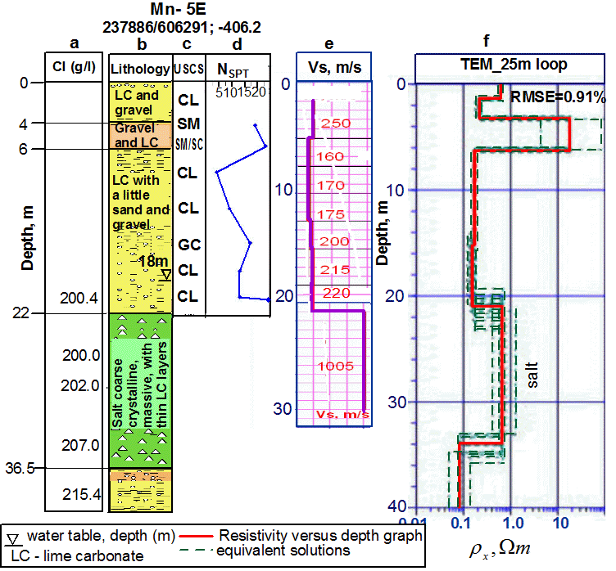
Fig. S3. Borehole Mn-5E and results of its testing, in respect to depth: (a) Chloride concentrations in the groundwater (g/l) (after Yechieli et al., 2004), (b) lithology; (c) soil classification based on Unified Soil Classification System (USCS) (d) N blows; (e) Shear wave velocity (Vs) profile based on downhole measurements; (f) inverted resistivity function. Thick line (in Fig. S3 f) denotes the inverted resistivity, whereas thin dashed lines are equivalent solutions. (Lithology and SPT sounding has been interpreted by Livne (2012)).
The lithology consists mainly of fine grain lime carbonates with few inter-layers of gravels. Brine-saturated lime carbonates (DS mud) do not exhibit cohesion (Frydman et al., 2008). This feature allows considering saturated lime carbonates as cohesionless sediments, like fine sands (Ezersky and Livne, 2013). They are characterized by low N values of 4-16 blows and low Vs values of 120 – 250 m/s. N is obtained from Standard Penetration Test (SPT) equal to the number of blows necessary to insert the sampler 30cm into the sediments. It is the index of mechanic properties of the sediment. This parameter is used for soil classification and it correlates with either relative density of the sandy-gravel (cohesionless) sediments or consistency of cohesive ones (Terzaghi et al. 1996). Vs is shear wave velocity.

EB-3E borehole (site 28 in Fig. S2c) was drilled in the alluvial fan of the Ein Boqeq site (Fig. S4).
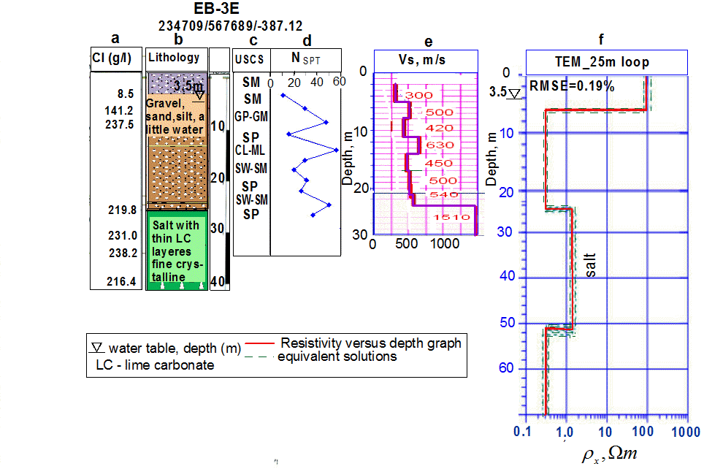
Fig. S4. Borehole EB-3E and results of its testing. (a) Chloride concentrations in the groundwater (g/l) (after Yechieli et al., 2004), (b) lithology; (c) soil classification based on Unified Soil Classification System (USCS) (d) N blows; (e) Shear wave velocity (Vs) profile based on downhole measurements; (f) inverted resistivity function. Thick line (in Fig. S4f) denotes the inverted resistivity, whereas thin dashed lines are equivalent solutions. (Lithology and SPT sounding has been interpreted by Livne (2012)).

The lithology consists mainly of coarse clastic sandy-gravel sediments (Livne 2012). Note that the section is typical of the DS fans. Similar coarse sandy-gravel lithology is reported by Taqieddin et al. (2000) on the Jordanian DS shore. In both boreholes a Standard Penetration Test (SPT) was carried out in addition to in-situ downhole and surface TEM measurements. Samples selected from the boreholes (both in the vadose zone and below the water table) were tested in the laboratory to determine density, water content, Atterberg limits and USCS classification (Livne, 2012).
The hydrogeological conditions of these sites have been studied by GSI using groundwater salinity monitoring (Yechieli, 2007). Results of SPT are presented in Figs. S3d and S4d.

