FIGURES
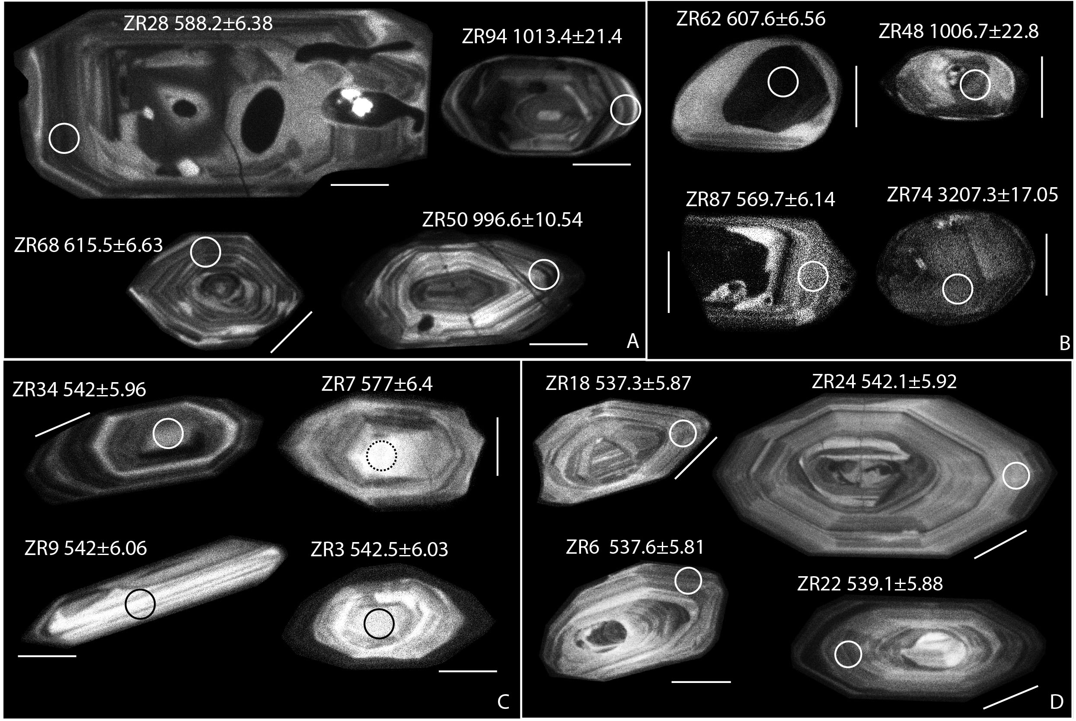
Fig. S1. Example of CL-imaging for analyzed zircon. A: sample MN1, B: sample MN4, C: sample MN2, D: sample MN3. Scale bars are 50 µm. Zircon numbers (ZRxx) and dates are in supplementary tables.

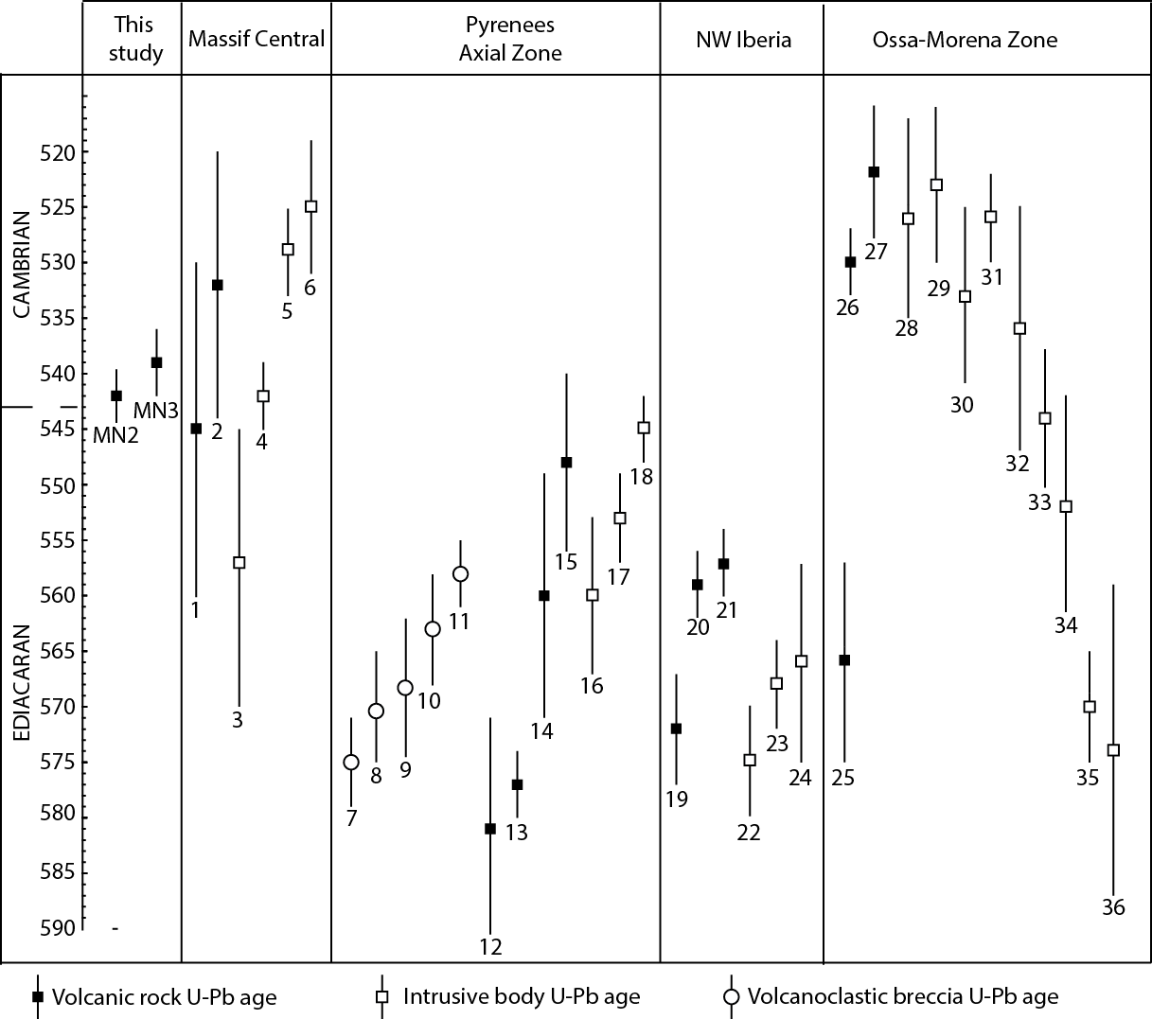
Fig. S2. Rivernous Fm U–Pb ages, MN2 and MN3, compared with regional magmatic ages in the Massif Central and Pyrenean massifs and in the Iberian domain across the Ediacaran–Cambrian transition. Massif Central : 1 – Sériès metadacite, 545±15 Ma(1); 2 – Murat Fm, 532±12 Ma(2) ; 3 - Caplongue granodiorite, 557±12 Ma (3); 4 – Arc-de-Fix and Ardéchois augen 541.8 ± 3.1 and 542.5 ± 3.1 Ma (4); 5 – Li14, Moulin du Chambon orthogneiss, 529±4Ma(3); 6 – Vergonzac orthogneiss, 525±6 Ma(3). Pyrenees Axial Zone : 7 – TG03, Tregurà volcanoclastic breccia, 575±4 Ma(5); 8 – TG01, Tregurà volcanoclastic breccia, 570±5 Ma(5); 9 - TG02, Tregurà volcanoclastic breccia, 568±6 Ma(5); 10 – CC0807, Cap de Creus volcanoclastic breccia 563±5 Ma(5); 11 – CC0808, Cap de Creus volcanoclastic breccia, 558±3Ma(5) ; 12 – GRA1, Mas des Sitges metarhyolithic tuff, 581±10 Ma(6); 13 – CC0801, 577±3 Ma(5); 14 – CC0502, Cap de Creus metatuff 560±11 Ma(7); 15 – RF3 Mas Blanc metarhyolithic tuff, 548±8 Ma(7); 16 – RF4, Mas Blanc gneiss, 560±7Ma(7); 17 – CC0507, Port gneiss 553±4 Ma(6); 18 – LOG, Laparan gneiss, 545±3 Ma(8). NW Iberia : 19 – PEN552, Allande group dacitic tuff, 572±5 Ma (9) ; 20 – NWIb, 559±3 Ma(10); 21 – CQ39 Cudillero rhyolite, 557±2.7 Ma(9) ; 22 – PEN151, Escrita diorite, 575±5 Ma(9) ; 23 – Lomes tonalite, 568±4 Ma(9) ; 24 – La Cueta granodiorite, 566±9 Ma(9). Ossa-Morena Zone : 25 – La Cardenchosilla amphibolite, 566±9 Ma(11); 26 – Bodonal porphyroid, 530±3 Ma(11); 27 – Escoural felsic gneiss, 522±5 Ma(11); 27 - Alcaçovas felsic gneiss, 526±9 Ma(11); 29 – Mina afortunada granitoids and migmatites, 523±7 Ma(11); 30 – Monestério granitoids and migmatites, 533±8 Ma(11); 31 –Barquete granite, 526±4 Ma(11); 32 – Monteagudo gabbro, 536±11 Ma(11); 33 – Mosquil tonalite 544±6 Ma(11); 34 – Ahillones granite, 552±10 Ma(11) ; 35 – Mouriscas gneiss, 570±5 Ma(11) ; 36 – Vale de Serena-Zalamea granodiorite, 573±14 Ma(11). Reference numbers : (1) Lescuyer and Cocherie 1992 ; (2) Ducrot et al., in Demange et al., 1995 ; (3) Melleton et al., 2010 and therein references ; (4) Couzinié et al., this issue ; (5) Casas et al., 2015 ; (6) Cocherie et al., 2005 ; (7) Castiñeiras et al., 2008 ; (8) Mezgher et al., 2016 ; (9) Rubio-Ordoñez et al., 2015 ; (10) Gutiérrez-Alonso et al., 2004 ; (11) Pereira et al., 2011 and references therein.

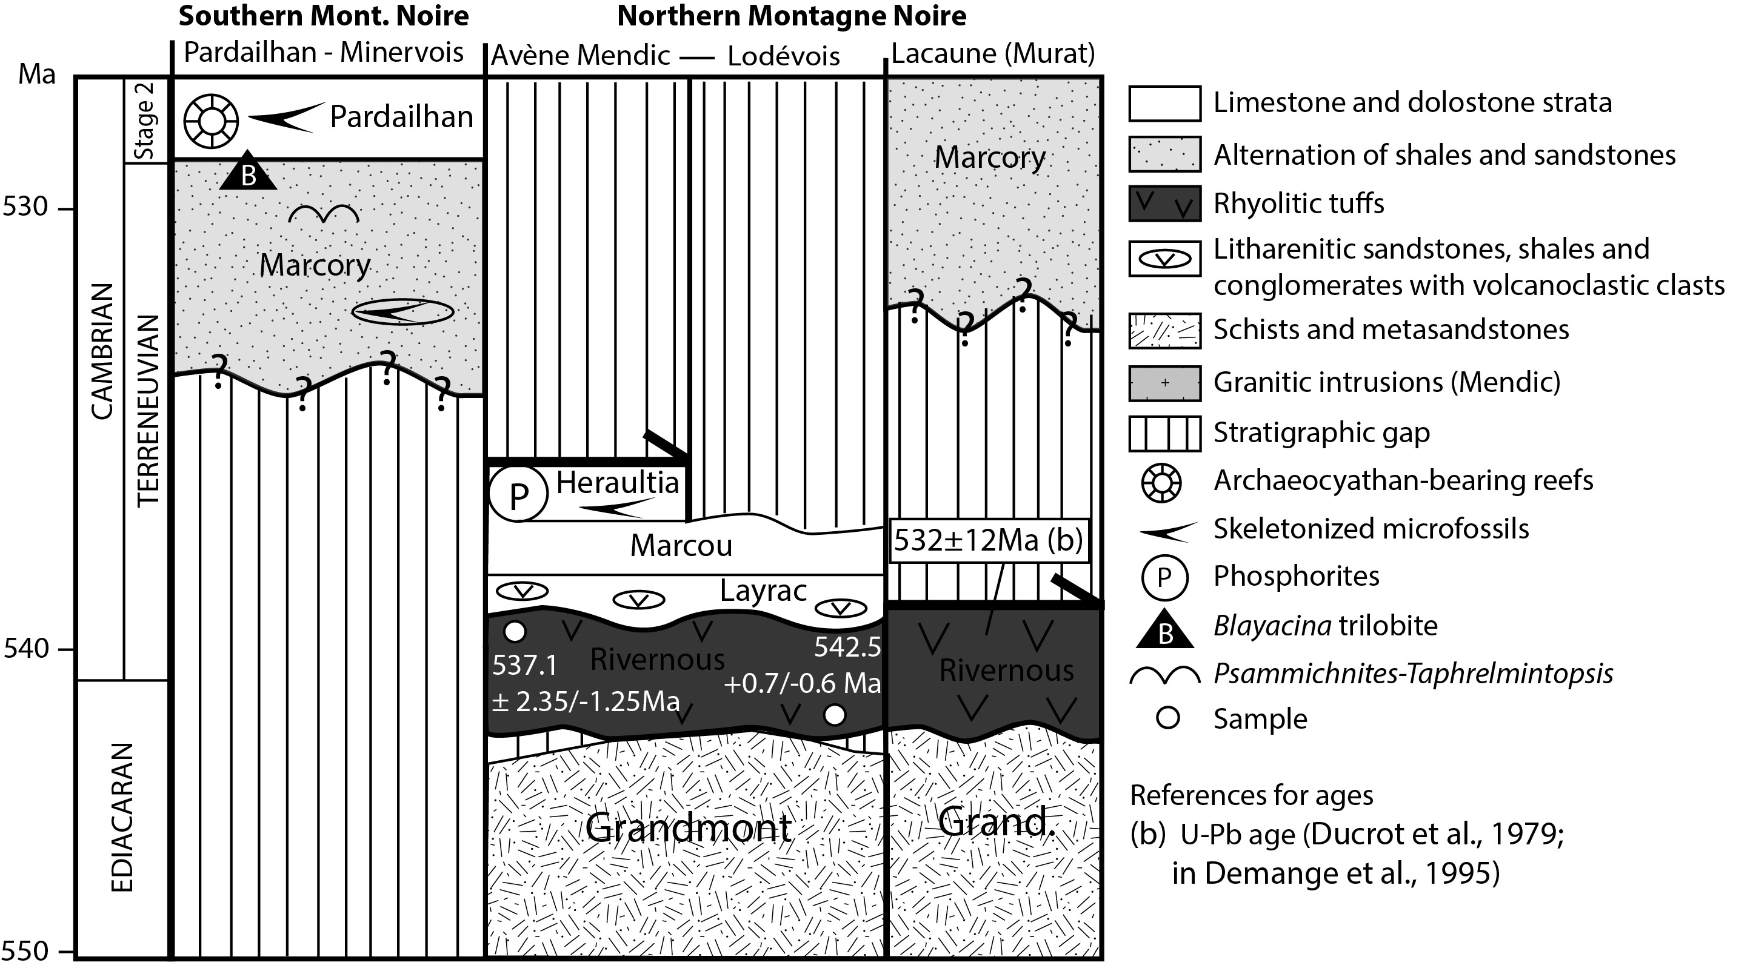
Fig. S3. Updated stratigraphy of the Ediacaran–Cambrian transition in the Montagne Noire with new U–Pb ages.

