Intraplate earthquakes and their link with mantle dynamics: insights from P-wave teleseismic tomography along northern part of the North-South Tectonic Zone in China

Chuansong He¹∗, M. Santosh^{2, 3}
¹Institute of Geophysics, China Earthquake Administration, Beijing 100081, China
² Centre for Tectonics, Exploration and Resources, Department of Earth Sciences, University of Adelaide, SA 5005, Australia
³School of Earth Sciences and Resources, China University of Geosciences Beijing, 29 Xueyuan Road, Beijing 100083, China

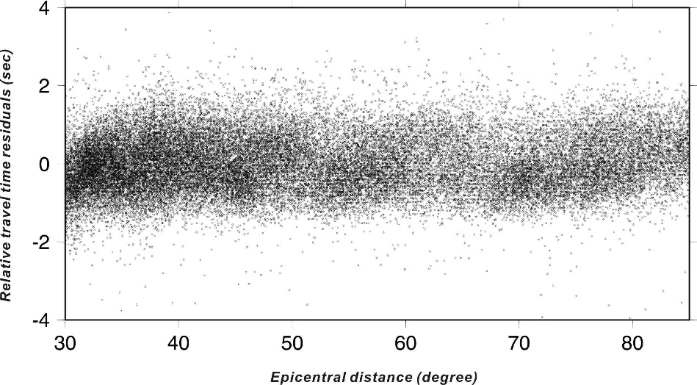

Fig. S1 Distribution of the relative travel-time residuals, data of great than 2s and less then -2s were used for tomographic inversion.
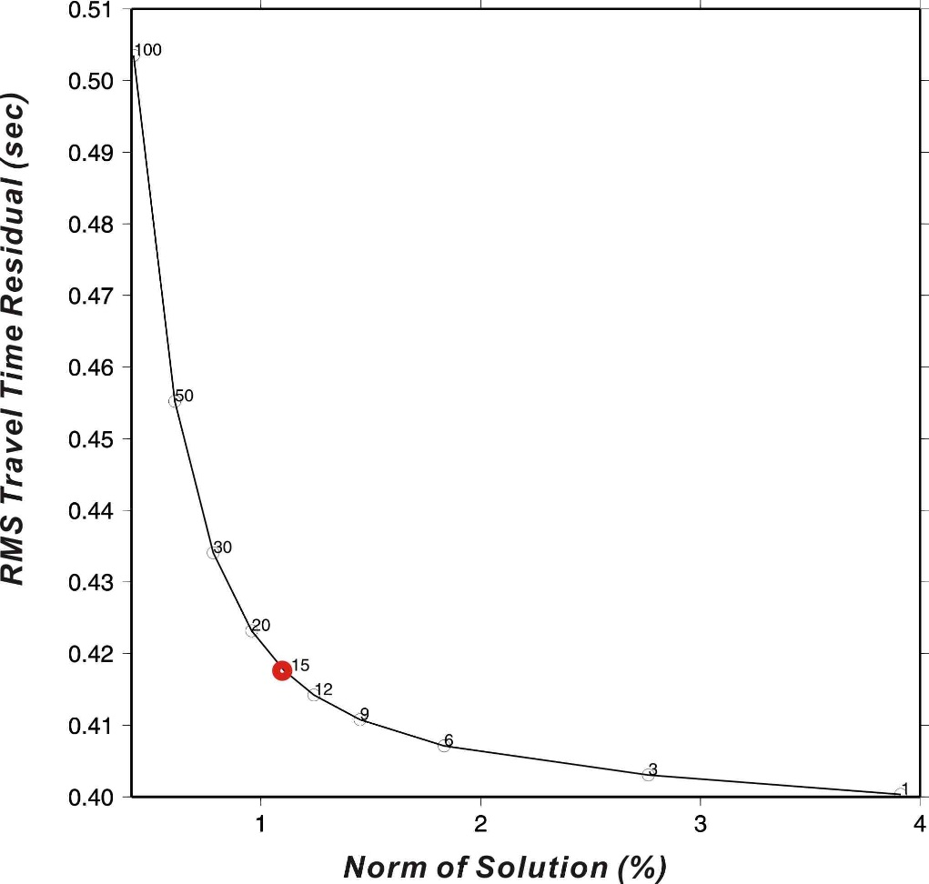
Fig. S2 The damping parameter 15 (red circle) is taken to invert final model after a series of tests.
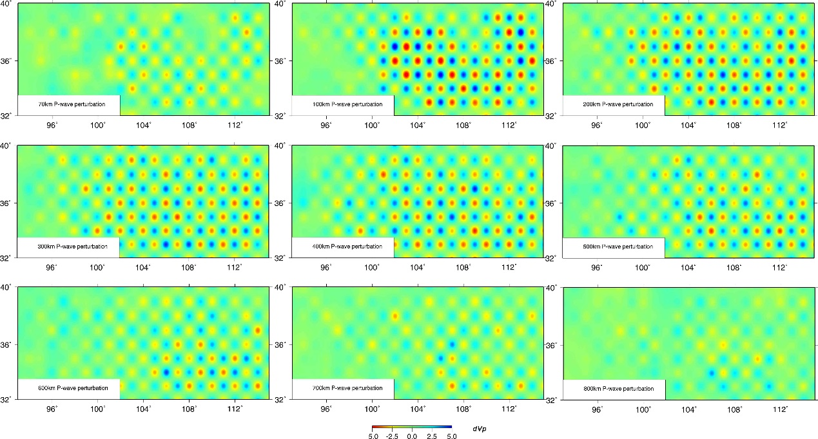
Fig. S3 Check board resolution test at 70, 100, 200, 300, 400, 500, 600, 700 and 800 km depth sections respectively relative to the iasp91 1-D Earth model (Kennett and Engdahl, 1991). The model was run using the same raypaths as the main inversion, with the same damping parameter.
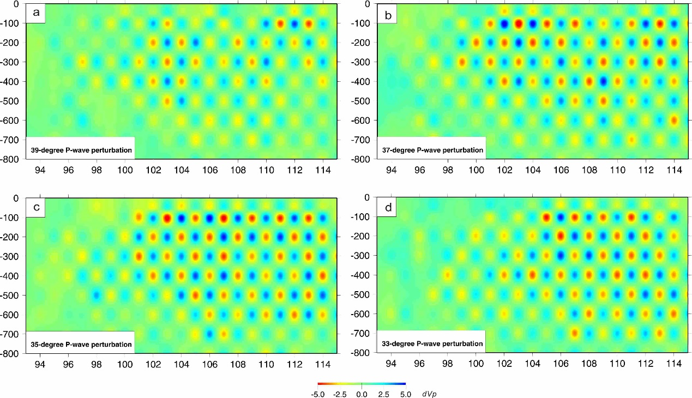
Fig. S4 CRT along the west-east profiles (see Fig. 1 for profile location). a, b, c and d are at 39 degree, 37 degree, 35 degree and 33 degree along latitudinal direction.
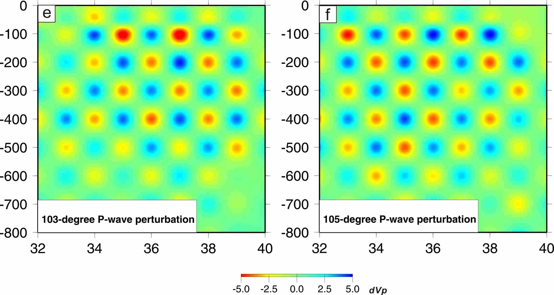
Fig. S5 CRT along the north-south profiles (see Fig. 1 for profile location), e and f are at 103 degree and 105 degree along meridians of longitude.

∗ Corresponding author. Tel.: 86-10-68729303; Fax: 86-10-83534760. Email address: hechuansong@aliyun.com

