Figure S1. Palaeocene to Eocene lithological formations in Tunis (modified from Tlig & al., 2010). The dashed line represents lateral changes in lithological facies.
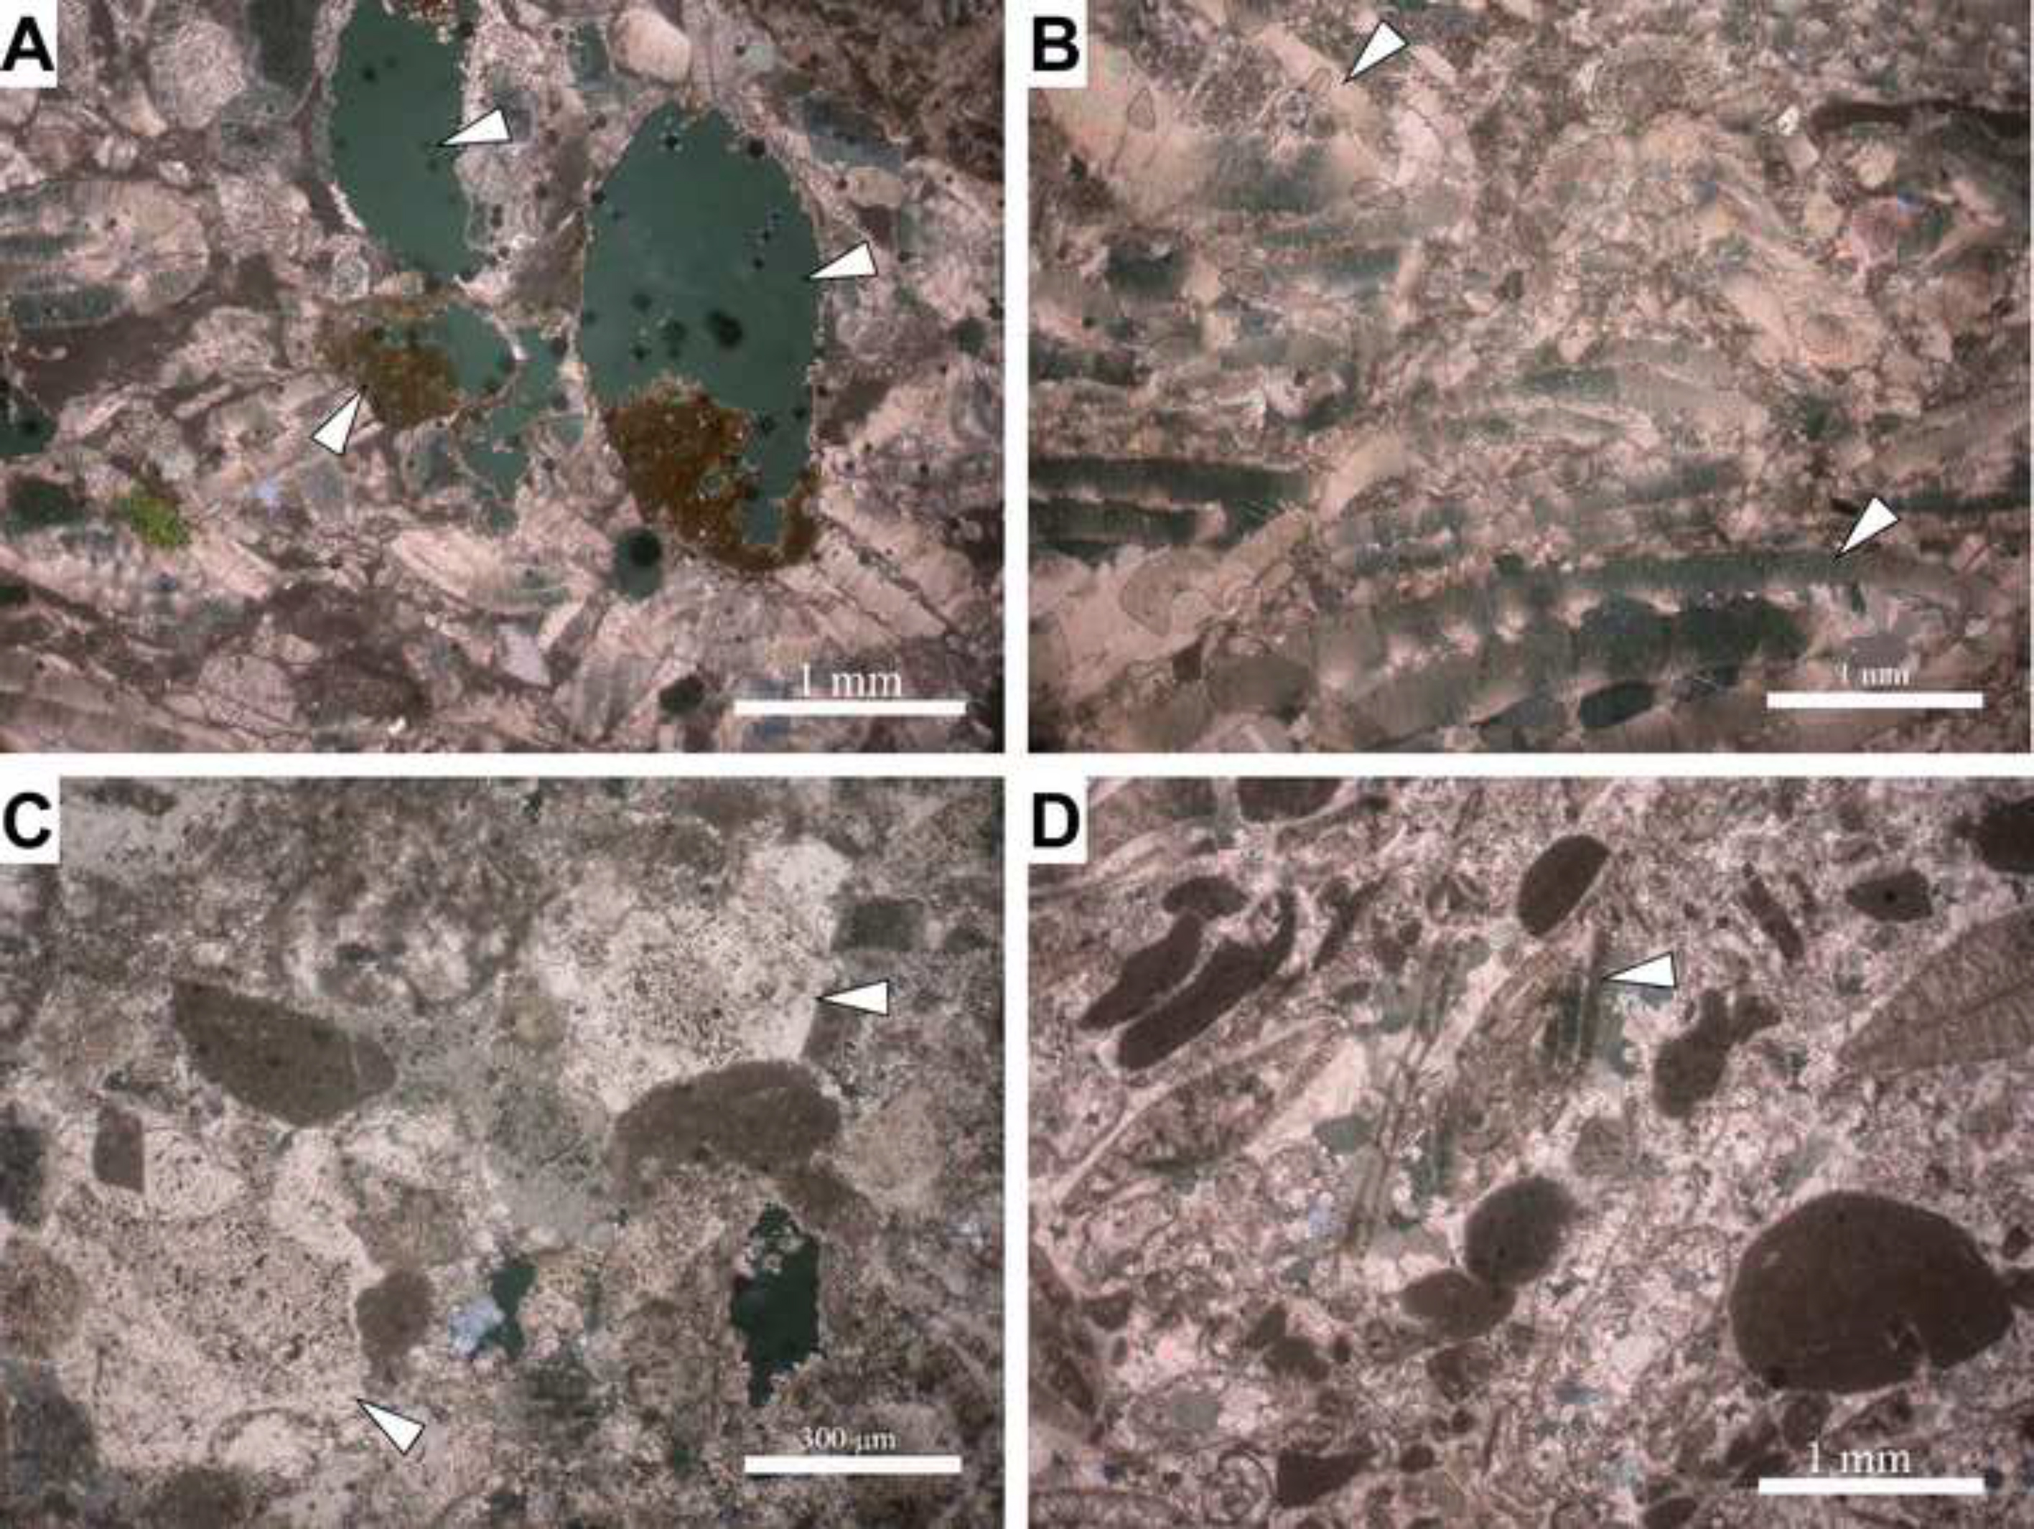

Figure S2. Google Earth image showing the Roman City of Dougga (left) and the location of the quarries (bottom centre and top right). The red dashed line denotes the trace of the stratigraphic section in Fig. 7.
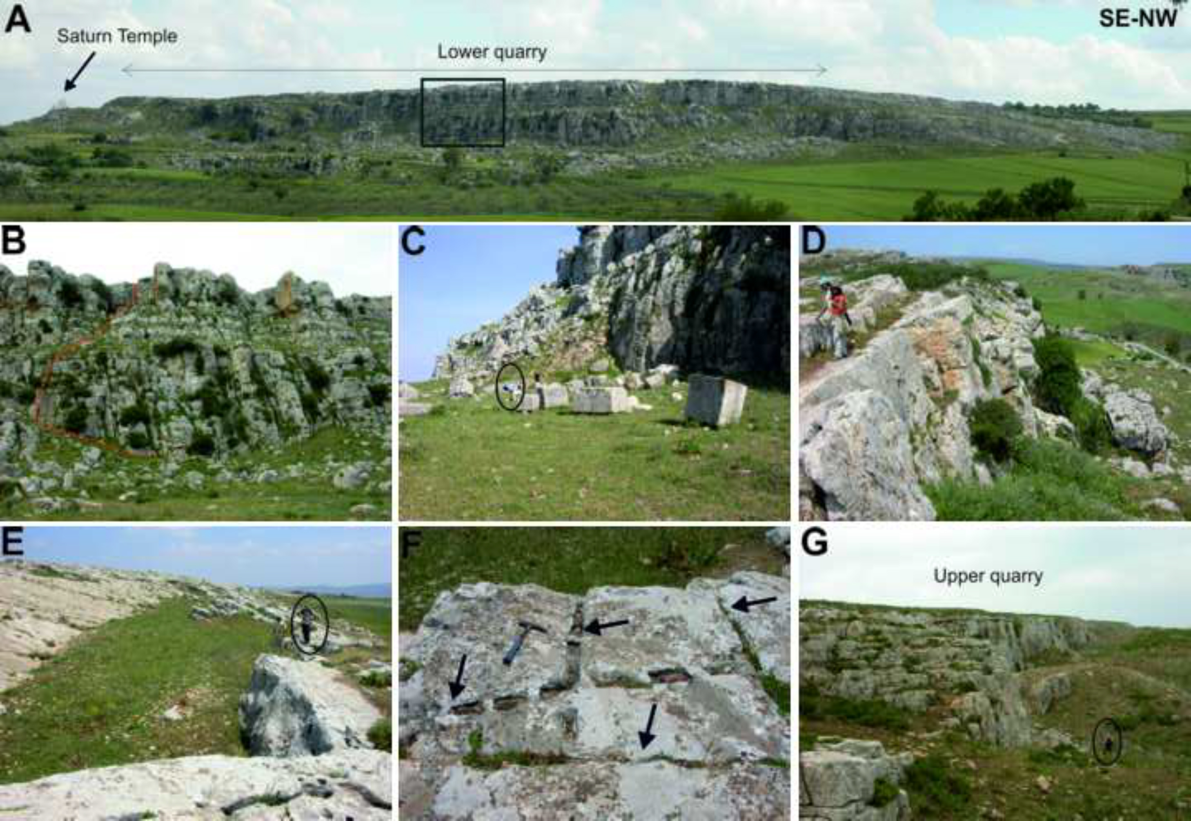

Figure S3. Photomicrographs of the lithotypes showing most important petrographic characteristics. (A) Lithotype L1 characterized by the partial to complete dissolution of sedimentary rock fragments (arrowed). (B) Lithotype L3 characterized by large nummulites (arrowed). (C) Lithotype 2F showing abundant syntaxial overgrowth cements. (D) Lithotype 2G showing higher proportion and bigger nummulites than lithotype 2F.
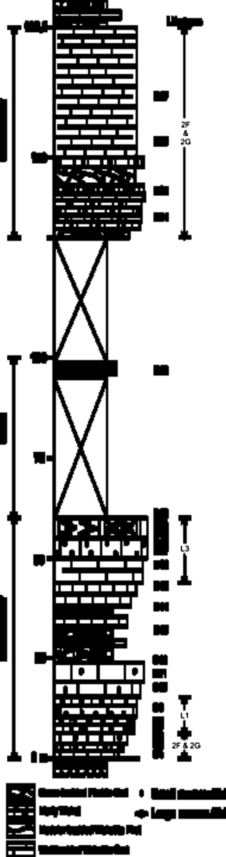

Figure S4. Field images of the quarries located in the surroundings of Dougga. (A) Field panorama showing the lower quarry (see Fig. 1 for location). (B) Detail of A (square) showing the bedding in the front part of the quarry and the trace of the stratigraphic log (red dashed line). Note the metre-scale thickness of the bedding in the bottom and top of the front. (C) Base of the lower quarry showing shaped metre-scale stone blocks ready to use. The origin of these ashlars is unknown, but they are most probably post-Roman. (D) Top of the lower quarry, showing marks of the extraction. Note the metre-scale thickness of the bedding. (E) Top beds of the lower quarry, showing marks of the extraction. The size and the lithotype of the rock suggest that the extracted blocks were used as columns. The surface dipping towards the right corresponds to the bedding. (F) Detail of E showing well-preserved lines of wedge-marks from splitting (arrow), presumably Roman in origin. (G) Panoramic view of the upper quarry.
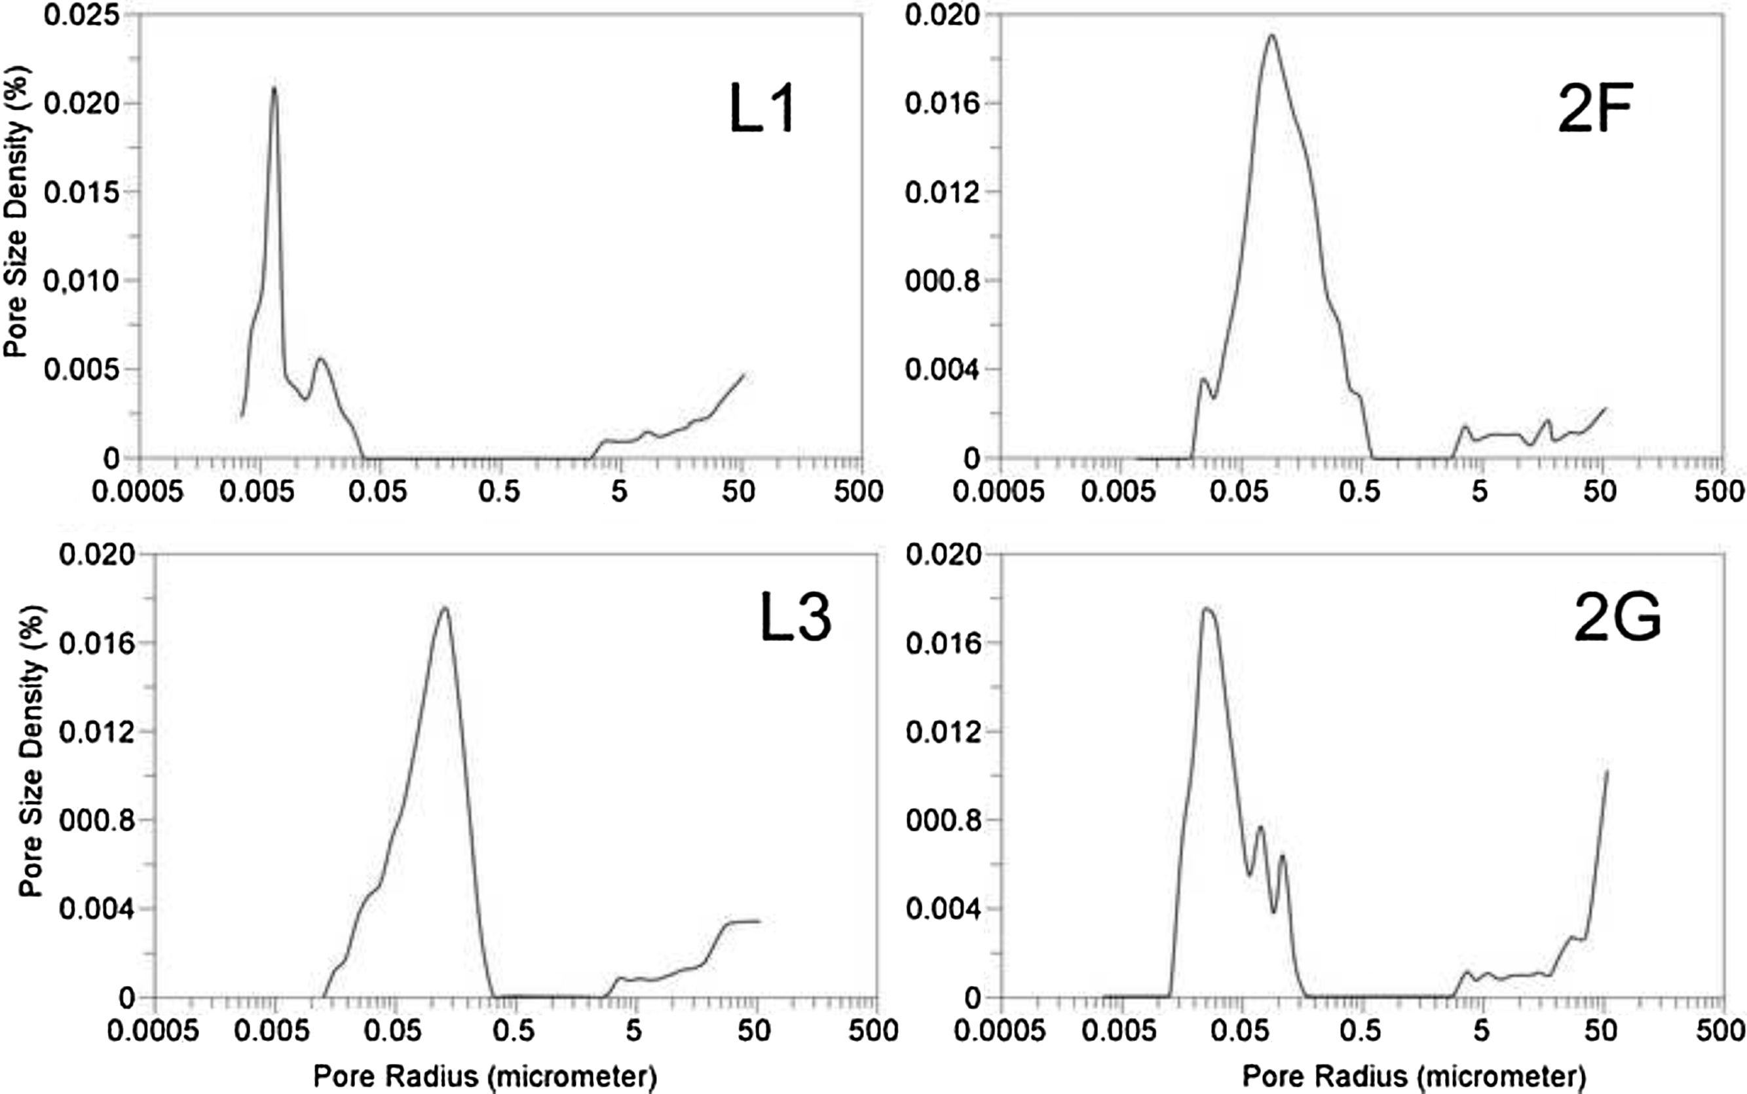

Figure S5. Stratigraphic log of the lithological succession cropping out in the surroundings of Dougga, showing the bedding characteristics of the nummulitic limestone, and the location of the samples (D-) and major quarries (see Fig. 1 for location). Pkst = packstone, Grst = grainstone, Wckst = wackstone.
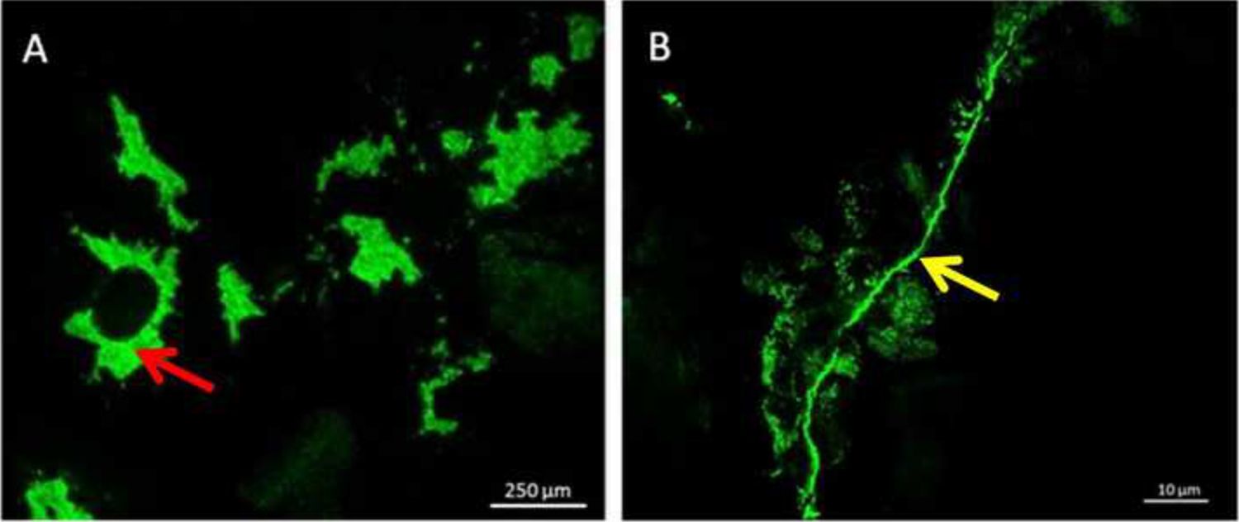

Figure S6. Pore size distribution of the four lithotypes showing smaller mean pore diameter in L1 (10–20 nm), medium in 2G and 2F (40–100 nm and 100–500 nm, respectively), and bigger in L3 (100–400 nm).
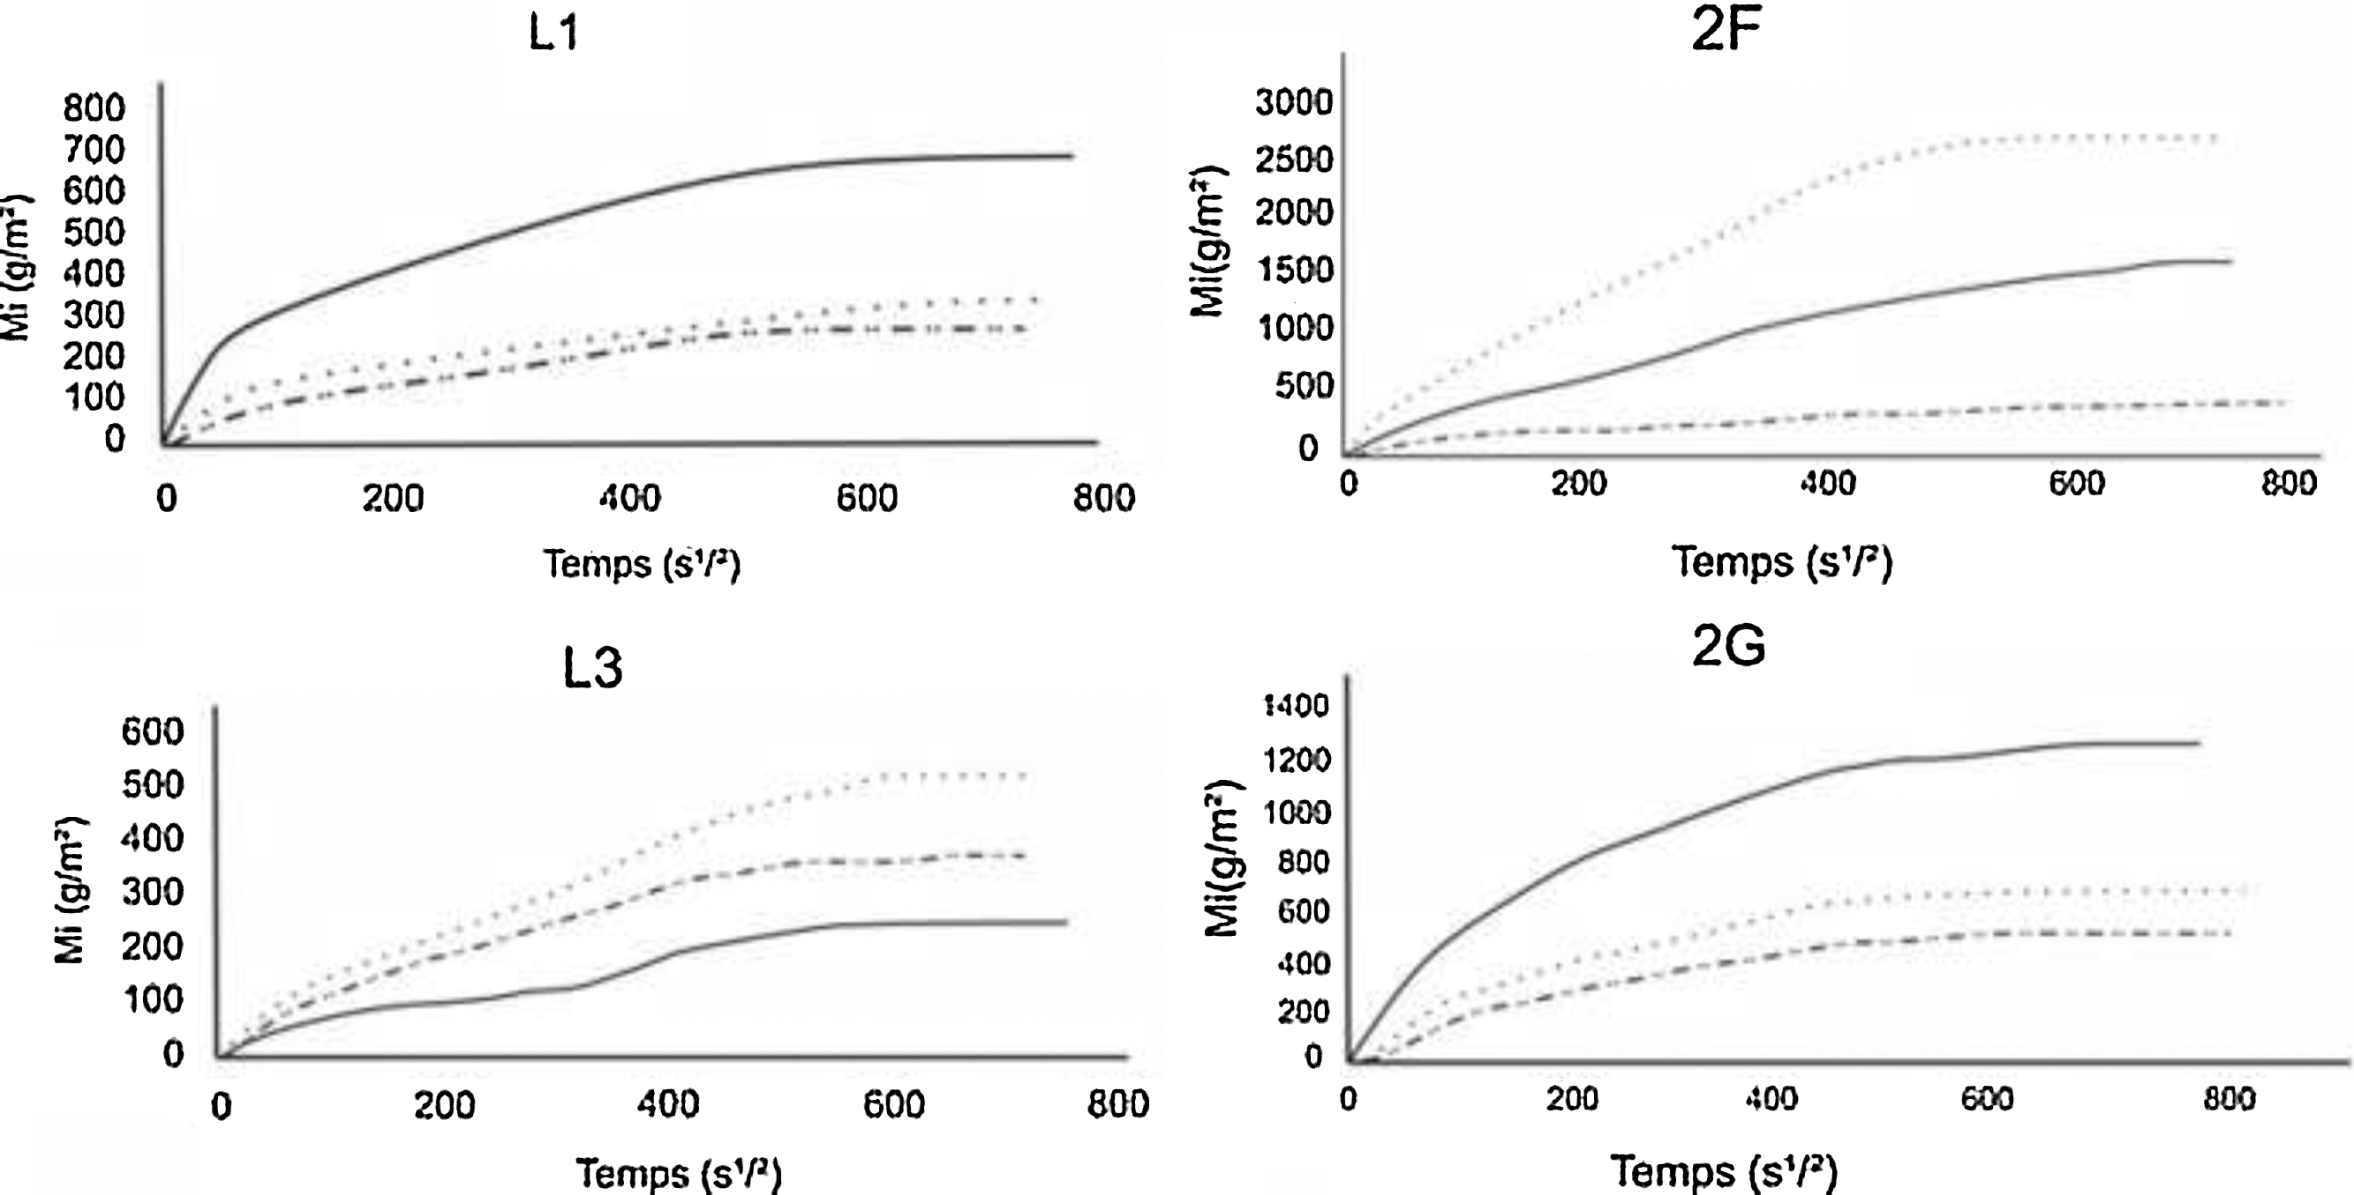

Figure S7. OFM images under fluorescence light showing the porous network (green colour) of the limestones. Most common pore types are vugs (A) and fissures (B).
