Appendix A. Supplementary Figures

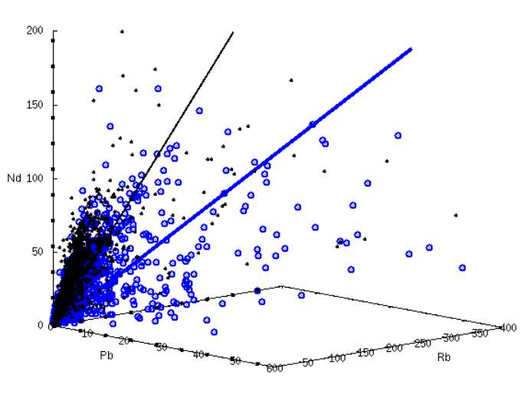
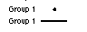

Supplementary Figure A1. Three-dimensional plot of Pb-Rb-Nd concentrations (in ppm) of Group 1 (black, IC1>0 and IC2<0) and Group 4 (blue, IC1>0 and IC2>0) basalts. The black dots and blue open circles represent the basalt data. The black and blue lines represent the regression lines for Group 1 and Group 4 basalts, respectively.

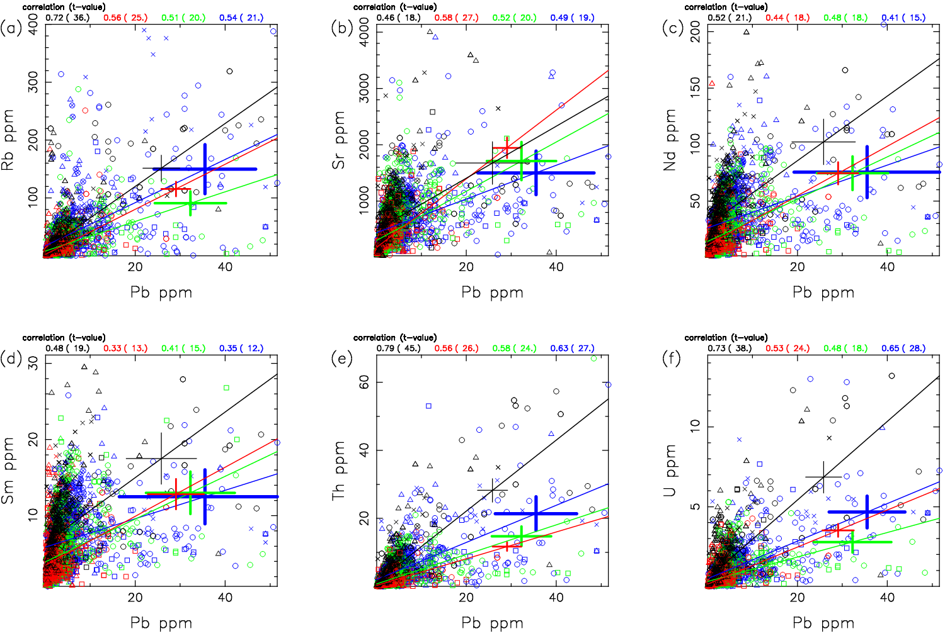
Supplementary Figure A2. Trace element variations of the basalt based on the Smirnov-Grubbs test. The Pb concentrations are plotted with (a) Rb, (b) Sr, (c) Nd, (d) Sm, (e) Th, and (f) U. The four lines are the linear regression lines for the individual basalt groups shown in Fig. 2: blue for Group 1 (IC1>0, IC2>0), green for Group 2 (IC1<0, IC2>0), red for Group 3 (IC1<0, IC2<0), and black for Group 4 (IC1>0, IC2<0). Triangle = MORB, cross = OIB, square = AB, circle = CB. Regression error bars for ±1σ are shown for the individual regression lines. The correlation coefficients are shown at the top of each figure for the four groups, with the t-values in the parenthesis, which indicate that all the regression lines are statistically significant.

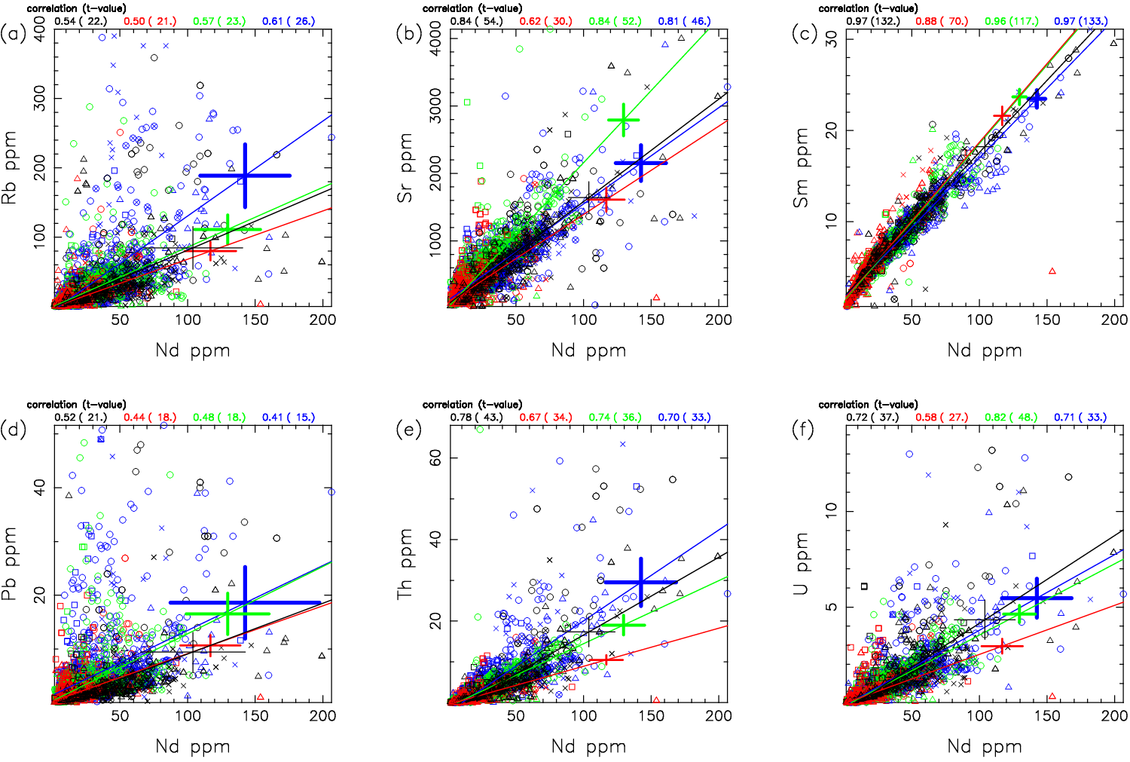

Supplementary Figure A3. Trace element variations of the basalt based on the Smirnov-Grubbs test. The Nd concentrations are plotted with (a) Rb, (b) Sr, (c) Sm, (d) Pb, (e) Th, and (f) U. The four lines are the linear regression lines for the individual basalt groups shown in Fig. 2: blue for Group 1 (IC1>0, IC2>0), green for Group 2 (IC1<0, IC2>0), red for Group 3 (IC1<0, IC2<0), and black for Group 4 (IC1>0, IC2<0). Triangle = MORB, cross = OIB, square = AB, circle = CB. Regression error bars for ±1σ are shown for the individual regression lines. The correlation coefficients are shown at the top of each figure for the four groups, with the t-values in the parenthesis, which indicate that all the regression lines are statistically significant.

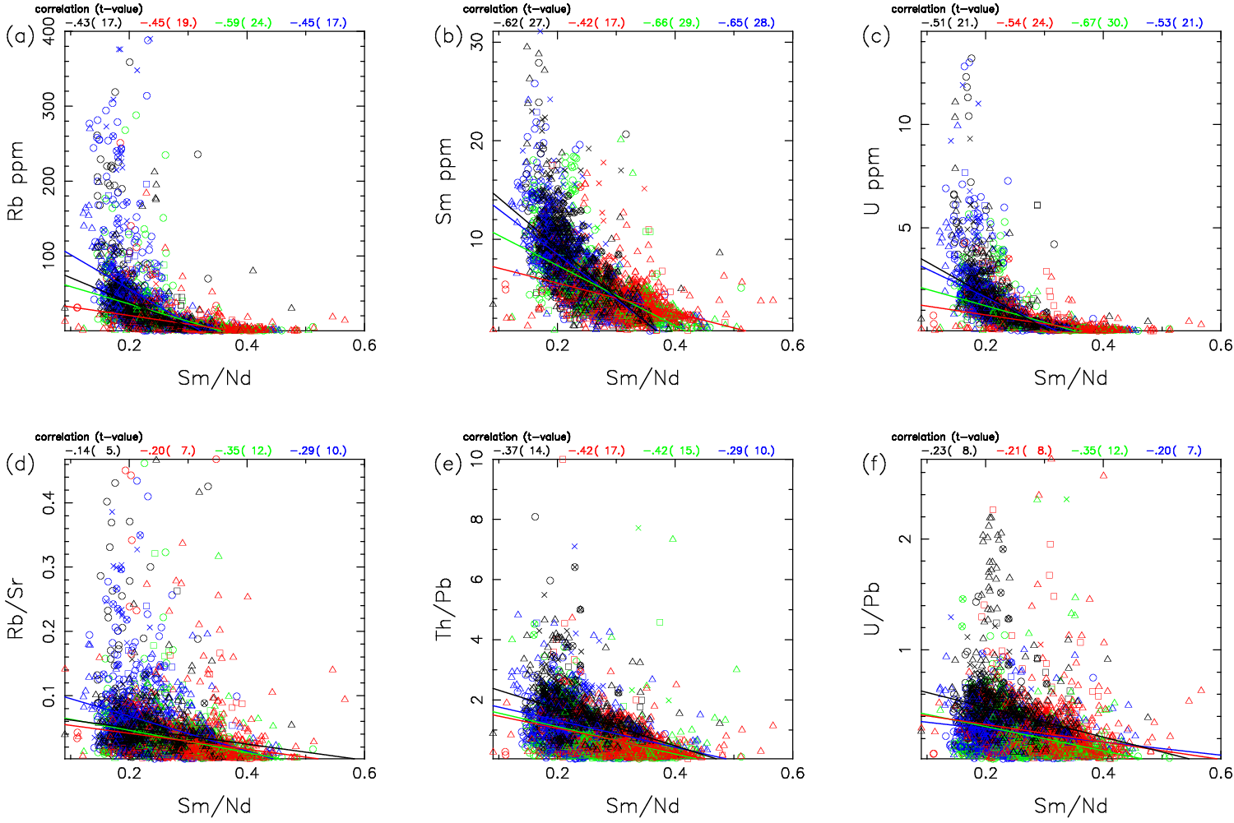

Supplementary Figure A4. Trace element variations of the basalt based on the Smirnov-Grubbs test. The Sm/Nd ratios are plotted with (a) Rb, (b) Sm, (c) U, (d) Rb/Sr, (e) Th/Pb, and (f) U/Pb. The four lines are the linear regression lines for the individual basalt groups shown in Fig. 2: blue for Group 1 (IC1>0, IC2>0), green for Group 2 (IC1<0, IC2>0), red for Group 3 (IC1<0, IC2<0), and black for Group 4 (IC1>0, IC2<0). Triangle = MORB, cross = OIB, square = AB, circle = CB. The correlation coefficients are shown at the top of each figure for the four groups, with the t-values in the parenthesis, which indicate that all the regression lines are statistically significant.

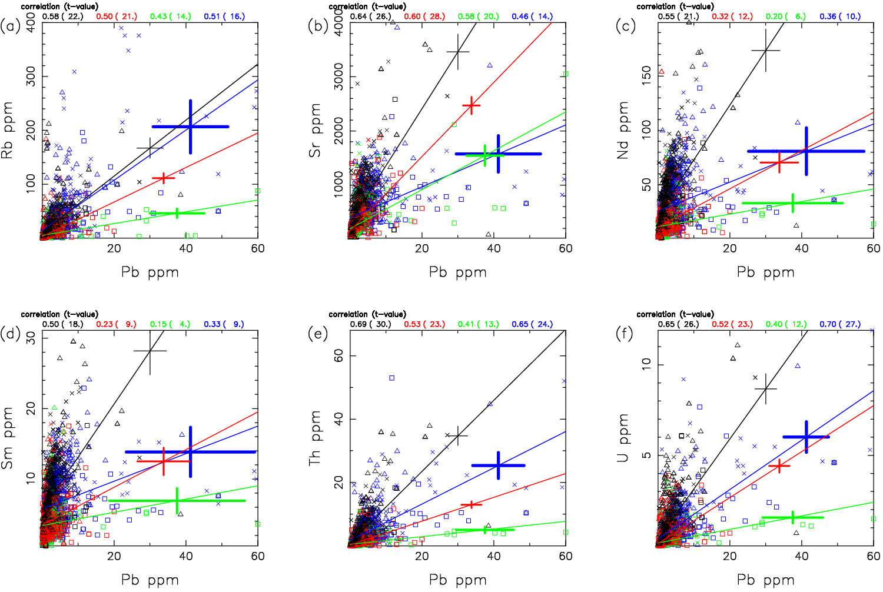
Supplementary Figure A5. Trace element variations of the basalt excluding the CB samples. The Pb concentrations are plotted with (a) Rb, (b) Sr, (c) Nd, (d) Sm, (e) Th, and (f) U. The four lines are the linear regression lines for the individual basalt groups shown in Fig. 2: blue for Group 1 (IC1>0, IC2>0), green for Group 2 (IC1<0, IC2>0), red for Group 3 (IC1<0, IC2<0), and black for Group 4 (IC1>0, IC2<0). Triangle = MORB, cross = OIB, square = AB. Regression error bars for ±1σ are shown for the individual regression lines. The correlation coefficients are shown at the top of each figure for the four groups, with the t-values in the parenthesis, which indicate that all the regression lines are statistically significant.

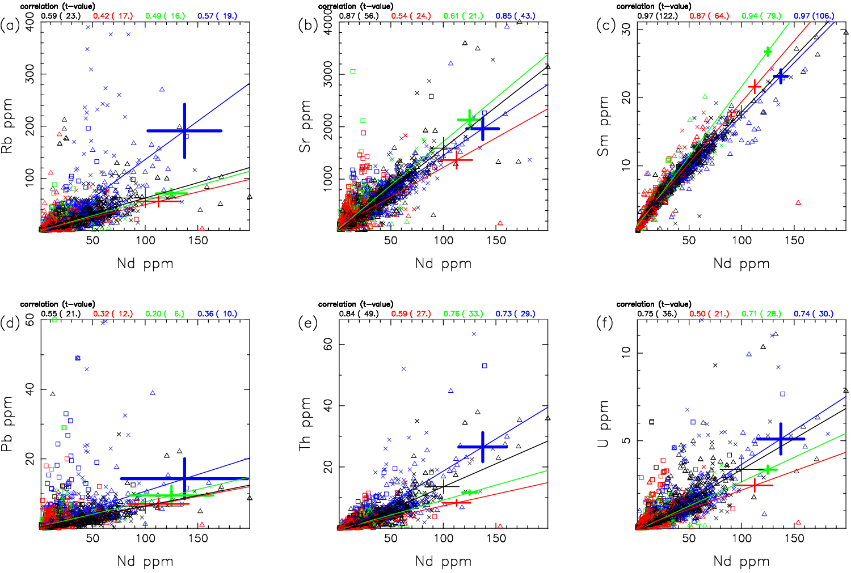

Supplementary Figure A6. Trace element variations of the basalt excluding the CB samples. The Nd concentrations are plotted with (a) Rb, (b) Sr, (c) Sm, (d) Pb, (e) Th, and (f) U. The four lines are the linear regression lines for the individual basalt groups shown in Fig. 2: blue for Group 1 (IC1>0, IC2>0), green for Group 2 (IC1<0, IC2>0), red for Group 3 (IC1<0, IC2<0), and black for Group 4 (IC1>0, IC2<0). Triangle = MORB, cross = OIB, square = AB. Regression error bars for ±1σ are shown for the individual regression lines. The correlation coefficients are shown at the top of each figure for the four groups, with the t-values in the parenthesis, which indicate that all the regression lines are statistically significant.

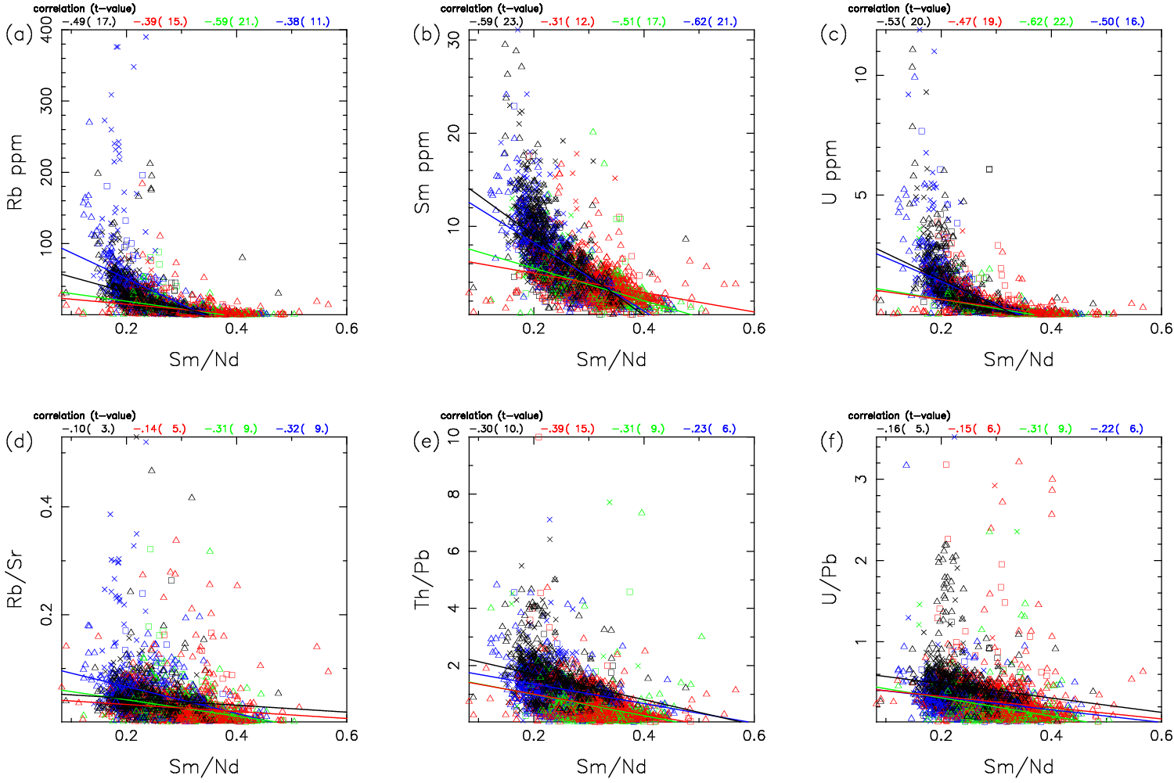

Supplementary Figure A7. Trace element variations of the basalt without the CB samples. The Sm/Nd ratios are plotted with (a) Rb, (b) Sm, (c) U, (d) Rb/Sr, (e) Th/Pb, and (f) U/Pb. The four lines are the linear regression lines for the individual basalt groups shown in Fig. 2: blue for Group 1 (IC1>0, IC2>0), green for Group 2 (IC1<0, IC2>0), red for Group 3 (IC1<0, IC2<0), and black for Group 4 (IC1>0, IC2<0). Triangle = MORB, cross = OIB, square = AB. The correlation coefficients are shown at the top of each figure for the four groups, with the t-values in the parenthesis, which indicate that all the regression lines are statistically significant.

