

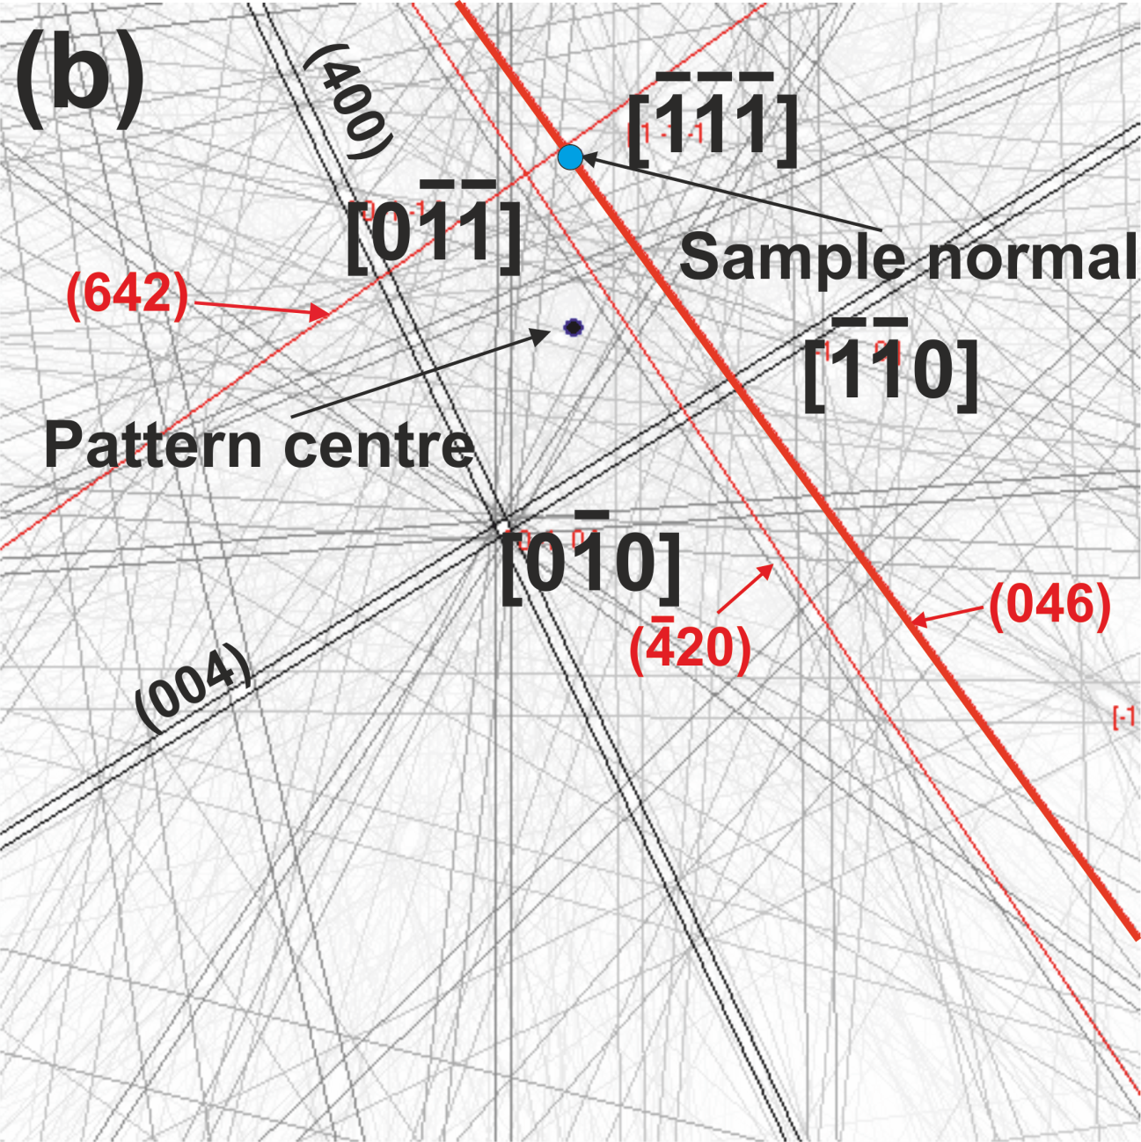

Fig. A.2. Indexing of the EBSD pattern from the single-crystal pyrope-rich garnet (M643). (a) An experimental Kikuchi pattern. The sample’s normal position (blue spot) is calibrated in the EBSD system. (b) The simulation for comparison. KL(046) and KL(642), intersected on the sample normal position, can be excited.