Appendix — Supplementary Material

**A1. Governing equations of mantle convection**

In this section, we introduce more details about the numerical model. As mentioned in the main text, we assume a truncated anelastic approximation of mantle material. The governing equations of convection are given as

$$∇∙\left(ρ\underline{v}\right)=0; ∇∙\underline{\underline{σ}}-∇p=ρ\underline{ g}; ρ C_{p,eff}\frac{DT}{Dt}=∇∙\left(k ∇T\right)+ρ H-α ρ g{ v}_{r}T+\underline{\underline{σ}}:\underline{\underline{\dot{e}}};$$

$\underline{\underline{σ}}=η \left(∇\underline{v}+∇\underline{v}{}_{}^{T}{}\right)$ (A1)

where ρ = density, dependent on temperature and composition; *v* = velocity, and *v*r its radial component; *σ* = stress; *p* = pressure; *g* = gravity; *Cp*,eff = effective heat capacity including the latent heat effects caused by phase transitions (Xie and Tackely, 2004); *T* = absolute temperature; *t* = time; *k* = thermal conductivity; *H* = radiogenic heating rate; *α* = effective thermal expansivity;  = strain rate; $η$ = viscosity.

The density of the mantle material, including the water effect, is assumed to be

$ρ=ρ\left(T_{ad},C,z\right)\left(1-α\left(T_{ad},C,z\right) \left(T-T_{ad}\right)\right)-{∆ρ}_{w}{ C}_{w}$ (A2)

where $ρ\left(T_{ad},C,z\right)$ is the combined reference density between harzburgite and MORB (Mid-Ocean-Ridge Basalt) compositions with 2.7 % density difference (3.6 % between olivine- and pyroxene-related phases; phase change parameters are listed in Table S1), $T_{ad}$ is the adiabatic temperature in the mantle, ${∆ρ}_{w}$ is the density variation due to the water content, and *C*w is the water content. Generally, the density of hydrous minerals is less than that of dry minerals (Mao et al., 2008; Inoue et al., 1998; Wang et al., 2006). Note that the value of ${∆ρ}_{w}$ is less constrained by high-*P*–*T* experiments; it is by 0.1–1.0% less than that for dry mantle minerals (Richard and Iwamori, 2010). Here we use a 1.0% density reduction caused by hydrous mantle minerals.

The equation of basaltic and ambient mantle material transport is given by

 (A3)

where *C* is the basaltic composition. The partial melting process is included to generate the oceanic crust and the associated heat extraction (e.g., Xie and Tackley, 2004; Nakagawa and Tackley, 2012). The procedure of melt transport is based on Christensen and Hofmann (1994) and Xie and Tackley (2004). The melt fraction brings the feedback to the temperature. The melt fraction is formulated as

$f_{melt}=min\left(c_{p}\frac{T - T_{solidus}\left(z,C_{w}\right)}{L},C\right)$ (A4)

$T→T-\frac{L f_{melt}}{c_{p}}$ (A5)

where *L* is the latent heat caused by partial melting, *cp* is the heat capacity of the mantle, and *f*melt is the melt fraction. The arrow in Eq. (A5) means that the temperature after processing melt migration should be included for latent heat effects. The temperature after processing melting migration, computed from the right-hand side of Eq. (A5), is used to solve the energy conservation (second equation in Eq. (A1)). Solving Eq. (A1) to (A5) numerically, we use the numerical code ‘StagYY’ based on a finite-volume multigrid solver with the active tracer particle approach for compositional field and melt fraction (Tackley, 2008). The model geometry, as illustrated in the main text, is assumed to be a spherical annulus (Hernlund and Tackley, 2008).

**A2. Water migration**

The equation of water transport is

$\frac{∂C_{w}}{∂t}+\underline{u}∙∇C_{w}=S_{w}\left(F_{R},F_{G},F_{H}\right)$ (A6)

where *C*w is the water content, and *S*W is the source-sink term as functions of ingassing ($F_{R}$), dehydration ($F_{H}$), and degassing ($F_{G}$) given in Eqs. (8) to (10) in the main text. Eq. (A6) expresses material transport in the solid mantle. On the surface boundary condition of water content, since most of the Earth’s surface is covered by seawater, the water content at the surface is given by Eqs. (6) and (7) in the main text. This condition also indicates that the oceanic crust may be instantaneously saturated with water at the surface temperature and pressure.

The solidus temperature of the mantle material is dependent on the water content, as described by the scaling law derived from Katz et al. [2003], given by

$T_{solidus}\left(T,z,C_{w}\right)=T_{solidus, dry}\left(T,z\right)-43{ \left(100 C_{w}\right)}^{0.75}$. (A7)

where the dry solidus temperature is that of Herzburg et al. (2000) in the upper mantle and Zerr et al. (1998) in the lower mantle. The solidus temperature reduces by 165 K when the water content in the mantle is the water solubility of the basaltic material at the surface (6%).

Ingassing is related to an amount of water transported by surface plate velocity integrated over the surface area at the surface boundary given by

$F_{R}=\left\{\begin{matrix}\int_{S}{ρ_{m }C_{w,s}{ u}_{z} dS if u_{z}>0} \\ 0 (otherwise)\end{matrix}\right.$ (A8)

where $ρ_{m}$ is the density of the mantle, $C_{w,s}$ is the water content at one grid below the surface, and $u_{z}$ is the downward velocity measured at one grid below the surface. Degassing is related to an amount of water release to the exosphere (ocean and atmosphere) associated with the volcanic eruption integral over the volume of the numerical grid *V* given by

$F_{G}=\frac{d}{dt}\int_{V}{ρ_{m,erupt}}C_{w,erupt} dV$ (A9)

where $ρ_{m,erupt}$ is the density of the erupted material and $C_{w,erupt}$ is the water content of the erupted material. The water content of the erupted material is obtained as

$C_{w,erupt}=\frac{C_{w,bulk}}{D_{w} + f_{melt }\left(1-D_{w}\right)}$ (A10)

where $C_{w,bulk}$ is the bulk water content, $D_{w}$ is the partition coefficient between the solid and the molten material set as 0.01, as described earlier, and $f_{melt}$ is the melt fraction described in the supporting material. Dehydration is related to excess water transportation in the mantle and is integrated over the surface area:

$F_{dehydration}=\int_{S}{\left(ρ_{m}-ρ_{w}\right) ϕ{ u}_{dehydration }{ΔC}_{w,ex} dS}$ (A11)

where $ρ_{m}$ is the density of the mantle, $ρ_{w}$ is the density of water, $u_{dehydration}$ is the migration velocity of excess water as computed in Nakagawa and Spiegelman (2017), and Nakagawa et al.(2018), ${∆C}_{w,ex}$ is the excess water computed from water solubility, and $ϕ$ is the transport rate of excess water, equivalent to the porosity of mantle rock. Here, we assume that mantle rock is a less porous material. Thus, porosity may be equal to the water content in the mantle. This dehydration flux is measured across the surface boundary. As indicated for both cases, generally, the ingassing from subducting oceanic lithosphere is much higher than mantle outgassing and dehydration fluxes. Ingassing is nearly an order of magnitude larger than degassing and dehydration, which gradually transports the surface seawater into the deep mantle until surface seawater is dried up. The amount of ingassing would range from 1012 to 1014 kg/yr across the surface but, as pointed out by Nakagawa et al. (2015), the actual ingassing flux into the deep mantle is reduced up to three orders of magnitude due to effects of the choke-point of mantle water solubility shown in Figure 1, which seems to be decreased up to 1011 kg/yr. This amount seems to be consistent with an estimate of subduction flux in Iwamori (2007) and Jarrard (2003).

Since the original version of STAGYY does not include excess water transport, that is, the dehydration process, excess water transport is applied following a procedure similar to that proposed by Iwamori and Nakakuki (2013), Quinquis and Buitner (2014), Nakagawa et al. (2015), and Nakao et al. (2016), which is based on an active tracer particle approach. Briefly described below, excess water can be computed between mantle water content and water solubility maps for each mantle composition. When excess water is found, it is allowed to migrate vertically. This migration process is continued until the water content in the whole domain reaches an undersaturated condition. Estimating the migrating velocity of excess water with this assumption, it would range from 0.5 m/yr to 5 m/yr with the averaged numerical grid spacing and characteristic time intervals estimated from the rheological strength of mantle water content. This would be an order of magnitude faster than the solid mantle velocity. Comparing the fluid velocity based on a two-phase flow model, which ranges from 0.25 to 25 m/yr as the typical fluid velocity (Wilson et al., 2014), the migrating velocity estimated here would be somewhat reasonable with two-phase flow models of intermediate to low permeability.

**A3. Core evolution**

For computing a bottom thermal boundary condition in mantle convection simulations, the thermodynamic theory of thermal evolution of the Earth’s core is useful for expressing a coupled core–mantle evolution (e.g., Nakagawa and Tackley, 2010). For the heat balance in the Earth’s core, it can be given as

$\frac{4}{3}π ρ_{c}{ c}_{c} \left(b^{3}-c^{3}\right)\frac{dT_{c}}{dt}={-Q}_{CMB}+4 π c^{2}ρ_{IC}\frac{dc}{dt}\left(E_{G}+L\right)$ (A8)

where $b$ is the radius of the Earth’s core, $c$ is the radius of the inner core, $ρ_{c}$ is the density of the outer core, $c_{c}$ is the heat capacity of the outer core, $T_{c}$ is the temperature at the inner core boundary (ICB), $Q_{CMB}$ is the heat flow across the CMB computed from mantle convection simulations, $ρ_{IC}=ρ_{c}+∆ρ_{IC}$ is the density of the inner core, $E_{G}$ and $L$ are gravitational energy release caused by compositional convection associated with the inner core growth and the latent heat release caused by inner core nucleation, given by

$E_{G}=∆p_{IC} g b\left(\frac{3}{10}-\frac{1}{2}{\left(\frac{c}{b}\right)}^{2}\right)$ (A9)

$L=ρ_{IC}{ T}_{m}\left(c\right) ∆S$ (A10)

where $g$ is the gravity acceleration at the CMB, $T_{m}\left(c\right)$ is the melting temperature at the ICB, and $∆S$ is the entropy change caused by the growth of the inner core. To compute the temperature at the CMB used for a bottom thermal condition of mantle convection simulations, we assume the isentropic (adiabatic) condition in the well-mixed core to be

$T_{CMB}=T_{c} exp\left(-ϕ\frac{b^{2}-c^{2}}{b^{2}}\right)$ (A11)

where the constant $ϕ$ is given as

$ϕ=\frac{2 π G{ ρ}_{c}^{2} b{ γ}_{c}}{3K_{0}}$ (A12)

where $G$ is the gravitational constant, $γ_{c}$ is the Grüneisen parameter of the core alloy, and $K_{0}$ is the bulk modulus of the core alloy. Solving the heat balance equation, it is required to use the initial value. Here, the initial temperature at the CMB is set, then is computed for the temperature at the ICB using isentropic temperature profile shown in Eqs. (A11) and (A12). For the growth of the inner core, we use the heat balance equation for the growth rate of the inner core. On the onset of the inner core, we assume the solution to the equation coupled between an isentropic temperature of the Earth’s core and the melting temperature of the core alloy. The melting temperature of the core alloy is obtained as

$T_{m}\left(c\right)=T_{m,0}-A c^{2}\left(\frac{∂T_{m}}{∂p}\right)+\left(\frac{c^{3}}{b^{3}-c^{3}}\right)X_{0}\left(\frac{∂T_{m}}{∂X}\right);A=\frac{2 π G ρ_{c}^{2}}{3}$ (A13)

where $T_{m,0}$ is the melting temperature of the core alloy at the center of the Earth, $\left({∂T_{p}}/{∂p}\right)$ is the pressure derivative of the melting temperature, $X_{0}$ is the initial concentration of light elements in the core alloy, and $\left({∂T_{m}}/{∂X}\right)$ is the compositional derivative of the melting temperature. At the onset of the inner core, since the temperature at the ICB is just below the melting temperature, the initial size of the inner core may be obtained under the assumption of no melting temperature reduction due to light element, which reads

$c\left(t=t_{onset}\right)={\left(\frac{T_{m,0}-T_{c}}{A\left(\frac{∂T_{m}}{∂p}\right)}\right)}^{\frac{1}{2}} if T_{c}<T_{m,0}$ (A14).

To compute the magnetic evolution in core evolution theory, the magnetic dissipation energy is generally used, which is applied following Lister (2003). The magnetic dissipation energy can be formulated as

$Φ=ε_{s}\left(Q_{CMB}-Q_{IS}\right)+\left(ε_{L}+ε_{G}\right) Q_{CMB}$ (A15)

where $ε_{s}$, $ε_{L},$ and $ε_{G}$ are thermodynamic efficiencies caused by thermal convection and latent heat release under the growth of the inner core and compositional convection caused by the growth of the inner core, given by

$ε_{s}=ε_{b }exp\left(ϕ\right)-1; ε_{b}=1-\frac{3}{5}ϕ+\frac{3}{14}ϕ^{2}$ (A16)

$ε_{L}=\frac{3{ S}_{L }\frac{c}{b} \left(1-ε_{b}\right)}{\left(2+3 \left(S_{L}+S_{G}\right) \frac{c}{b}\right)}$ (A17)

$ε_{G}=\frac{3 S_{G} \frac{c}{b}}{\left(2+3\left(S_{L}+S_{G}\right) \frac{c}{b}\right)}$ (A18)

$S_{L}=\frac{4}{3}π{ b}^{3}\frac{L}{M_{c}}$ (A19)

$S_{G}=\frac{4}{5}π\frac{A{ b}^{5}}{M_{c}}\frac{∆ρ_{IC}}{ρ_{c}}$ (A20)

$M_{c}=\frac{4}{3}π{ ρ}_{c} b^{3}c_{c} T_{m,0} ϕ ε_{b}\left(1-\frac{2}{3 γ_{c}}\right)$ (A21),

$S_{L}$ and $S_{G}$ are dimensionless parameters that characterize the energy released as latent heat and by compositional convection caused by the growth of the inner core, respectively, $M_{c}$ is the effective heat capacity of the entire metallic core, and $Q_{IS}$ is the isentropic heat flow, given by

$Q_{IS}=\frac{2 ϕ}{b}k_{c}{ T}_{CMB}$ (A22)

where $k_{c}$ is the thermal conductivity of the core alloy. All parameters used for computing the core’s evolution are listed in Table 2 of the main text.

**Appendix A4. Model sensitivity of hydration state of oceanic crust**

Here, we test the sensitivity of the hydration state of the oceanic crust to the numerical model. Four additional cases are used, which assume two values of the total amount of water (8 and 12 ocean masses and two values of the boundary condition of water circulation (0.6 and 6 wt. percent). To clarify how the plate-like behavior works for water evolution, the water-weakening effect is not used, which assumes a constant friction coefficient, so that the plate-like behavior can be found; it is chosen as 0.02. This is because there are several alternative weakening mechanisms of the oceanic lithosphere to get the plate-like behavior (Foley, 2018; Karato and Barbot, 2018). Figure A1 indicates the sensitivity of the hydrate condition of the oceanic lithosphere to the water mass evolution of mantle and surface. The total amount of water in the system is assumed as 12 ocean masses. Figure A2 indicates the water mass evolution of the mantle and of the surface for eight ocean masses of total water mass in the planetary system. As shown in Figure A1 and A2, water evolution in both mantle and surface would not be very sensitive to the hydration state of the oceanic lithosphere. However, the survival time of surface seawater seems to have longer time-scale as the water content of the oceanic lithosphere decreases. For cases with ocean masses of 8 times the total amount of water in the planetary system (Figure A2), the surface seawater may be dried up in about a few billion years, even for the case with 0.6 wt. percent of the water content of the oceanic lithosphere. As pointed out by Carlson (2003), the water content in the oceanic crust may be around 0.6 wt. percent using the elastic properties of the oceanic lithosphere. Moreover, in the subduction-scale modeling, the minimum water content of the oceanic lithosphere seems to be around more than two wt. percent to have the volcanic activities beneath the island arc (Horiuchi and Iwamori, 2016). This suggests that the possible water content of the oceanic lithosphere pointed out from the elastic properties and constraints for the volcanic activities beneath the island arc may give a result similar to the full-saturated water content of the oceanic lithosphere because 2 percent of water in the oceanic lithosphere indicates a water content between 0.6 and 6 percent in the oceanic lithosphere. Therefore, as pointed out by Figures A1 and A2, the numerical models provided in this study seem to be robust enough for assessing the Earth-like behaviors of the mantle water cycle.

**References**

Carlson, R. L., 2003. Bound water content of lower oceanic crust estimated from model analysis and seismic velocities of ocean diabase and gabbro. Geophys. Res. Lett. 30, 2142; doi: 10. 1029/2003GL018213.

Christensen, U., Hofmann, A.W., 1994. Segregation of subducted oceanic crust in the convecting mantle. J. Geophys. Res. 99, 19867–19884.

Foley, B. J., 2018. The dependence of planetary tectonics on mantle thermal state: applications to early Earth evolution, Phil. Trans. Royal Soc. A 376, 20170409; doi: 10.1098/rsta/2017.0409.

Hernlund, J. W., Tackley, P.J., 2008. Modeling mantle convection in the spherical annulus. Phys. Earth Planet. Inter. 171, 48–54.

Herzberg, C., Raterron, P., Zhang, J., 2000. New experimental observations on the anhydrous solidus for periodite KLB-1. Geochem. Geophys. Geosyst. 1; doi: 10.1029/2000GC000089.

Inoue, T., Weidner, D.J., Northrup, P.A., Parise,J.B., 1998. Elastic properties of hydrous ringwoodite (γ-phase) in Mg2SiO4. Earth Planet. Sci. Lett. 160, 107–113.

Iwamori, H., 2007. Transportation of H2O beneath the Japan arcs and its implications for global water circulation. Chem. Geol. 239, 182–198.

Iwamori, H., Nakakuki, T., 2013. Fluid Processes in Subduction Zones and Water Transport to the Deep Mantle. In: Karato, S. I. (Ed.), Physics and Chemistry of the Deep Mantle, John Wiley and Sons, Ltd, pp. 372–391.

Jarrard, R. D., 2003. Subduction fluxes of water, carbon dioxide, chlorine, and potassium. Geochem. Geophys. Geosyst. 4; doi: 10.1029/2002GC000392.

Karato, S.-i., 2011. Water distribution across the mantle transition zone and its implications for global material circulation. Earth. Planet. Sci. Lett. 301, 413–423. doi: 10.1016/j.epsl.2010.11.038.

Katz, R. F., Spiegelman, M., Langmuir, C.H., 2003. A new parameterization of hydrous mantle melting. Geochem. Geophys. Geosyst. 4, 1073; doi: 10.1029/2002GC000433.

Mao, Z., S. D. Jacobsen, F. Jiang, J. R. Smyth, C. M. Holl, D. J. Frost, and T. S. Duffy, T.S., 2008. Single-crystal elasticity of wadsleyites, β-MgsSiO4 containing 0.37–1.66 wt.% H2O, Earth Planet. Sci. Lett. 266, 78–89.

Nakagawa, T., Nakakuki, T., Iwamori, H., 2015. Water circulation and global mantle dynamics: Insight from numerical modeling. Geochem. Geophys. Geosyst. 16, 1449–1464; doi:10.1002/2014/GC005701.

Nakagawa, T., Iwamori, H., Yanagi, R., Nakao, A., 2018. On the evolution of the water ocean in the plate-mantle system, Prog. Earth Planet. Sci. 5, 51; doi: 10.1186/s40645-018-0209-2.

Nakagawa, T., Spiegelman, M.W., 2017. Global-scale water circulation in the Earth’s mantle: Implications for the mantle water budget in the early Earth. Earth. Planet. Sci. Lett. 464, 189–199; doi:10.1016/j.epsl.2017.02.010, 2017.

Nakagawa, T.,Tackley, P.J., 2010. Influence of initial CMB temperature and other parameters on the thermal evolution of Earth’s core resulting from thermo-chemical spherical mantle convection. Geochem. Geophys. Geosyst. 11, Q06001, doi: 10.1029/2010GC003031.

Nakagawa, T., Tackley, P.J., 2011. Effects of low-viscosity post-perovskite on thermo-chemical mantle convection in a 3-D spherical shell. Geophys. Res. Lett. 38, L04309; doi:10.1029/2010GL046494.

Nakagawa, T., Tackley, P.J., 2012. Influence of magmatism on mantle cooling surface heat flow and Urey ratio. Earth Planet. Sci. Lett., 323–330, 1–10; doi: 10.1016/j.epsl.2012, 02.011.

Nakao, A., Iwamori, H., Nakakuki, T., 2016. Effects of water transportation on subduction dynamics: Roles of viscosity and density reduction. Earth Planet. Sci. Lett. 454, 178–191.

Quinquis, M. E. T., Buiter, S.J.H., 2014. Testing the effects of basic numerical implementations of water migration on models of subduction dynamics. Solid Earth 5, 537–555; doi: 10.5194/se-5-537-2014.

Richard, G. C., and H. Iwamori, H., 2010. Stagnant slab, wet plumes and Cenozoic volcanism in East Asia. Phys. Earth Planet. Inter. 183, 280–287.

Tackley, P. J., 2008. Modelling compressible mantle convection with large viscosity contrasts in a three-dimensional sphere shell using the yin-yang grid. Phys. Earth Planet. Inter. 171, 7–18; doi:10.1016/j.pepi.2008.08.005.

Wang, J., Sinogeikin, S.V., Inoue, T., Bass, J.D., 2006. Elastic properties of hydrous ringwoodite at high-pressure conditions, Geophys. Res. Lett., 33, L14308; doi:10.1029/2006GL026441, 2006.

Wilson, C. R., Spiegelman, M., van Keken, P.E., Hacker, B.R., 20 14. Fluid flow in subduction zones: The role of solid rheology and compaction pressure. Earth Planet. Sci. Lett. 401, 261–274.

Wang, J., Sinogeikin, S.V., Inoue, T., Bass, J.D., 2006. Elastic properties of hydrous ringwoodite at high-pressure conditions, Geophys. Res. Lett., 33, L14308; doi:10.1029/2006GL026441, 2006.

Wilson, C. R., Spiegelman, M., van Keken, P.E., Hacker, B.R., 20 14. Fluid flow in subduction zones: The role of solid rheology and compaction pressure. Earth Planet. Sci. Lett. 401, 261–274.

Xie, S., Tackley, P.J., 2004. Evolution of U–Pb and Sm–Nd systems in numerical models of mantle convection. J. Geophys. Res. 109, B11204; doi:10.1029/2004JB003176.

Yamazaki, D., Karato, S., 2001. Some mineral physics constraints on the rheology and geothermal structure of Earth’s lower mantle. Am. Mineral. 86, 385–301.

Zerr, A., Diegeler, A., Boehler, R., 1998. Solidus of Earth’s Deep Mantle. Science 281, 243–246.

Figure A1. Water mass evolution for two different water contents of the oceanic lithosphere. The total water mass in the planetary system (surface and deep interior) is chosen as 12 ocean masses. (a) Surface seawater and (b) mantle water.

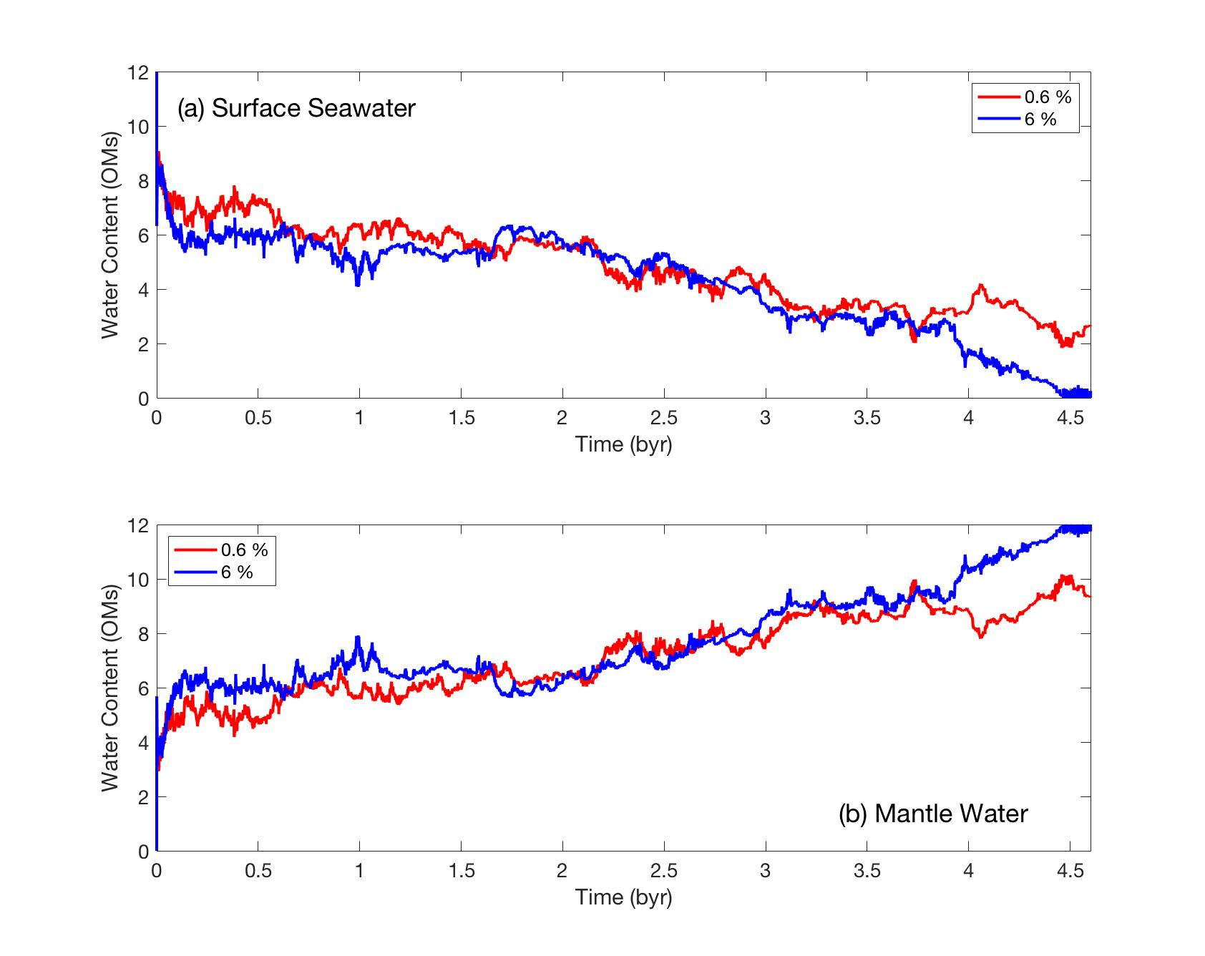

Figure A2. The same as in Figure A1, but for cases with 8 ocean masses of the total water mass in the planetary system. (a) Surface seawater and (b) mantle water.

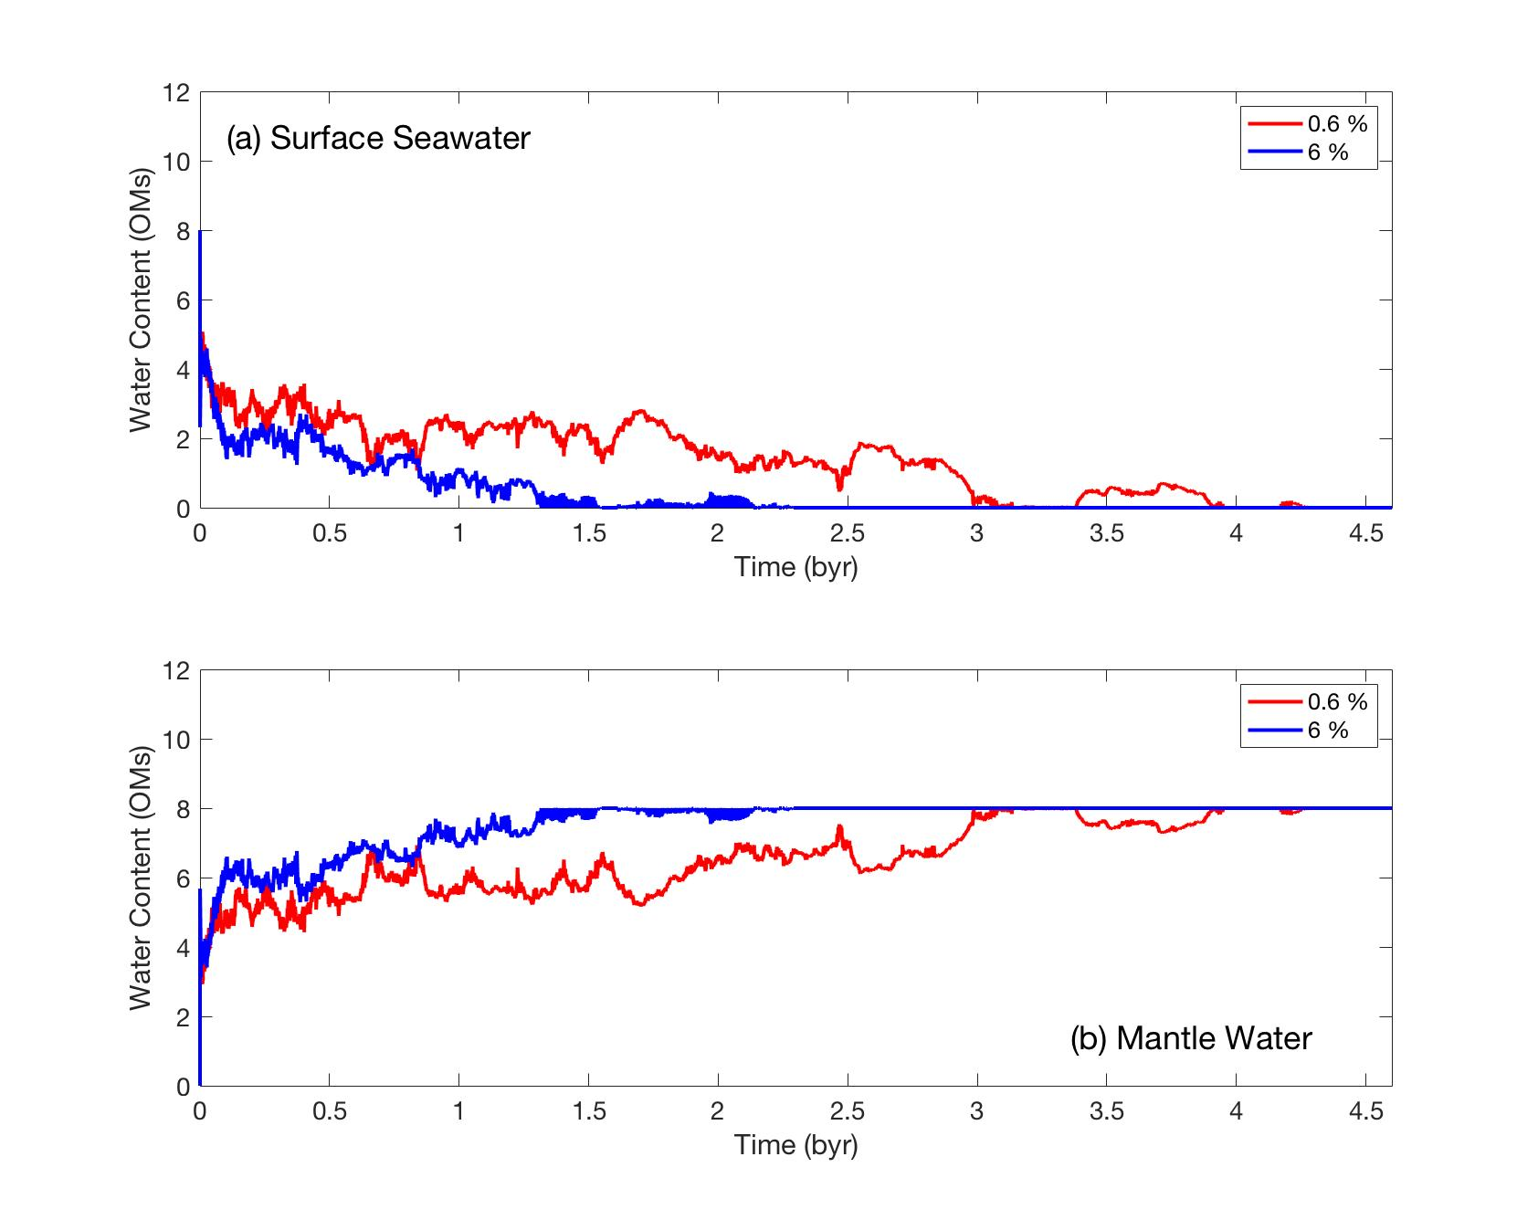

Table S1. Physical parameters for multi-component phase changes taken from Nakagawa and Tackley (2011).

|  |  |  |  |  |  |
| --- | --- | --- | --- | --- | --- |
| # | Depth (km) | Temperature (k) | (kg·m–3) | (MPa/K) | Width (km) |
| Olivine–spinel–perovskite–post-perovskite | | | | | |
| 1 | 410 | 1600 | 280 | +2.5 | 30.0 |
| 2 | 660 | 1900 | 400 | -2.5 | 30.0 |
| 3 | 2740 | 2650 | 60 | +12.0 | 30.0 |
| Pyroxene–garnet–perovskite–post-perovskite | | | | | |
| 1 | 60 | 0 | 350 | 0 | 30.0 |
| 2 | 400 | 1600 | 100 | +1.0 | 75.0 |
| 3 | 720 | 1900 | 500 | +1.0 | 75.0 |
| 4 | 2700 | 2650 | 60 | +12.0 | 30.0 |