# SUPPLEMENTARY MATERIAL

**Supplementary Material 1**

Overview of the characteristics for the five models tested.

|  |  |  |  |
| --- | --- | --- | --- |
| **Models** | **WB** | **Makhlouf** | **Mouelhi** |
| **Parameters** | *x*1 : Direct runoff  *x*2 : Instantaneous runoff  γ : Soil capacity (γcan beassimilated to WHC for WB2) | *x*1 : Modulator of Rainfall and PET  *x*2 : Modulator of output Discharge of reservoir S  *A* : Soil capacity (*A*can beassimilated to WHCforMK2) | *x*1 : Modulator of Rainfall and PET  *x*2 : Exchange Coefficient of outside |
| **reservoir(s)** | A soil water reservoir characterised by γ | A ground reservoir (H) : production function, characterised by *A*  A gravity water reservoir (S): transfer function. | A ground reservoir (S) : production function, characterised by *A*  A gravity water reservoir (R): transfer and production function. |
| **Inputs** | Rainfall (R)  Potential EvapoTranspiration (PET)  WHC(for WB2 and MK2) | | |
| **Output** | Runoff(Q) | | |
| **Calibration algorithm** | Rosenbrock Method followed by Simplex Method | | |
| **Operating scheme** |  |  |  |

**Supplementary Material 2**

*Behaviour of the goodness-of-fit criteria according to annual rainfall across the 241 catchments of the five rainfall–runoff models. The number of runs with a performances of at least 60 is on the median line of the boxplots.*

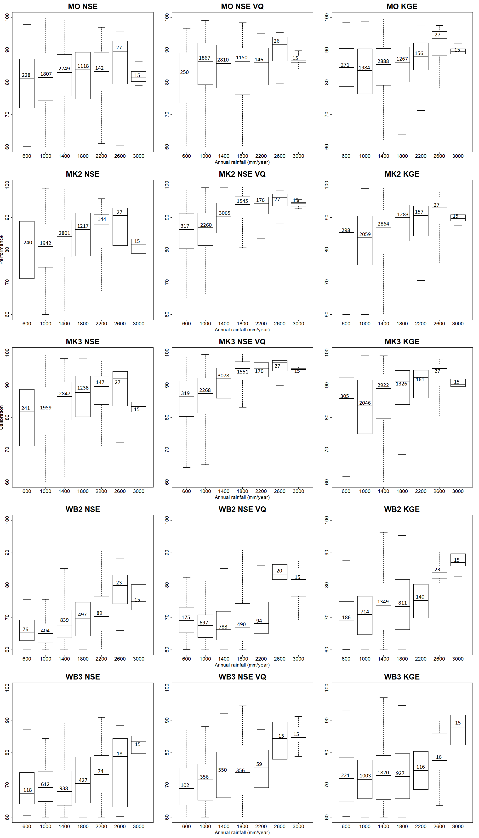

**Supplementary Material 3**

*Behaviour of the goodness-of-fit criteria according to annual rainfall PET across the 241 catchments of the five rainfall–runoff models. The number of runs with performances of at least 60 is on the median line of the boxplots.*

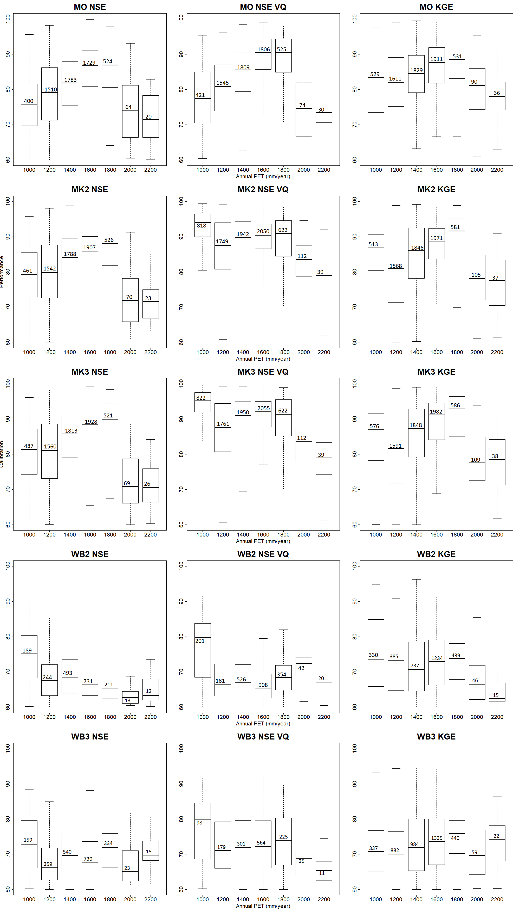

**Supplementary Material 4**

*Robustness according to the annual rainfall variation.*

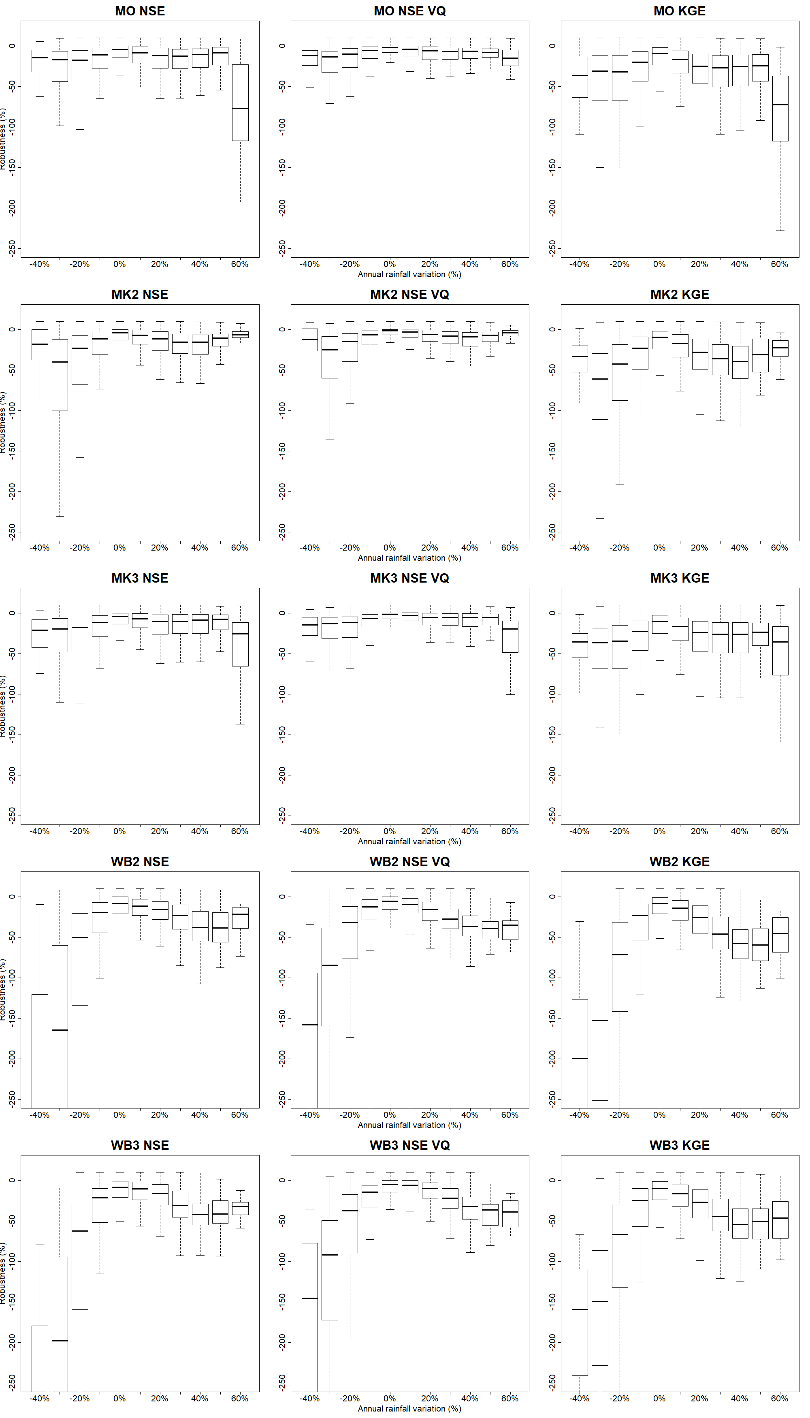

**Supplementary Material 5**

*Robustness according to the annual PET variation.*

