**Supplementary Data S2**

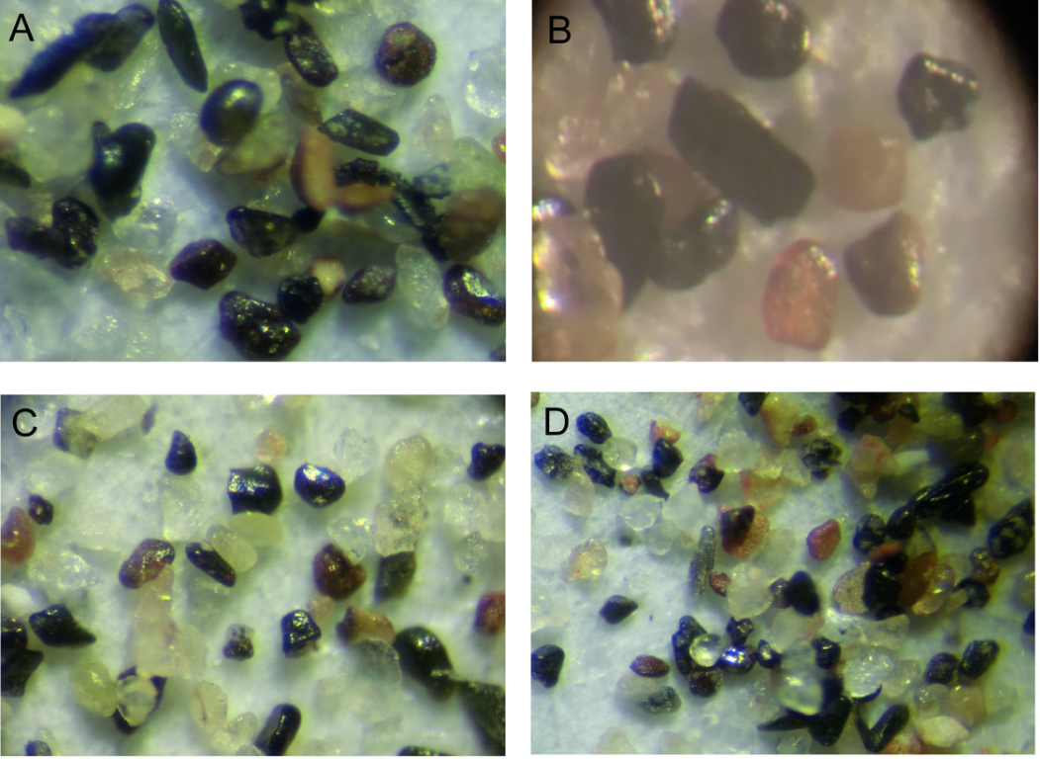

**Figure 5.** Optical micrographs of magnetically extracted material (iron oxides) and heavy minerals (e.g. garnet, tourmaline) in the 50–250 μm grain-size fractions (see locations in Fig. 6; A: at 6 cm; B: at 26.5 cm; C: at 56.5 cm; D: at 82.5 cm)

## Surface microtextures of quartz grains

The aeolian feature microtextures are evident on the grain surface from 93.5, 79 and 37 cm depth. Indeed, at 93.5 cm depth the material shows rounded to sub-rounded grains with low relief, bulbous edges and vast triangular incisions (aeolian pitting) as illustrated in Figure 7 (A and D). Furthermore, the crescentic percussion marks and elongated depressions (dish-shaped concavities) can be observed in Figure 7 (A and D) pointing out an aeolian transportation of the grain. For the sand level located at 79 cm depth, the upturned plates are formed due to the shattering of quartz grains during high-energy collision, and hence these are a prominent feature on quartz grains from aeolian environments (Fig. 7 C). The level of 37 cm depth is characterized by rounded grains showing a crescentic percussion marks, arcuate steps with bulbous edge and small-scale conchoidal fractures (Fig. 7E). Moreover, we notice that the fracture edges are slightly curved to dish-shaped specifying an aeolian transport. Between the curved conchoidal fractures, we can see chatter marks (Fig. 7F) testifying to mechanical abrasion that can be formed during violent aeolization affecting highly the heterogeneous size of sediments. The aeolian features of the above microtextures suggest strong wind energy that occurred in different periods of the Sebkha history.

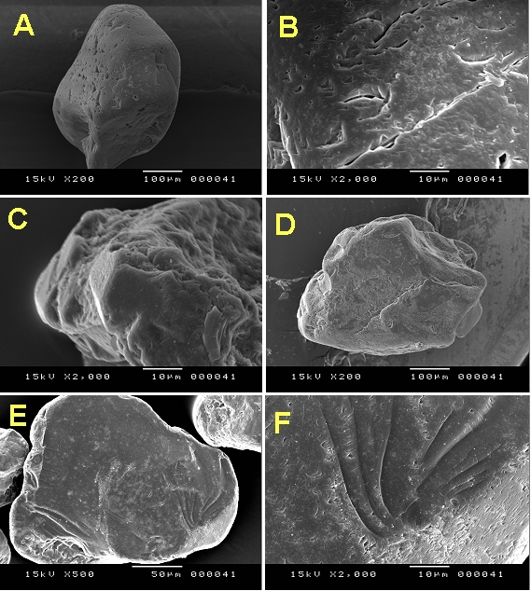

**Figure 7.** Scanning electron micrographs of aeolian quartz grains from core Mh1: (A) Rounded grain with low relief and bulbous edges (Mh1-187: at 93.5 cm depth). (B) Numerous crescentic percussion marks. (C) Grain with upturned plates and crystalline overgrowths (Mh1-158: at 79 cm depth). (D) Sub-rounded grain with bulbous edges and numerous dish-shaped percussions (Mh1-74 at 37 cm depth). (E) Rounded grain with small-scale conchoidal fractures, crescentic percussion marks, arcuate steps and bulbous edge (Mh1-74: at 37 cm depth). (F) Detail of arcuate steps and numerous chatter marks.

Samples from 66.5, 56.5 and 42.5 cm depths (Mh1-133, Mh1-113 and Mh1-85, respectively) exhibited spectacular angular grains. The quartz grains of Mh1-85 sample (Fig. 8 A and B) appeared to have conchoidal fractures forming arcuate and straight steps. They are produced by a powerful impact or pressure on the grain surface. Besides, straight or curved grooves and scratches are presented in Figure 8B together with V-shaped percussion cracks. A grain with mainly subangular appearance can be seen in Figure 8C (Mh1-113), with straight grooves and some fractures. These microtextures could have formed during transport by fluvial streams.

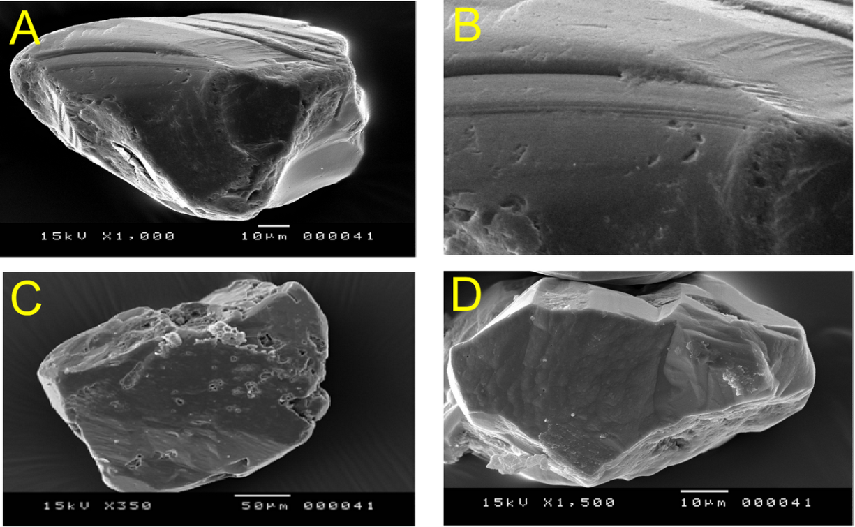

**Figure 8.** Scanning electron micrographs of fluvial quartz grains from core Mh1: (A) Angular grain showing fractures forming arcuate and straight steps (Mh1-85: at 42.5 cm depth). (B) Detail of arcuate steps and V–shaped percussions. (C) Subangular grain showing straight grooves, adhered particules and solution pits (Mh1-113: at 56.5 cm depth). (D) Angular grain showing high relief (Mh1-133: at 66.5 cm depth).

Oriented etch pits are a common feature of almost all the grains, sometimes covering >50% of their surface. Figure 8C shows presence of adhering particles, solution pits, and fractures due to quartz dissolution. Crystalline overgrowths are represented in Figure 7C. Chemical scaly exfoliations are also seen in Figures 7C, D and 8A indicating a high erosive water-chemical environment.